Google Cybersecurity Certificate overview Apr 6, 2026
This reading introduces the Google Cybersecurity Certificate program, outlining its purpose, what learners will gain, and the career opportunities it opens up.

Program Overview
- The program explores the growing field of cybersecurity, teaching crucial skills for protecting organizations and individuals.
- It prepares learners for entry-level roles like cybersecurity analyst and security operations center (SOC) analyst, with no prior experience required.

Why Cybersecurity is in Demand
- The digital transformation has led to an increase in devices, applications, and data, which in turn has expanded threats and vulnerabilities.
- Cybersecurity professionals are essential to safeguard organizations, people, and data from these growing risks.

Certificate Courses and Benefits
- The certificate includes eight courses covering core cybersecurity concepts, models, frameworks, network protection, incident response, and automation with Python.
- Upon completion, graduates gain access to job search resources, including resume building, mock interviews, job postings, career coaching, and preparation for the CompTIA Security+ exam.
Course 1 overview Apr 6, 2026
This course, "Foundations of Cybersecurity," is the first step in the Google Cybersecurity Certificate program, designed to introduce you to the field of cybersecurity.
Course Overview
- You will learn about the main responsibilities and essential skills of cybersecurity professionals.
- The course covers the eight Certified Information Systems Security Professional (CISSP) security domains, various security frameworks, controls, and the confidentiality, integrity, and availability (CIA) triad.
Google Cybersecurity Certificate Program
- This certificate program consists of eight courses, with "Foundations of Cybersecurity" being the initial one.
- The program aims to equip you with the necessary skills for entry-level cybersecurity roles, with no prior experience required.
Course Content and Learning Experience
- The course is divided into modules, allowing you to learn at your own pace, with the entire certificate program designed to be completed in about six months.
- You'll engage with various learning opportunities, including videos led by Google instructors, readings, self-review activities, labs, and quizzes to reinforce your understanding.
Welcome to module 1 Apr 6, 2026
This course provides an introduction to the field of cybersecurity, outlining its importance in protecting businesses, users, and devices, and aiming to contribute to a safer internet.
Foundational Security Concepts
- The course will define security and explore the common job responsibilities of security analysts.
- It will also cover the core skills that a security analyst typically possesses and discuss the value of security for organizations and individuals.
Key Areas of Cybersecurity
- The curriculum will delve into eight security domains, providing a comprehensive overview of different aspects of cybersecurity.
- It will also cover common security frameworks and controls used to manage and mitigate security risks.
Tools and Resources for Entry-Level Analysts
- The course will conclude by discussing common tools and programming languages that entry-level security analysts may utilize.
- It will also provide resources to help learners maximize their experience within the program.
Get started with your Google Cybersecurity Certificate Apr 6, 2026
This video provides an overview of the Google Cybersecurity Certificate program, highlighting its benefits, resources, and tips for success.
Program Benefits and Resources
- The program helps you develop job-ready skills and provides an industry-recognized credential from Google to enhance your resume and professional profiles.
- Graduates receive a discount for the CompTIA Security+ certification, further demonstrating cybersecurity skills to employers.
Job Search Support
- The certificate program includes a course on using AI to streamline your job search, helping you identify transferable skills, update your resume, and practice interviewing.
- Learners in the United States can access one-on-one career coaching and job postings through CareerCircle at no cost.
Tips for Success
- Stay on top of deadlines, especially in the early weeks, as this significantly increases the likelihood of completing the certificate.
- Engage with the Learner Community to get advice and connect with peers, which can boost your chances of success.
Introduction to cybersecurity Apr 6, 2026
This video explains how organizations prepare for and respond to security incidents, defining cybersecurity and outlining the roles of security professionals.
Understanding Cybersecurity
- Cybersecurity is the practice of protecting information's confidentiality, integrity, and availability from unauthorized access or exploitation.
- This involves safeguarding networks, devices, people, and data, for example, by using complex passwords to prevent threat actors (individuals or groups posing security risks) from compromising systems.
Roles of Security Teams
- Security teams protect against both external threats (outsiders trying to gain access) and internal threats (current/former employees, vendors, or partners, often accidental but sometimes intentional).
- They also ensure regulatory compliance with laws and guidelines, helping organizations avoid fines, audits, and uphold ethical obligations to protect users.
Benefits of Strong Security
- Maintaining and improving business productivity by establishing business continuity plans, allowing operations to continue even during data breaches.
- Reducing expenses associated with risks like data loss recovery or operational downtime, and preserving brand trust by protecting services and customer data.
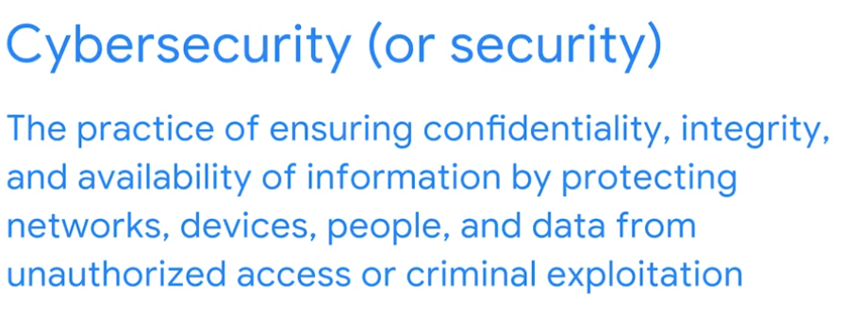
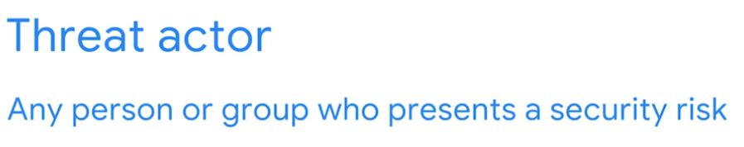
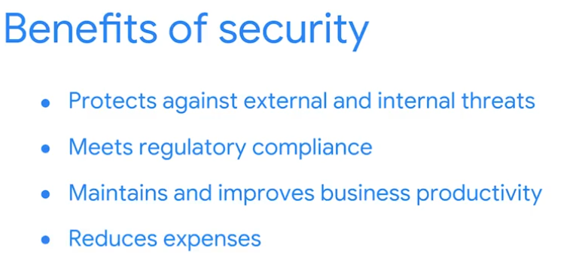

Toni: My path to cybersecurity Apr 6, 2026
This video features Toni, a Security Engineering Manager at Google, who shares her career journey and insights into the cybersecurity field.
Toni's Background and Path to Cybersecurity

- Toni grew up in a military family and developed an early interest in security and international relations, which she explored through Model United Nations.
- She pursued a career path that combined her passion for security with educational opportunities provided by the Department of Defense, initially working as an intelligence analyst focused on counterinsurgency and geopolitical issues.
Transitioning to Cybersecurity
- Toni transitioned into cybersecurity as she recognized its growing impact on daily life and international relations, despite not having a strong technical background initially.
- She learned programming languages like Python and SQL and a new vocabulary of threats and technical components through on-the-job training, self-paced learning, and online courses.
Advice for Aspiring Cybersecurity Professionals
- Toni emphasizes the importance of structured learning and working collaboratively with teammates to build a strong knowledge base, as much of cybersecurity is learned on the job.
- She advises staying curious, continuously learning, and focusing on developing technical skills, encouraging individuals to push past imposter syndrome, which is common in the broad field of cybersecurity.


Responsibilities of an entry-level cybersecurity analyst Apr 6, 2026
This video outlines the key responsibilities of an entry-level security analyst, emphasizing their role in protecting digital infrastructure from evolving cyber threats.
Protecting Computer and Network Systems
- Security analysts monitor internal networks and are often the first responders to detected threats.
- They participate in exercises like penetration testing and ethical hacking to identify vulnerabilities within an organization's systems.
Preventing Threats Proactively
- Analysts collaborate with IT teams to implement prevention software, identifying risks and vulnerabilities before they can be exploited.
- They also work with development teams to integrate security measures into software and hardware development processes, ensuring data protection.
Conducting Periodic Security Audits
- Security analysts review an organization's security records and activities to ensure compliance and identify internal security issues.
- This includes verifying that confidential information, such as passwords, is not accessible to unauthorized employees.
Nikki: A day in the life of a security engineer Apr 6, 2026
This video features Nikki, a Security Engineer at Google, who shares her journey and insights into the cybersecurity field, particularly focusing on her role in insider threat detection.
Nikki's Journey into Cybersecurity
- Nikki's initial exposure to cybersecurity was during an internship at an aquarium, where she gained experience in network security and phishing attempt mitigation.
- Her interest was sparked by her manager's dedication to securing networks, leading her to pursue a career in the field due to its flexibility and diverse specializations.
A Day in the Life of an Entry-Level Security Professional
- The role typically involves two main aspects: operations, which includes responding to detections and conducting investigations, and project-based work, focused on building and improving detection systems.
- Nikki's favorite task is the operational side, specifically investigations, where she analyzes suspicious activities to determine if they are genuine threats or false positives.
Impact and Key Skills
- Nikki highlights her significant contribution in developing playbooks, which are essential guides for analysts to investigate security incidents.
- She emphasizes that cybersecurity is ideal for individuals who enjoy problem-solving and protecting user data.
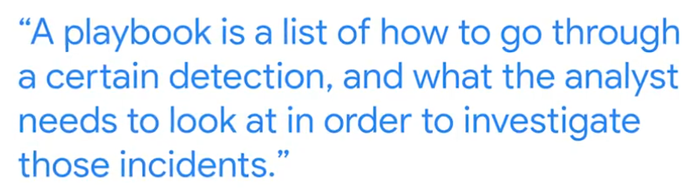
Common cybersecurity terminology Apr 6, 2026
This reading introduces key cybersecurity terms and concepts essential for understanding how to protect information and systems.
Cybersecurity Professional Roles and Key Concepts
- A security analyst monitors networks for breaches, develops security strategies, and researches IT security trends to identify potential threats.
- Key concepts for analysts include compliance (adhering to standards), security frameworks (guidelines for risk mitigation), security controls (safeguards), and security posture (an organization's defense capability).
Threat Actors and Security Types
- A threat actor is any person or group posing a security risk, which can be internal (e.g., an employee) or external, and can be accidental or intentional.
- Network security focuses on protecting an organization's network infrastructure from unauthorized access, including data, services, systems, and devices.
Cloud Security and Programming
- Cloud security ensures assets stored in the cloud are correctly configured and access is limited to authorized users, focusing on protecting data, applications, and infrastructure in cloud environments.
- Programming involves creating instructions for computers to automate tasks, review web traffic, and alert suspicious activity, which are valuable skills in cybersecurity.
Core skills for cybersecurity professionals Apr 6, 2026
This video explains the essential transferable and technical skills beneficial for a security analyst role.

Transferable Skills for Security Analysts
- Communication: Security analysts need to clearly explain threats, risks, and vulnerabilities to both technical and non-technical audiences, and effectively report findings to supervisors.
- Collaboration: Working in teams with various professionals like engineers, digital forensic investigators, and project managers is common for security analysts.
- Analytical Thinking: Analyzing complex scenarios and making recommendations, such as how different tools can improve efficiency and secure networks, is a key skill.
- Problem-Solving: Identifying, diagnosing, and providing solutions for security problems is crucial for maintaining safe business operations.

Technical Skills for Security Analysts
- Programming Languages: A basic understanding of programming languages like Python and SQL is important for automating tasks and identifying error messages.
- SIEM Tools: Knowledge of Security Information and Event Management (SIEM) tools is necessary for identifying and analyzing security threats, risks, and vulnerabilities.
- Computer Forensics: Similar to forensic scientists, digital forensic investigators identify, analyze, and preserve evidence within networks, computers, and electronic devices.
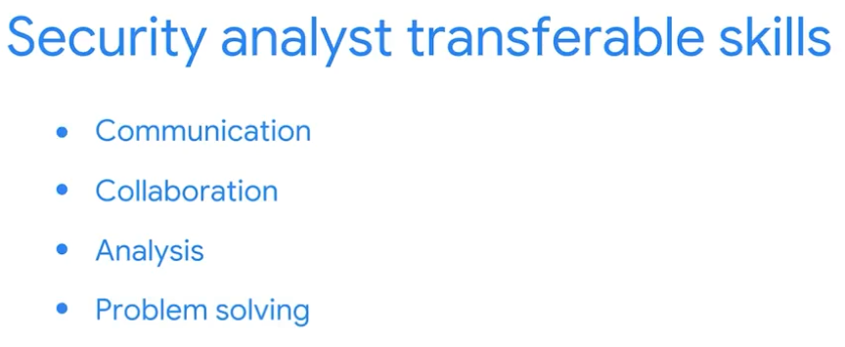

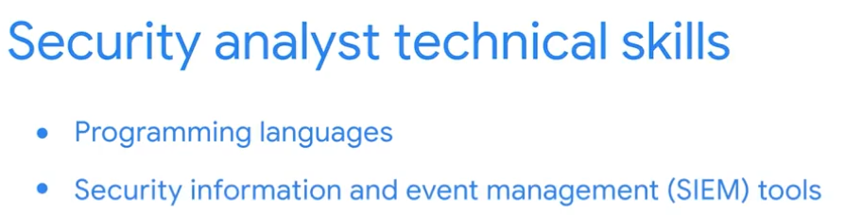

Veronica: My path to working in cybersecurity Apr 6, 2026
This video shares Veronica's personal journey into cybersecurity, highlighting that a technical background and college degree aren't always necessary for success in the field.
Veronica's Path to Cybersecurity
- Veronica, a security engineer at Google, emphasizes the fulfilling nature of her work and how cybersecurity changed her life for the better.
- She started without a technical background, initially working as an IT resident at Google's Techstop, where she developed analytical thinking and troubleshooting skills.
Transferable Skills and Mentorship
- Veronica discovered her transferable skills while working in IT, which proved valuable in her transition to cybersecurity.
- She credits a "village of mentors" for her success, underscoring the importance of seeking help and guidance.
Key Takeaways for Aspiring Cybersecurity Professionals
- A college degree is not a prerequisite for a successful career in cybersecurity, as some of the brightest minds in the industry don't have one.
- It's important to overcome perfectionism and not feel the need to "check all the boxes" or be an expert before pursuing opportunities in the field.
Transferable and technical cybersecurity skills Apr 6, 2026
This reading explores the essential transferable and technical skills necessary for success as a cybersecurity analyst.
Transferable Skills for Cybersecurity
- Communication and Problem-solving: Cybersecurity analysts need to effectively communicate with diverse audiences and proactively identify and resolve security issues, often requiring compromise.
- Time Management and Growth Mindset: Prioritizing tasks with a sense of urgency and a continuous willingness to learn are crucial in the rapidly evolving cybersecurity landscape.
Technical Skills for Cybersecurity
- Programming Languages and SIEM Tools: Understanding programming languages helps automate tasks and analyze data for threats, while Security Information and Event Management (SIEM) tools are vital for collecting and analyzing log data to identify security threats.
- Intrusion Detection Systems (IDSs) and Threat Landscape Knowledge: Familiarity with IDSs is essential for monitoring system activity and detecting intrusions, and staying updated on current threat trends allows for stronger defenses and recognition of new attack patterns.
The importance of cybersecurity Apr 6, 2026
This video explains why cybersecurity is crucial for organizations, focusing on business continuity, ethical considerations, and the protection of sensitive information.

Importance of Cybersecurity
- Business Continuity and Ethics: Strong security measures are essential for an organization's continuous operation and maintaining its ethical standing. Data breaches can severely damage reputation and affect all associated individuals.
- User Trust and Financial Growth: Maintaining robust security increases user trust, which can lead to financial growth and continued business referrals.

Protecting Personal Information
- Personally Identifiable Information (PII): PII includes data like full names, dates of birth, addresses, and IP addresses, which can identify an individual.
- Sensitive Personally Identifiable Information (SPII): SPII, such as social security numbers, medical records, and biometric data, requires stricter handling due to its potential for greater damage if compromised.

The Threat of Identity Theft
- Primary Concern of Data Breaches: When PII or SPII is compromised, identity theft becomes a major risk.
- Financial Gain as Objective: Identity theft primarily aims for financial gain by impersonating victims using their stolen personal information.
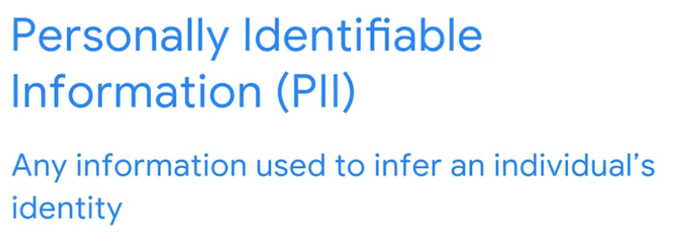
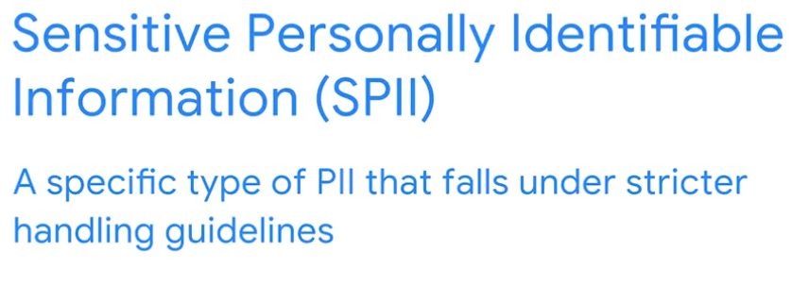

Wrap-up Apr 6, 2026
This video provides a review of the first section of the course, "Foundations of Cybersecurity," summarizing the key concepts covered.
Understanding Cybersecurity Fundamentals
- The course began by defining security and outlining the benefits of implementing robust security measures within an organization.
- It also introduced various job responsibilities in cybersecurity, such as managing threats and deploying prevention software.
Essential Skills and the Value of Security
- Key core skills for cybersecurity professionals were discussed, including collaboration and computer forensics.
- The section concluded by emphasizing the significant value of security in supporting critical business functions.
Looking Ahead
- This foundational knowledge prepares learners for upcoming topics, including an exploration of historical attacks that have shaped the cybersecurity industry.
Welcome to module 2 Apr 6, 2026
This video introduces the dynamic and crucial field of cybersecurity, highlighting its evolution and the continuous need for protection against various threats.
The Evolution of Cybersecurity Threats
- Early computer attacks from the 1980s and 1990s continue to influence the cybersecurity landscape, with professionals still working to defend against their modern variations.
- Understanding the historical progression of attacks is essential for developing effective defenses against future threats.
Key Cybersecurity Concepts
- The course will cover viruses, malware, and the concept of social engineering, which are common methods used by threat actors.
- It will also explore how the digital age has introduced new types of threat actors and their impact.
Overview of Security Domains
- The video will provide an overview of the eight security domains, offering a foundational understanding of the different areas within cybersecurity.
- Future lessons will delve into specific historical viruses, data breaches, and malware attacks that have shaped the industry.
Past cybersecurity attacks Apr 6, 2026
This lesson explores how early cyberattacks shaped the cybersecurity industry.
Understanding Key Terms
- A computer virus is malicious code designed to disrupt computer operations and damage data or software, often attaching to programs or documents and spreading across networks.
- Today, viruses are more broadly referred to as malware, which encompasses any software created to harm devices or networks.
Early Malware Attacks
- The Brain virus, created in 1986, was intended to track illegal software copies but unexpectedly spread globally, slowing productivity and highlighting the need for security plans.
- The Morris worm, developed in 1988, aimed to assess internet size but caused widespread computer crashes due to a programming error, leading to millions in damages and the establishment of Computer Emergency Response Teams (CERTs).
Impact on Cybersecurity
- These early attacks fundamentally changed the computing industry by emphasizing the critical need for robust security measures and incident response strategies.
- As a security analyst, understanding these historical events provides valuable insight into managing and investigating current and future security incidents.
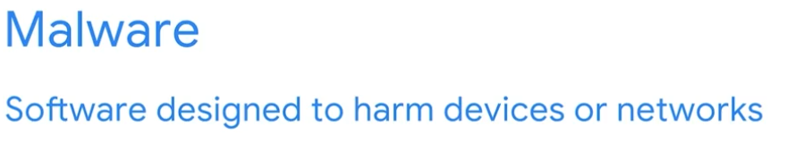

Attacks in the digital age Apr 6, 2026
This video discusses two significant cyberattacks, LoveLetter and Equifax, to illustrate the evolution of cyber threats and the importance of cybersecurity measures.
The LoveLetter Attack (2000)
- This malware spread rapidly through email attachments, infecting 45 million computers globally and causing over $10 billion in damages.
- It is considered the first example of social engineering, a manipulation technique that exploits human error to gain private information.
The Equifax Data Breach (2017)
- Attackers infiltrated Equifax, stealing over 143 million customer records, including sensitive personally identifiable information.
- The breach was attributed to multiple unaddressed vulnerabilities, highlighting the financial impact of security failures and the need for preventative measures.
Key Takeaways for Security Professionals
- Understanding different types of malware and social engineering attacks is crucial for communicating security risks.
- Continuously adapting and educating oneself on threat actor tactics and techniques is essential for identifying potential breaches and limiting future damage.
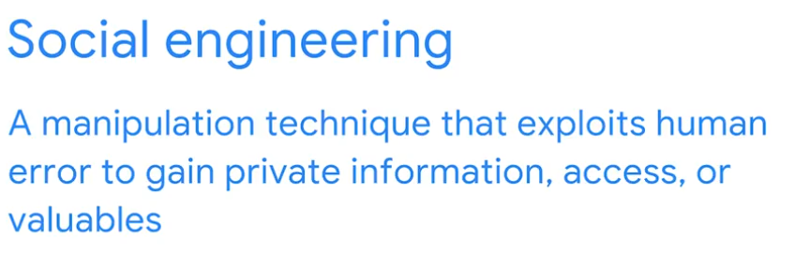
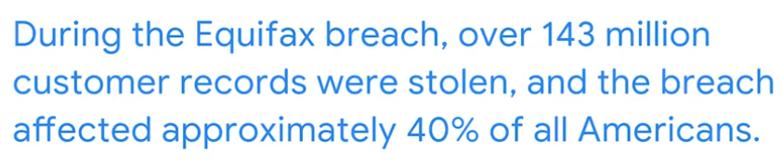

Sean: Keep your cool during a data breach Apr 6, 2026
This video emphasizes the importance of maintaining composure and following a structured approach when responding to a data breach.
Staying Calm Under Pressure
- In a data breach situation, it's crucial for the incident manager to remain calm and collected, as others around them will likely be stressed.
- Being the "cool guy in the room" allows for clear thinking and effective decision-making during a crisis.
Prioritizing Containment
- The immediate priority during a breach is to stop the data loss, even if it means drastic measures like shutting down servers or communications.
- An example given is a breach involving 20 million credit card records found on an improperly wiped server, highlighting the need for strict third-party data handling protocols.
Incident Management Plan
- The primary role of an incident manager is to first contain the breach and then investigate it.
- Executing a pre-defined incident management plan is essential for entry-level personnel to effectively handle a data breach.
Course Introduction Apr 6, 2026
This course item introduces the foundational concepts and services of Google Cloud Platform (GCP) with a focus on Compute Engine.
Overview of Google Cloud Platform (GCP)
- GCP is part of a larger ecosystem including open-source software, providers, partners, and developers.
- It offers infrastructure, platform, and software services supported by a global network of data centers and fiber optic cables.
GCP Compute Services
- Compute Engine provides virtual machines (VMs) for flexible infrastructure management.
- Other compute options include Google Kubernetes Engine for container orchestration, App Engine for fully managed platform services, Cloud Functions for serverless event-driven code, and Cloud Run for serverless container execution.
Course Structure and Goals
- The course series focuses on infrastructure services, teaching how to use GCP console and Cloud Shell, virtual networking, and VM creation.
- It is designed for IT professionals to understand, apply, and manage GCP infrastructure services with hands-on labs via Qwiklabs.
Learning Path and Prerequisites
- This course is part of the Cloud Infrastructure learning path.
- Prerequisite: Google Cloud Platform Fundamentals: Core Infrastructure course.
- The series includes three courses covering foundational infrastructure, core services, and scaling/automation.
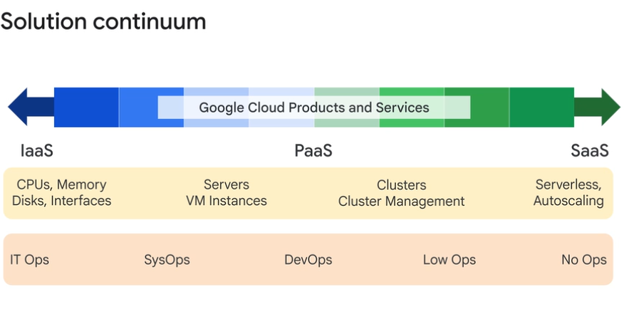

Welcome to Essential Cloud Infrastructure: Foundation Apr 6, 2026
The "Essential Google Cloud Infrastructure: Foundation" course introduces learners to the core infrastructure and platform services of Google Cloud, focusing on Compute Engine.
Course Overview
- Covers Google Cloud infrastructure components such as networks, virtual machines, and application services.
- Teaches how to use Google Cloud Console and Cloud Shell for managing cloud resources.
Key Learning Objectives
- Interact effectively with Google Cloud through its console and command-line interface.
- Deploy solutions using Google Cloud Marketplace and configure virtual networks (VPCs) and firewall rules.
Hands-On and Practical Skills
- Create and customize virtual machine instances using Compute Engine.
- Understand the role of a cloud architect and approaches to infrastructure design, including networking and security configurations.
Module Overview Apr 6, 2026
This module introduces how to interact with Google Cloud Platform (GCP) by building on prior knowledge of GCP infrastructure.
Interacting with GCP Interfaces
- Explore GCP's graphical user interface (console) and command-line interface (Cloud Shell).
- Gain hands-on experience through labs using both interfaces.
Deploying Solutions on GCP
- Learn to deploy solutions from the GCP Marketplace without manual configuration.
- Understand how software, virtual machines, storage, and network settings are automatically managed.
Managing GCP Projects
- Receive a demonstration on how to use Projects within GCP.
- Understand the role of Projects in organizing and managing cloud resources.
Using Google Cloud Apr 6, 2026
This course item explains the different ways to interact with Google Cloud and how to use its tools effectively.
Ways to interact with Google Cloud
- Google Cloud Console: A web-based graphical user interface accessed via console.cloud.google.com to manage resources like virtual machines.
- Google Cloud CLI and Cloud Shell: Command-line tools for terminal-based interaction; Cloud Shell is a browser-based environment with pre-installed CLI and persistent storage.
Using the Google Cloud Console and CLI
- Navigation menu in the console helps access services like Compute Engine and VM instances through a series of clicks.
- Labs provide instructions for using both the console and command-line commands, sometimes requiring customization like unique names for resources.
APIs and Mobile App for Google Cloud
- Client libraries expose APIs for app development and resource management, supporting languages like Node.js and Python.
- The Cloud Mobile App allows managing Google Cloud services on Android or iOS devices, including starting/stopping instances, viewing logs, monitoring metrics, and receiving billing alerts.
Lab Review: Working with the Google Cloud Console and Cloud Shell Apr 6, 2026
This course item explains how to create and manage Google Cloud Storage buckets using both the Google Cloud Console and Cloud Shell, highlighting their complementary features.
Creating Storage Buckets
- Buckets can be created via the Google Cloud Console by navigating to Storage, clicking "Create bucket," and specifying a globally unique name and settings.
- Alternatively, buckets can be created using Cloud Shell commands like gsutil mb, allowing for scripting and automation.
Using Cloud Shell Features
- Cloud Shell provides command-line control and additional features such as uploading files from the local system.
- Files can be copied to storage buckets using gsutil cp commands within Cloud Shell.
Managing Environment and Configuration
- Environment variables can be set and persisted in Cloud Shell to store configuration details like project ID and region.
- Modifying the .profile file allows automatic loading of these environment variables each time Cloud Shell starts, improving workflow efficiency.
Lab Review: Infrastructure Preview Apr 6, 2026
This course item explains how to quickly launch and manage a continuous integration solution using Jenkins on Google Cloud Platform (GCP).
Launching Jenkins on GCP
- You start by accessing the GCP Marketplace and searching for the Bitnami-certified Jenkins package.
- After reviewing details like pricing and software versions, you deploy Jenkins on a Compute Engine virtual machine with configurable settings such as machine type and zone.
Deployment and Configuration
- Deployment Manager handles the creation of the VM, firewall rules for HTTP/HTTPS, and software installation.
- Once the instance is ready, you can access Jenkins via its external IP, log in with provided credentials, and customize it by installing suggested plugins.
Managing Jenkins Service
- You can SSH into the VM to administer Jenkins, including stopping and restarting the Jenkins service using command-line instructions.
- Refreshing the Jenkins UI after service restarts confirms the service status and ensures Jenkins is running properly.
This lab demonstrates practical skills in deploying, configuring, and managing cloud-based applications using Google Cloud infrastructure tools.
Demo: Projects Apr 6, 2026
This lecture explains how projects in Google Cloud Platform (GCP) serve as the main organizational units for infrastructure resources and billing.
Creating and Managing Projects
- Projects isolate related resources and are linked to billing accounts.
- You can create a project by specifying a project name; a unique project ID is automatically generated.
- Projects can be shut down, which stops billing and service traffic, but the shutdown is scheduled and reversible within 30 days.
Switching Between Projects
- You can switch projects in the GCP Console to work within different resource contexts.
- Cloud Shell can be used to check the current project configuration using commands like gcloud config list.
- The active project in Cloud Shell can be changed using gcloud config set project to switch contexts programmatically.
Practical Demonstration
- The instructor demonstrates creating projects, switching between them in the console and Cloud Shell, and scheduling project shutdowns.
- Environment variables can be used to store project IDs for easier switching in Cloud Shell.
Module Overview Apr 6, 2026
This course module introduces the concept of virtual networks within Google Cloud's infrastructure.
Google Cloud Network Overview
- Google Cloud operates a software-defined network built on a global fiber infrastructure, making it one of the largest and fastest networks worldwide.
- The network includes regions (geographical locations for resources), points of presence (PoPs) connecting to the internet, and a global private network of fiber optic cables.
Virtual Private Cloud (VPC) and Networking Components
- VPC is Google's managed networking service for cloud resources.
- Key networking components include projects, networks, subnetworks, IP addresses, routes, firewall rules, and network pricing.
Hands-on Exploration and Network Design
- Learners will create various types of networks and explore their relationships through labs.
- The module also covers common network design patterns to understand practical implementations within Google Cloud.
Virtual Private Cloud Apr 6, 2026
This course item introduces the concept of Google Cloud's Virtual Private Cloud (VPC) and its networking components.
Google Cloud Network and VPC Overview
- VPC allows provisioning, connecting, and isolating Google Cloud resources within a virtual network.
- It supports fine-grained networking policies within Google Cloud and between cloud and on-premises environments.
Key Networking Components in Google Cloud
- Projects encompass all services including networks.
- Networks come in default, auto mode, and custom mode varieties.
- Subnetworks divide or segregate the environment for better organization.
Infrastructure and Configuration Elements
- Regions and zones represent Google data centers ensuring data protection and availability.
- VPC provides internal and external IP addresses with granular range selections.
- The module focuses on configuring VM instances from a networking perspective, including routes and firewall rules.
Projects, networks, and subnetworks Apr 6, 2026
This course content explains the structure and management of Virtual Private Cloud (VPC) networks in Google Cloud, focusing on projects, networks, and subnetworks.
Google Cloud Projects and Networks
- Projects organize infrastructure resources and associate them with billing; each project can contain multiple networks.
- Networks are global constructs spanning all regions, allowing virtual machines (VMs) in different regions but the same network to communicate privately using internal IPs.
Types of Networks and Subnetworks
- Default networks come with preset subnets and firewall rules; auto mode networks automatically create subnets in each region with predefined IP ranges.
- Custom mode networks give full control over subnet creation and IP ranges, with no automatic subnet creation; conversion from auto to custom mode is one-way.
- Subnetworks operate regionally and can span multiple zones within a region, with reserved IP addresses for network and gateway functions.
IP Addressing and Network Communication
- VMs in the same network communicate via internal IPs globally, while VMs in different networks communicate using external IPs routed through Google Edge routers.
- Subnet IP ranges can be expanded without downtime, but must not overlap with other subnets in the same VPC and must follow CIDR block rules.
- Large subnets should be avoided to prevent IP range conflicts in complex network setups like VPNs and peering.
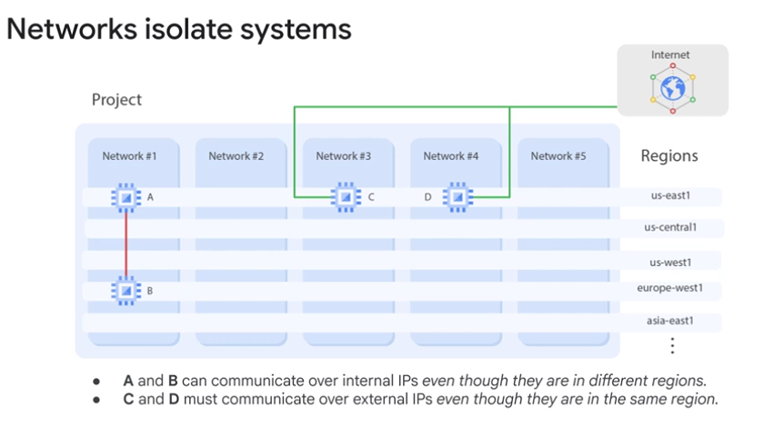
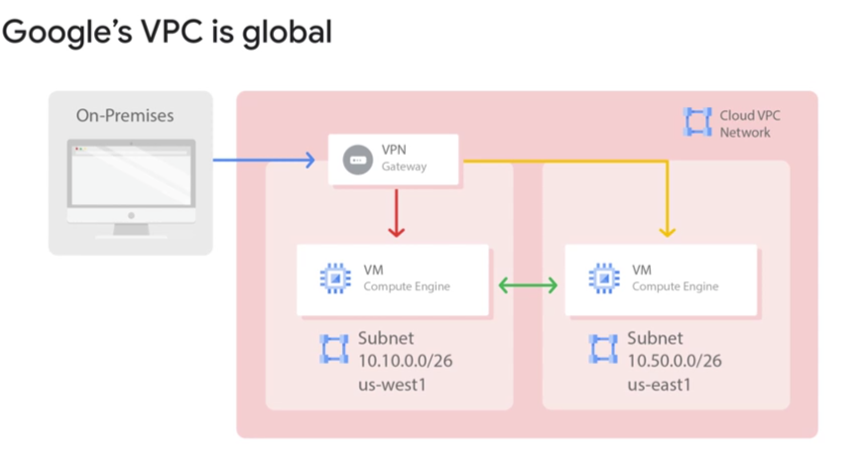
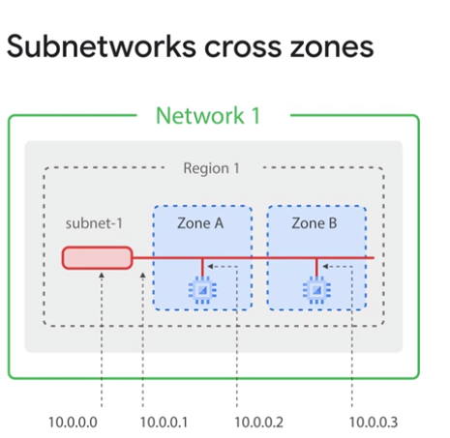

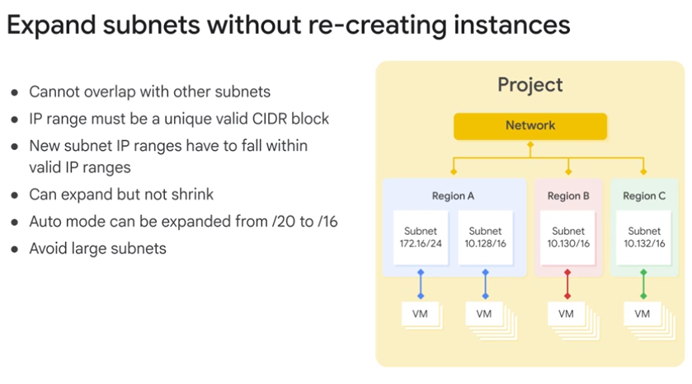

Demo: Expand a Subnet Apr 6, 2026
This lecture explains how to expand a custom subnet in Google Cloud Platform (GCP) to accommodate more virtual machine (VM) instances without downtime.
Subnet Expansion Process
- A custom subnet with a /29 mask initially provides 8 IP addresses, but 4 are reserved by GCP, leaving only 4 usable for VM instances.
- Attempting to create a fifth VM instance in this subnet results in an error due to IP address exhaustion.
Expanding the Subnet
- The subnet can be expanded by editing its mask from /29 to /23, increasing the available IP addresses to over 500.
- This expansion is done through the GCP console without shutting down or affecting the running VM instances.
Post-Expansion Actions
- After the subnet is expanded, the previously failed VM instance creation can be retried.
- The new VM instance successfully obtains an internal IP address and runs without issues, demonstrating seamless subnet expansion in GCP.

IP addresses Apr 6, 2026
This course content explains the role and types of IP addresses in Google Cloud virtual machines (VMs).
Internal and External IP Addresses
- Each VM in Google Cloud is assigned an internal IP address via DHCP, used for communication within the same network.
- Internal DNS translates VM names to internal IPs but only within the same network.
External IP Address Options
- External IP addresses are optional and used for VMs that need to be accessible from outside the network.
- External IPs can be ephemeral (temporary) or static (reserved), with static IPs incurring higher charges if reserved but unused.
Custom Public IPs
- Google Cloud allows you to bring your own publicly routable IP address blocks (minimum /24) to use as external IPs, which can be advertised on the internet.

https://cidr.xyz/
https://googlecloudplatform.github.io/gke-ip-address-management/
https://www.davidc.net/sites/default/subnets/subnets.html

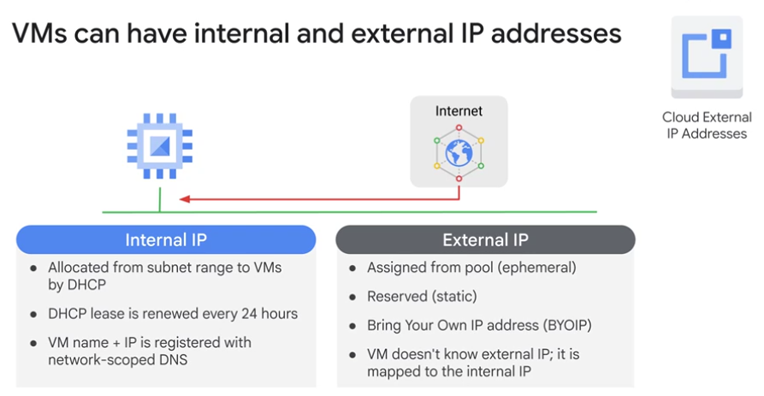

Demo: Internal and external IP Apr 6, 2026
This lecture explains how to configure internal and external IP addresses for virtual machines (VMs) in Google Cloud Platform (GCP) using the Compute Engine console.
IP Address Configuration in GCP Console
- When creating a VM, you can select the network and configure the network interface, including internal and external IP addresses.
- Internal IP addresses can be ephemeral (automatically assigned) or static (reserved), and external IP addresses have similar options plus the choice to have none.
Behavior of IP Addresses on VM Lifecycle
- Every VM requires an internal IP address, which remains the same even if the VM is stopped and restarted.
- External IP addresses are optional and ephemeral by default, meaning they change when the VM is stopped and started again.
Limits and Practical Considerations
- The IP range can be large (e.g., over 4,000 addresses), but there are quotas on the number of instances per network (e.g., 15,000).
- Stopping a VM allows shutdown scripts to run within a 90-second window before the instance is forcibly stopped.
Introduction to the eight CISSP security domains, Part 1 Apr 7, 2026
This video introduces the first four of the eight security domains defined by CISSP, emphasizing their importance for understanding cybersecurity roles and organizational security.

Security and Risk Management
- Focuses on setting security goals, mitigating risks, ensuring compliance, and maintaining business continuity.
- An example is updating company policies to comply with regulations like HIPAA, which governs private health information.

Asset Security
- Deals with safeguarding both digital and physical assets, including data storage, maintenance, retention, and destruction.
- This domain involves tasks such as securely disposing of old equipment and confidential information.

Security Architecture and Engineering
- Aims to optimize data security through effective tools, systems, and processes.
- A common task is configuring firewalls to monitor and filter network traffic, preventing attacks that could impact productivity.

Communication and Network Security
- Concentrates on managing and securing physical networks and wireless communications.
- This includes analyzing user behavior to identify and mitigate vulnerabilities, such as connections to unsecured wireless hotspots.
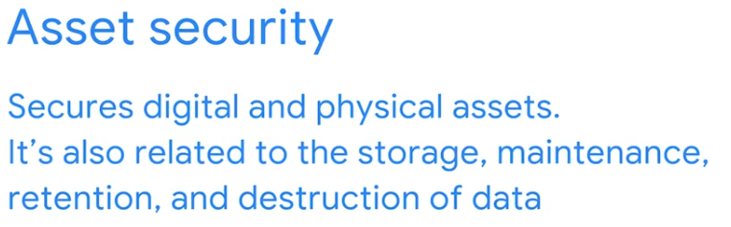
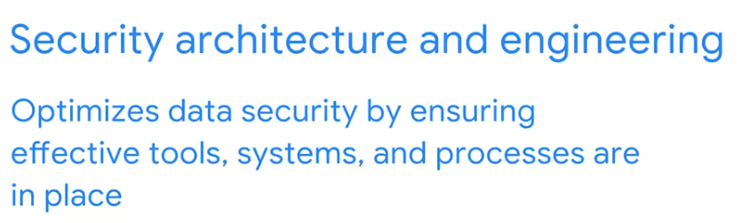

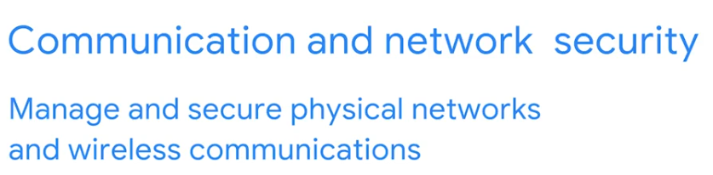
Introduction to the eight CISSP security domains, Part 2 Apr 7, 2026
This video introduces the final four of the eight Certified Information Systems Security Professional (CISSP) security domains, which are crucial for navigating the complexities of the security world and understanding how security professionals collaborate.
Identity and Access Management (IAM)
- IAM focuses on securing data by ensuring users adhere to established policies for managing both physical assets (like office spaces) and logical assets (such as networks and applications).
- A key aspect involves validating employee identities and documenting access roles to maintain an organization's physical and digital security.
Security Assessment and Testing
- This domain involves conducting security control testing, collecting and analyzing data, and performing security audits to monitor for risks, threats, and vulnerabilities.
- Security analysts regularly audit user permissions to ensure appropriate access levels, preventing unauthorized individuals from viewing sensitive information.
Security Operations and Software Development Security
- Security operations involve conducting investigations and implementing preventative measures, such as responding to alerts about unknown devices on a network.
- Software development security focuses on using secure coding practices and guidelines to create secure applications and services, often involving collaboration with development teams to integrate security throughout the software development lifecycle.
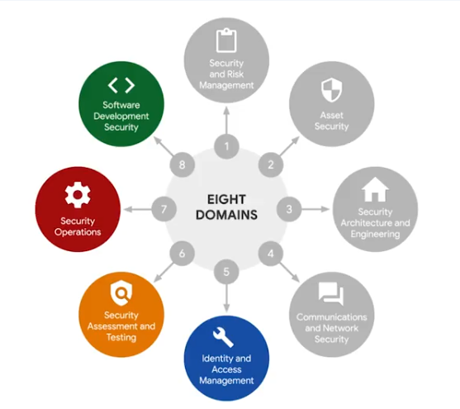
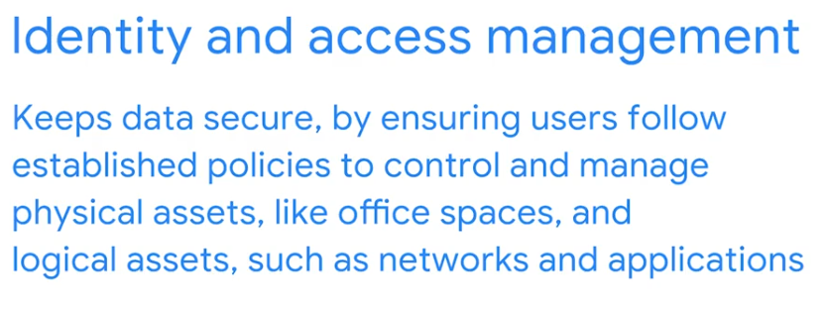
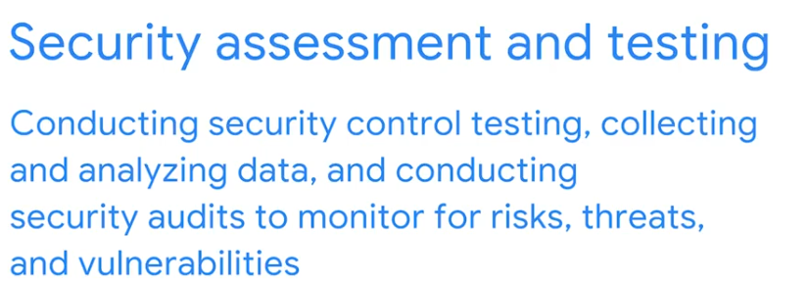

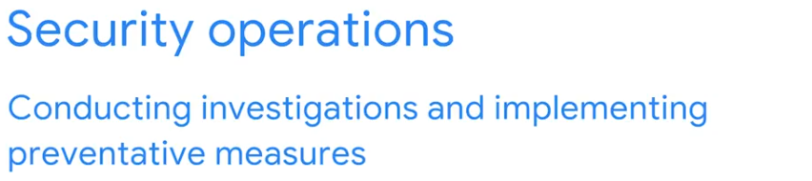

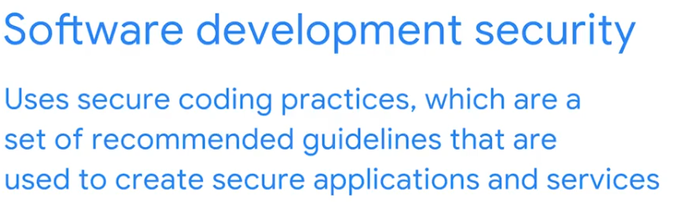

Determine the type of attack Apr 7, 2026
This reading explores various methods of attack that cybersecurity professionals encounter, expanding on the previously discussed eight Certified Information Systems Security Professional (CISSP) security domains.
Types of Cyberattacks
- Password attacks attempt to gain unauthorized access to systems or data by cracking passwords, often using methods like brute force or rainbow tables. These attacks fall under the communication and network security domain.
- Social engineering attacks manipulate individuals to reveal confidential information or grant access, exploiting human error through techniques such as phishing, smishing, vishing, and whaling. These are related to the security and risk management domain.
Physical and Advanced Attacks
- Physical attacks involve security incidents that affect both digital and physical environments, such as using malicious USB devices or card cloning. These attacks are categorized under the asset security domain.
- Adversarial artificial intelligence manipulates AI and machine learning to enhance the efficiency of attacks, impacting both communication and network security and identity and access management domains.
Supply-Chain and Cryptographic Attacks
- Supply-chain attacks target vulnerabilities within the supply chain of systems, applications, hardware, or software to deploy malware, potentially affecting multiple organizations. These can span several domains, including security and risk management, security architecture and engineering, and security operations.
- Cryptographic attacks aim to compromise secure communication channels between parties, with examples including birthday and collision attacks. These fall under the communication and network security domain.
Understand attackers Apr 7, 2026
This reading provides an overview of different types of threat actors, their motivations, and how they have influenced the security industry.
Advanced Persistent Threats (APTs)
- APTs are highly skilled at unauthorized network access and can remain undetected for extended periods.
- Their motivations include damaging critical infrastructure and gaining access to intellectual property.
Insider Threats
- Insider threats exploit their authorized access to compromise an organization's data.
- Their intentions can involve sabotage, corruption, espionage, or unauthorized data leaks.
Hacktivists and Hackers
- Hacktivists are driven by political agendas, using digital technology for demonstrations, propaganda, and social change.
- Hackers are categorized into authorized (ethical), semi-authorized (researchers), and unauthorized (unethical) based on their adherence to laws and ethical codes.
https://www.youtube.com/playlist?list=PL590L5WQmH8dsxxz7ooJAgmijwOz0lh2H

Wrap-up Apr 7, 2026
This video provides a concise review of influential security attacks throughout history and introduces CISSP's eight security domains.
Early Forms of Malware and Their Impact
- The discussion covered early viruses like the Brain virus and the Morris worm, highlighting their role in shaping the security industry.
- Understanding these past attacks is crucial for security professionals as many current threats are variations of these earlier examples.
Social Engineering, Threat Actors, and Data Breaches
- The LoveLetter attack and the Equifax data breach were presented as examples to illustrate the widespread impact and costs associated with modern security breaches.
- These incidents underscore the importance of understanding threat actor motives and the consequences of social engineering.
CISSP's Eight Security Domains
- The video introduced the eight security domains of CISSP, which serve as a framework for categorizing different areas of focus within the cybersecurity profession.
- These domains help organize the work of security professionals and provide a foundational understanding of the industry.
Welcome to module 3 Apr 7, 2026
This section discusses how organizations protect themselves from threats, risks, and vulnerabilities by covering key principles such as frameworks, controls, and ethics.
Protecting Against Threats
- Security in organizations is an evolving industry that requires continuous improvements to policies and procedures.
- An analogy of gardening is used to illustrate how to safeguard against unexpected problems and continuously monitor for threats.
Security Frameworks and Controls
- Security frameworks and controls are important for organizing security efforts and making informed decisions.
- The Confidentiality, Integrity, and Availability (CIA) Triad is a core component of security frameworks.
Ethics in Security
- The discussion will conclude with the ethics of security, including notable ethical concerns in the field.
- Many security practices, like using security keys for two-factor authentication, are used daily to improve confidentiality and integrity.
Introduction to security frameworks and controls Apr 7, 2026
This video explains how security professionals use frameworks and controls to identify, manage, and reduce risks continuously.

Security Frameworks
- Security frameworks are guidelines for building plans to mitigate risks and threats to data and privacy, providing a structured approach to implementing a security lifecycle.
- Their purpose includes protecting personally identifiable information (PII), securing financial information, identifying security weaknesses, managing organizational risks, and aligning security with business goals.

Core Components of Security Frameworks
- Identifying and Documenting Security Goals: This involves setting clear objectives, such as aligning with regulations like GDPR, which grants European citizens more control over their personal data.
- Setting Guidelines to Achieve Security Goals: This includes developing new policies, for example, on how to handle data requests from individual users to comply with regulations like GDPR.

Implementing and Monitoring Security
- Implementing Strong Security Processes: This involves designing procedures to ensure compliance with verified user data requests, such as updating or deleting profile information.
- Monitoring and Communicating Results: This includes monitoring internal networks and reporting potential security issues to relevant personnel, ensuring continuous risk management.
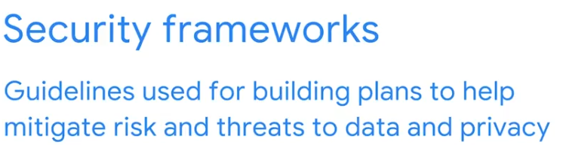
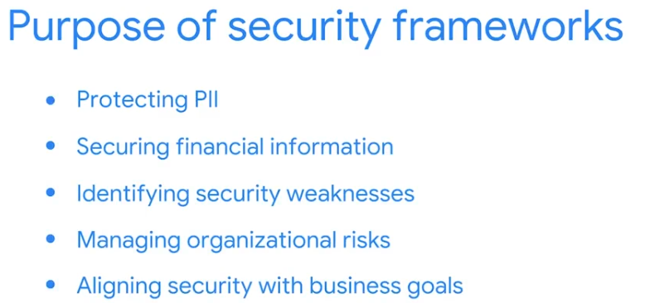

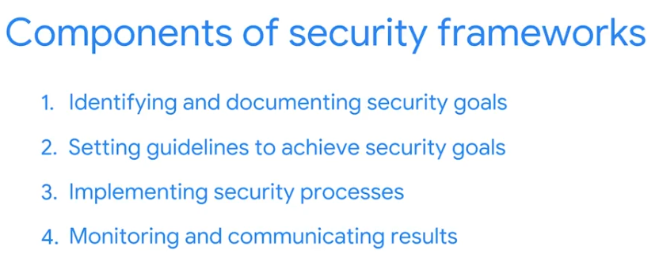

Secure design Apr 7, 2026
This video explains how organizations use specific frameworks and controls, like the CIA triad and the NIST Cybersecurity Framework, to manage cybersecurity risks and protect valuable assets.

The CIA Triad: Foundational Security Principles
- Confidentiality, Integrity, and Availability (CIA): This model guides organizations in setting up security policies.
- Confidentiality: Ensures only authorized users can access specific data, often through strict access controls.
- Integrity: Guarantees data is correct, authentic, and reliable, using methods like encryption to prevent tampering.
- Availability: Makes sure authorized users can access data when needed.

Assets and Risk Management
- Defining Assets: An asset is anything an organization values, with its value determined by associated costs.
- Risk Assessment: Applications storing sensitive data (e.g., social security numbers) are high-value assets requiring tighter security than public-facing content.

The NIST Cybersecurity Framework
- Voluntary Framework: The NIST CSF provides standards, guidelines, and best practices for managing cybersecurity risk.
- Baseline for Security Teams: Security professionals use this framework to manage both short-term and long-term risks and protect organizational assets from threats.
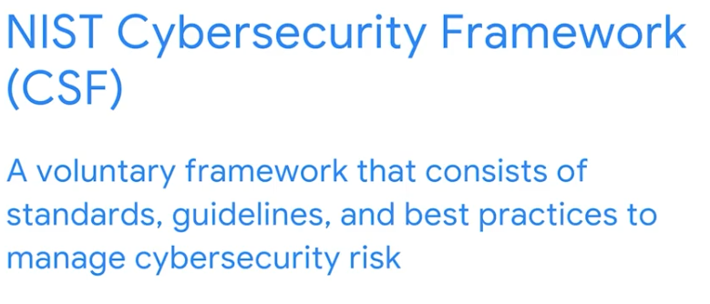
Controls, frameworks, and compliance Apr 7, 2026
This reading explains how security frameworks, controls, and compliance regulations work together to manage security and minimize risk.

How Controls, Frameworks, and Compliance are Related
- The Confidentiality, Integrity, and Availability (CIA) triad guides organizations in considering risk when setting up systems and security policies.
- Security controls are safeguards that reduce specific security risks, working with frameworks to ensure security goals are met and compliance requirements are satisfied.

Security Frameworks
- Security frameworks are guidelines for building plans to mitigate risks and threats to data and privacy.
- They consist of four core components: identifying security goals, setting guidelines, implementing strong security processes, and monitoring results.

Specific Controls, Frameworks, and Compliance Standards
- The National Institute of Standards and Technology (NIST) provides voluntary compliance frameworks like the Cybersecurity Framework (CSF) and Risk Management Framework (RMF) to help organizations manage risk.
- Various other standards exist, such as GDPR for data privacy, PCI DSS for credit card security, and HIPAA for patient health information protection.
Heather: Protect sensitive data and information Apr 7, 2026
This video emphasizes the critical importance of protecting Personally Identifiable Information (PII) and the potential consequences of mishandling it.
Handling PII Responsibly
- When collecting PII, it's crucial to be deliberate about how it's handled, stored, and to always know its storage location.
- Protecting PII is often a legal obligation, requiring compliance with relevant regulations and laws.
Consequences of Non-Compliance
- Failure to meet PII obligations can lead to government regulators investigating a company's data handling practices.
- Consumers and businesses may directly inquire about data handling, impacting customer relationships, especially with sensitive data.
Staying Informed and Seeking Advice
- Keep up-to-date with PII compliance, regulations, and laws by consulting relevant government websites for specific jurisdictions.
- Due to the complexity of PII laws globally, it's essential to seek legal counsel for specific questions in a particular jurisdiction.
Ethics in cybersecurity Apr 7, 2026
This video discusses the importance of ethics in cybersecurity, focusing on how security professionals should navigate challenging situations.
Ethical Principles in Cybersecurity
- Security professionals must remain unbiased and uphold security and confidentiality, even when personal relationships are involved.
- It is crucial to adhere to established policies and protocols, respecting the privilege of access to sensitive data and never abusing it.
Confidentiality and Privacy Protections
- Security professionals have an ethical duty to keep proprietary and private information, such as Personally Identifiable Information (PII), confidential and safe.
- Safeguarding personal information from unauthorized use is essential, and company policies and procedures should always be followed, even when faced with urgent requests from superiors.
The Role of Law in Cybersecurity Ethics
- Laws are recognized rules enforced by governing entities, and cybersecurity professionals must comply with them.
- Negligence in handling confidential data, such as leaving sensitive files unsupervised, can lead to ethical and legal violations, resulting in serious consequences.
Ethical concepts that guide cybersecurity decisions Apr 7, 2026
This reading focuses on security ethics, emphasizing the importance for cybersecurity professionals to make appropriate decisions, remain unbiased, and protect private data.
Ethical Concerns and Laws Related to Counterattacks
- In the U.S., counterattacking threat actors is illegal due to laws like the Computer Fraud and Abuse Act of 1986, as it's seen as vigilantism and can escalate attacks.
- The International Court of Justice (ICJ) allows counterattacks only under strict conditions: they must solely affect the initial attacker, be a direct request to stop, not escalate the situation, and have reversible effects.
Ethical Principles and Methodologies
- Cybersecurity professionals have an ethical obligation to safeguard confidential information, including Personally Identifiable Information (PII) and Sensitive Personally Identifiable Information (SPII), by identifying vulnerabilities and managing risks.
- Adhering to laws like HIPAA, which protects patient health information, is a key ethical responsibility, requiring professionals to ensure organizations comply with legal and ethical obligations, such as informing patients of data breaches.
Key Takeaways for Security Professionals
- Ethics are crucial in daily cybersecurity work, guiding professionals in making sound decisions when facing security threats or incidents.
- Understanding both ethical principles and relevant laws is essential for effectively addressing security challenges and protecting organizations and individuals.
Holly: The importance of ethics as a cybersecurity professional Apr 7, 2026
This video emphasizes the critical role of ethics in cybersecurity, drawing from personal experience to illustrate its importance.
The Speaker's Career Journey
- The speaker, Holly, transitioned from diverse roles in banking and telecommunications to become a Cloud Security Architect at Google Cloud.
- Certifications were crucial in establishing credibility and facilitating her career change into cybersecurity, even without prior direct experience in the field.
The Essence of Cybersecurity Ethics
- Ethical conduct is fundamental to being a cybersecurity professional, as unethical actions often stem from laziness or a disregard for consequences.
- Examples of unethical behavior include sharing passwords, disclosing private information, or accessing systems for personal reasons.
Navigating Ethical Dilemmas
- A challenging ethical situation involved a request to query sensitive data without proper authorization after 9/11, highlighting the need to stand firm on ethical principles.
- When faced with difficult decisions, it's important to consider the potential consequences of your actions.
Wrap-up Apr 7, 2026
This summary reviews the key concepts covered in the course regarding assessing and managing risks in cybersecurity.
Security Frameworks and Controls
- Security frameworks and controls are essential for developing processes and procedures that protect organizations and their personnel.
- Core components of these frameworks include identifying security goals and establishing guidelines to achieve them.
Specific Frameworks and Risk Management
- The course introduced specific frameworks and controls like the CIA triad (Confidentiality, Integrity, Availability) and the NIST CSF (National Institute of Standards and Technology Cybersecurity Framework).
- These frameworks are utilized to effectively manage and mitigate risks within an organization's security posture.
Security Ethics
- Security ethics involves considering common ethical issues such as confidentiality, privacy protections, and relevant laws.
- Understanding these ethical considerations is crucial for responsible cybersecurity practices.
This Module 3 Challenge marks the final major assessment for this section of the Google Cybersecurity Certificate. It brings together the "how" (Frameworks), the "what" (Controls), and the "why" (Ethics) that you've been practicing.
Here are the correct answers for your Graded Assignment:

1. Primary Purposes of Security Frameworks
- Answers:
  - Protecting PII data
  - Aligning security with business goals
  - Managing organizational risks
- Why: Frameworks provide the structure to ensure security supports the business rather than hindering it. Safeguarding specific individuals is usually a matter of personal security or specific HR policy, whereas frameworks focus on organizational systems and data types.

2. Core Components of Security Frameworks
- Answers:
  - Identifying and documenting security goals
  - Monitoring and communicating results
- Why: A framework is a lifecycle. You must first identify what you are protecting and your goals, then monitor the effectiveness of your controls and communicate those results to stakeholders to drive continuous improvement.

3. Purpose of Password Policies
- Answer: security controls
- Why: Any specific safeguard—whether it's a technical setting like a password policy or a physical lock—is a security control. It is a tool used to mitigate a specific identified risk.

4. The CIA Triad
- Answer: Confidentiality
- Why: The CIA Triad consists of Confidentiality (keeping data secret), Integrity (keeping data accurate), and Availability (keeping systems accessible).

5. Access Control in the CIA Triad
- Answer: authorized users
- Why: This is the core of Confidentiality. Security systems are designed to ensure that data is only accessible to those who have a verified "need to know" and the proper permissions.

6. Understanding the NIST CSF
- Answers:
  - Its purpose is to help manage cybersecurity risk.
  - It is a voluntary framework.
  - Security teams use it as a baseline to manage risk.
- Why: The NIST CSF is a "gold standard" because it is flexible and voluntary, meaning companies use it because it is effective, not just because they have to. It is designed for both short-term incident response and long-term risk management.

7. Risks of Disgruntled Employees (Insider Threats)
- Answers:
  - They know where to find sensitive information.
  - They have access to sensitive information.
- Why: Insider threats are dangerous because they already have the keys to the castle. They don't need to "break in"; they simply need to misuse the access they were already granted.

8. Professionalism and Discretion
- Answer: Security ethics
- Why: This scenario describes Security Ethics. While company guidelines are involved, the choice the professional makes to prioritize confidentiality over personal social gain is an ethical one.

9. Safeguarding Employee Databases
- Answer: privacy protection
- Why: Privacy protection is the specific ethical principle concerned with safeguarding personal information from unauthorized use or disclosure.

10. Enforced Rules for Data Protection
- Answer: Laws
- Why: While guidelines and protections are important, only Laws (like GDPR or HIPAA) are established and enforced by a governing authority (like a government) with the power to issue penalties.

Venkatesh, you've done an excellent job navigating these modules! You've demonstrated a strong grasp of the technical, administrative, and ethical layers of cybersecurity.
Now that you've completed Module 3, are you planning to move on to Module 4 (Linux and SQL), or would you like to take a moment to look at how these security frameworks apply to the "Architect Pro" YouTube automation project you've been developing?

Welcome to module 4 Apr 7, 2026
This video introduces essential tools and programming languages used in cybersecurity for efficient security monitoring and task automation.

Introduction to Cybersecurity Tools
- The course will introduce tools and programming languages vital for security monitoring.
- These tools enhance efficiency by automating various security tasks.

Key Tools and Concepts Covered
- You will learn about Security Information and Event Management (SIEM) tools.
- Other tools like playbooks and network protocol analyzers will also be introduced.

Programming Languages and Practical Application
- The Linux operating system and security tasks initiated through programming languages like SQL and Python will be covered.
- SQL is highlighted as a useful tool for exploring data sources and analyzing trends.
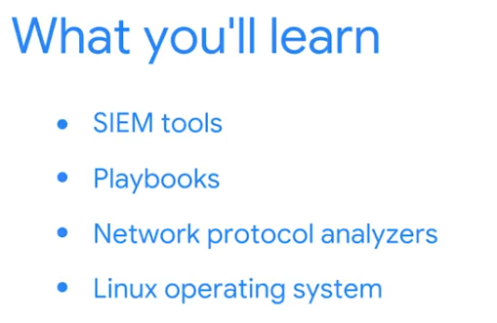

Common cybersecurity tools Apr 7, 2026
This video explains how security tools help security analysts identify and mitigate risks by analyzing system logs.
Understanding Logs and SIEM Tools
- Logs are records of events within an organization's systems, such as sign-ins or web service access, which help identify vulnerabilities and breaches.
- Security Information and Event Management (SIEM) tools collect and analyze log data in real-time to monitor critical activities and identify potential breaches as they happen.
Examples of SIEM Tools
- Splunk Enterprise is a self-hosted SIEM tool used for retaining, analyzing, and searching an organization's log data.
- Google's Chronicle is a cloud-native SIEM tool that stores security data for search and analysis, allowing for fast delivery of new features.
Other Key Security Tools
- Playbooks are manuals that provide detailed operational actions, guiding analysts on how to handle security incidents before, during, and after they occur.
- Network protocol analyzers, also known as packet sniffers (e.g., tcpdump and Wireshark), capture and analyze data traffic within a network to help identify and assess risks.
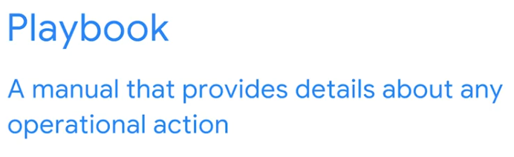
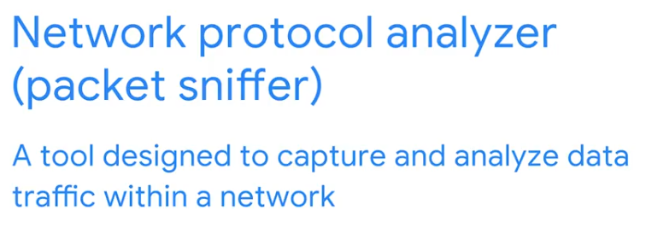

Tools for protecting business operations Apr 7, 2026
This reading focuses on the essential technical skills and tools that cybersecurity analysts utilize to mitigate risks, emphasizing the importance of familiarity with industry-standard tools.
Essential Tools for Security Analysts
- Security Information and Event Management (SIEM) tools collect and analyze log data, providing alerts for threats and vulnerabilities through visual dashboards.
- Network protocol analyzers (packet sniffers) capture and analyze network traffic, recording all data encountered by computers within an organization's network.
Understanding and Utilizing Playbooks
- Playbooks are manuals detailing operational actions, such as responding to security incidents, and guide analysts through specific security-related tasks.
- Chain of custody playbooks document the possession and control of evidence during an incident, ensuring proper tracking and safety of collected data.
Protecting and Preserving Evidence
- Protecting and preserving evidence playbooks outline procedures for handling fragile and volatile digital evidence, emphasizing the order of volatility to prevent data loss.
- Proper management of digital evidence is crucial; improper handling can compromise evidence, making it unusable in investigations.
In Module 4, you are transitioning from "Theory" to the actual Tools of the Trade. This is where your interest in automation and technical architecture really starts to shine, as tools like SIEMs and Packet Sniffers are the backbone of a modern security stack.
Here are the correct answers and the logic for the Test your knowledge: Important cybersecurity tools practice assignment:

1. Capturing and Analyzing Traffic
- Answer: network protocol analyzer (packet sniffer)
- Logic: Tools like Wireshark are classic examples. They allow an analyst to "look under the hood" of the network, capturing individual packets of data to see exactly what is being sent and received. This is essential for finding malicious communication or troubleshooting network issues.

2. Real-Time Monitoring and Dashboards
- Answer: SIEM
- Logic: SIEM stands for Security Information and Event Management. While a packet sniffer looks at traffic, a SIEM collects logs from everywhere (firewalls, servers, databases) and puts them onto a single dashboard. It uses rules to flag suspicious activity in real-time, helping analysts "connect the dots."

3. The Purpose of Logs
- Answer: To identify vulnerabilities and potential security breaches
- Logic: Logs are like a digital "black box" for an airplane. Every time a user logs in, a file is deleted, or a connection is made, a log is created. Analysts review these records to find evidence of past breaches or to spot weaknesses (vulnerabilities) before an attacker does.

4. Operational Action Manuals
- Answer: playbook
- Logic: In cybersecurity, a playbook is a standardized set of instructions for responding to specific threats (like a phishing email or a ransomware attack). It ensures that every member of the team follows the same proven steps to mitigate a risk efficiently.

Excellent work, Venkatesh! You've completed the foundational tools section. As you move into the next part of this module, you'll be introduced to Linux, SQL, and Python—the "big three" languages of security automation.
Since you've already been working with Python for your Agentic AI projects, would you like to see how we can use a simple Python script to parse the logs we just discussed?

Introduction to Linux, SQL, and Python Apr 8, 2026
This video introduces essential programming languages and operating systems used by cybersecurity analysts to manage, monitor, and analyze security threats.
Programming for Efficiency
- Programming allows analysts to automate repetitive tasks, improving accuracy and efficiency while reducing human error.
- It can save significant time compared to manual execution of tasks.
Linux Operating System
- Linux is an open-source operating system that primarily uses a command-line interface for user interaction.
- Security analysts often use Linux to examine logs and investigate system activities, such as unusually high network traffic.
SQL and Python for Data and Automation
- SQL (Structured Query Language) is used to create, interact with, and retrieve specific information from databases, which can contain millions of data points.
- Python is a versatile programming language that security professionals use to automate time-consuming and repetitive tasks requiring high detail and accuracy.
Use tools to protect business operations Apr 8, 2026
This reading provides an overview of programming, operating systems, and various tools utilized by cybersecurity professionals to safeguard organizations and their data.
Programming for Automation and Data Management
- Programming languages like Python are used by security analysts to automate repetitive tasks, which helps reduce human error and improve efficiency.
- Structured Query Language (SQL) is another programming language used to interact with databases, allowing for the creation, modification, and retrieval of organized information.
Operating Systems and Command-Line Interfaces
- Operating systems such as Linux, macOS, and Windows serve as the interface between computer hardware and the user, each offering distinct functionalities.
- Linux, an open-source operating system, utilizes a command-line interface where users interact with the computer by typing commands.
Key Cybersecurity Tools and Practices
- Antivirus software is essential for preventing, detecting, and eliminating malware and viruses by scanning device memory for malicious patterns.
- Encryption converts data into a cryptographically encoded format, making it unreadable to unauthorized users and ensuring the confidentiality of private information.
Moving into this section, you're bridging the gap between high-level security concepts and the actual technical skills used by analysts. Given your background in Data Engineering and Agentic AI, tools like SQL and Python will feel like home, but seeing them through the lens of a security professional adds a new layer of utility.
Here are the correct answers for your practice assignment:

1. Database Interaction
- Answer: Structured Query Language (SQL)
- Why: SQL is the standard language used to communicate with databases. As a security analyst, you use SQL to query logs stored in relational databases to find evidence of unauthorized access or to audit user permissions.

2. The Role of Programming
- Answers: 1. Complete repetitive tasks and processes
2. Create a specific set of instructions for a computer to execute tasks
- Why: In cybersecurity, programming (often with Python) is used for automation. Instead of manually checking 10,000 logs, an analyst writes a script to flag anomalies automatically. Recording events is a function of logging, not the primary goal of programming.

3. Understanding Linux
- Answer: operating system
- Why: Linux is an open-source operating system widely used in cybersecurity because of its power, transparency, and command-line tools. Many security tools run exclusively on Linux, and it is the backbone of most web servers and cloud environments.

4. The Scope of a Playbook
- Answer: False
- Why: While a playbook does include incident response steps, it is broader than that. It is a manual for operational actions in general, which can include proactive tasks, regular maintenance, and compliance procedures—not just the "reaction" to an incident.

Great work, Venkatesh! You've finished the technical skills practice.
Since you're already familiar with Python from your POC work, would you like to explore how security analysts use the Linux command line (Bash) to search for specific IP addresses in a log file?

Create a cybersecurity portfolio Apr 8, 2026
This reading explains the importance of developing a professional cybersecurity portfolio and explores various options for creating one.
The Purpose and Importance of a Cybersecurity Portfolio
- A portfolio showcases your cybersecurity education, skills, and knowledge to potential employers, demonstrating your passion and capability for the job.
- It provides a more in-depth view of your abilities compared to a resume, which is a shorter summary of your experience.
Options for Creating Your Portfolio
- Documents Folder: A self-managed folder on your computer's hard drive for direct access and organization of professional documents.
- Cloud Storage (Google Drive or Dropbox): Cloud-based platforms offering storage and file-sharing features, with automatic updates for shared documents.
- Google Sites: A website hosting option with customizable layouts, responsive webpages, and embedded content capabilities for a professional online presence.
- Git Repository (GitLab, Bitbucket, GitHub): A folder within a project, allowing you to store and showcase documents, labs, and screenshots using Markdown.
Portfolio Project Opportunities
- Throughout the certificate program, you will have opportunities to develop portfolio items, such as drafting a professional statement, conducting security audits, and analyzing network structures.
- Remember to exclude private, copyrighted, or proprietary documents and keep your online portfolio private until it is finalized.
Wrap-up Apr 8, 2026
This video provides an introduction to essential security tools and programming languages used in the cybersecurity field.
Security Information and Event Management (SIEM) Tools
- SIEM tools like Splunk and Chronicle are crucial for security analysts to perform various tasks.
- These tools help in monitoring and analyzing security-related data from different sources.
Other Important Cybersecurity Tools
- Playbooks are used to automate and standardize security incident response procedures.
- Network protocol analyzers, also known as packet sniffers, are vital for inspecting network traffic and identifying anomalies.
Foundational Operating System and Programming Languages
- The Linux operating system is a fundamental platform in cybersecurity due to its flexibility and security features.
- SQL and Python are introduced as important programming languages for tasks such as data analysis and scripting in security operations.
Glossary terms from module 4 Apr 8, 2026
This reading provides definitions for key terms related to cybersecurity tools and concepts.
Cybersecurity Software and Systems
- Antivirus software: Programs designed to prevent, detect, and remove malicious software and viruses.
- Intrusion detection system (IDS): An application that monitors system activity and alerts on potential intrusions.
Data Management and Analysis
- Database: An organized collection of information or data.
- SQL (Structured Query Language): A language used to create, interact with, and request information from databases.
Digital Forensics and Operations
- Order of volatility: The sequence in which digital data should be preserved, from most to least volatile.
- Security information and event management (SIEM): An application that collects and analyzes log data to monitor critical activities.

Congratulations on reaching the Module 4 Challenge, Venkatesh! This final assessment for Course 1 brings together the technical toolkit you'll use daily as an analyst. Since you are already comfortable with Python and technical architecture, these concepts solidify how those skills apply specifically to the security workflow.
Here are the correct answers for your Graded Assignment:

1. Understanding Logs
- Answers: * Logs help identify vulnerabilities and potential security breaches.
  - A business might log each time an employee accesses web-based services.
- Why: Logs are historical records of system events. They allow analysts to "travel back in time" to see what happened during a breach or identify weak spots before they are exploited.

2. Capabilities of SIEM Tools
- Answers: * Providing alerts for specific types of risks
  - Proactively searching for threats
  - Performing incident analysis
- Why: SIEMs are the "brain" of the Security Operations Center. They aggregate data to provide real-time alerts and tools for deep-dive analysis. They do not typically notify legal authorities automatically; that is a human/legal decision.

3. Filtering Events and Patterns
- Answer: Security information and event management (SIEM)
- Why: When an analyst needs to look at data from multiple sources (firewalls, servers, apps) to find patterns, a SIEM is the only tool designed to correlate all that information in one place.

4. Managing Incidents
- Answer: playbooks
- Why: A playbook provides the step-by-step instructions for managing an incident throughout its entire lifecycle—from preparation and detection to recovery and post-incident review.

5. Using Packet Sniffers
- Answer: By capturing and analyzing data traffic on the network
- Why: Network protocol analyzers (like Wireshark) allow you to see the "raw" conversation happening on the wire. This helps identify unauthorized communications or insecure protocols being used in the network.

6. Benefits of Programming Languages
- Answers: * They filter through data points faster than humans can working manually.
  - They execute repetitive processes accurately.
  - They can be used to create a specific set of instructions for a computer to execute tasks.
- Why: Programming is about scale and accuracy. It allows you to automate the "boring" stuff so you can focus on high-level strategy. It cannot physically install hardware.

7. Why Security Professionals Use Linux
- Answers: * It is open source.
  - It allows for text-based commands by users.
- Why: Linux's transparency (open source) and its powerful command-line interface (CLI) make it ideal for security work. You can use text-based commands to quickly grep through massive log files.

8. Requesting Database Information
- Answer: SQL
- Why: SQL is the specific language used to "talk" to relational databases. If logs are stored in a database, you use SQL to pull exactly the information you need.

9. Benefits of Python for Security
- Answers: * It helps security professionals work with high levels of detail.
  - It simplifies repetitive tasks.
  - It enables security professionals to be more accurate.
- Why: Python is the "Swiss Army Knife" of security. It allows for high-detail data manipulation and automates repetitive tasks (like scanning ports or parsing logs) with much higher accuracy than a human performing the task manually.

Venkatesh, you've officially completed the technical review for Course 1! Your professional statement draft is now backed by a solid understanding of SIEMs, SQL, and Python automation. After you submit this challenge, you'll be ready to move on to the next course in the certificate program.
Since you've mastered these tools, would you like to see a sample SQL query a security analyst might use to find failed login attempts in a database?
Course wrap-up Apr 8, 2026
This video provides a recap of the key topics covered in the first course of the Google Cybersecurity Certificate program, celebrating the progress made and looking ahead to future learning.
Core Cybersecurity Concepts
- The course introduced fundamental security concepts, including its definition and importance.
- It also outlined the responsibilities and necessary skills for an entry-level security analyst.
Security Domains and Frameworks
- The curriculum covered eight security domains, such as security and risk management, asset security, and security operations.
- Key security frameworks and controls were highlighted, specifically the CIA triad model and the NIST Cybersecurity Framework.
Tools and Future Learning
- The course explored common tools and programming languages used by security analysts, including SIEMs, playbooks, SQL, and Python.
- The next course will delve deeper into security domains and business operations, building upon the foundational knowledge established in this course.

Play It Safe: Manage Security Risks

Introduction to Course 2 Apr 8, 2026
This course provides a deeper understanding of security concepts, focusing on risk management, security frameworks, and controls.
Review of Previous Concepts
- The course will build upon prior knowledge of security definitions and the responsibilities of entry-level security analysts.
- It will also revisit core skills and knowledge needed by analysts, as well as historical events that shaped the security field.
Key Topics in This Course
- The course will cover the eight security domains of the Certified Information Systems Security Professional (CISSP) certification.
- It will also delve into security frameworks and controls, with a particular focus on NIST's Risk Management Framework.
Practical Applications
- You will learn about security audits, including the common elements of internal audits.
- The course will introduce basic security tools and provide opportunities to practice using them to protect assets and data from threats.
Course 2 overview Apr 8, 2026
This reading introduces "Play It Safe: Manage Security Risks," the second course in the Google Cybersecurity Certificate program, outlining its learning objectives and structure.
Course Focus and Objectives
- This course will help you understand the eight Certified Information Systems Security Professional (CISSP) security domains.
- You will learn about specific security frameworks and controls, and how to use security tools and audits to protect assets and data.
Google Cybersecurity Certificate Program Overview
- The program consists of eight courses, with "Play It Safe: Manage Security Risks" being the second.
- Other courses cover topics such as cybersecurity fundamentals, network security, Linux and SQL, asset protection, incident detection and response, Python for cybersecurity, and job preparation.
Course 2 Modules
- Module 1: Security domains will cover the CISSP's eight security domains, primary threats, risks, vulnerabilities, and the National Institute of Standards and Technology’s (NIST) Risk Management Framework.
- Module 2: Security frameworks and controls will focus on security frameworks, controls, the Confidentiality, Integrity, and Availability (CIA) triad, Open Web Application Security Project (OWASP) principles, and security audits.
- Module 3: Introduction to cybersecurity tools will explore Security Information and Event Management (SIEM) tools and their use by entry-level security analysts.
- Module 4: Use playbooks to respond to incidents will teach you about the purpose and use of playbooks in responding to identified threats, risks, and vulnerabilities.
Explore the CISSP security domains, Part 1 Apr 8, 2026
This video discusses the first four of the eight security domains identified by CISSP, which security teams use to organize tasks, identify security gaps, and establish their security posture.
Security and Risk Management
- This domain focuses on defining security goals, mitigating risks, ensuring compliance with policies and regulations, and establishing business continuity plans.
- Security professionals must adhere to ethical behavior and legal regulations to minimize negligence, abuse, or fraud.
Asset Security
- This domain is concerned with securing both digital and physical assets, including personally identifiable information (PII) and sensitive personally identifiable information (SPII).
- Organizations need policies for the proper storage, maintenance, retention, and destruction of data to mitigate risks.
Security Architecture and Engineering
- This domain aims to optimize data security through effective tools, systems, and processes.
- A core concept is shared responsibility, where all individuals contribute to lowering risk and maintaining security.
Communication and Network Security
- This domain focuses on managing and securing physical networks and wireless communications.
- It involves protecting data and communications whether on-site, in the cloud, or when connecting remotely, and discouraging insecure behaviors.
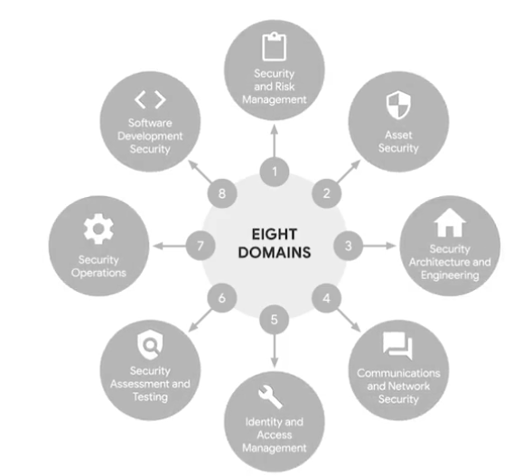

Explore the CISSP security domains, Part 2 Apr 8, 2026
This video covers the last four domains of IT security: identity and access management, security assessment and testing, security operations, and software development security.

Identity and Access Management (IAM)
- IAM focuses on controlling access and authorization to keep data secure by ensuring users follow established policies.
- It involves identification (verifying who a user is), authentication (proving identity), authorization (determining access level based on role), and accountability (monitoring user actions).

Security Assessment and Testing
- This domain involves conducting security control testing, collecting and analyzing data, and performing security audits to identify risks, threats, and vulnerabilities.
- The goal is to identify new ways to mitigate threats and improve existing controls or implement new ones, such as multi-factor authentication.

Security Operations
- Security operations focus on conducting investigations and implementing preventative measures after a security incident has been identified.
- This includes mitigating active attacks, collecting digital and physical evidence for forensic investigations, and determining areas for improvement to prevent future attacks.

Software Development Security
- This domain emphasizes using secure coding practices throughout the software development lifecycle.
- Security is integrated into each phase, from secure design reviews to secure code reviews and penetration testing, to ensure software is secure and sensitive data is protected.
Security domains cybersecurity analysts need to know Apr 8, 2026
This reading explores the eight security domains defined by CISSP (Certified Information Systems Security Professional) and their relevance to the work of a security analyst.

Security and Risk Management
- This domain focuses on an organization's ability to defend critical assets and data, and react to changes in the threat landscape.
- Key elements include security goals, risk mitigation, compliance, business continuity, and information security (InfoSec) processes like incident response and vulnerability management.

Asset Security
- This domain involves managing the cybersecurity processes related to organizational assets, encompassing their storage, maintenance, retention, and destruction.
- It emphasizes the importance of tracking assets and their data to prevent loss or theft, which could expose the organization to increased risk.

Security Architecture and Engineering
- This domain is centered on managing data security through effective tools, systems, and processes.
- A core concept is shared responsibility, where all individuals contribute to lowering risk during the design of security systems.

Communication and Network Security
- This domain focuses on securing physical networks and wireless communications, including on-site, remote, and cloud environments.
- The challenge lies in ensuring data remains secure across various work environments and managing external connections for remote workers.

Identity and Access Management (IAM)
- IAM aims to secure data by ensuring user identities are trusted and authenticated, and access to assets is authorized.
- It utilizes the principle of least privilege, granting users only the minimal access required to perform their tasks.

Security Assessment and Testing
- This domain is dedicated to identifying and mitigating risks, threats, and vulnerabilities through various assessments.
- Activities include security control testing, data collection and analysis, and security audits to reduce the probability of data breaches.
Ashley: My path to cybersecurity Apr 8, 2026
This video features Ashley, a CE Enablement Lead at Google, who shares her unconventional journey into the tech industry and highlights the importance of soft skills in cybersecurity.
Ashley's Path to Tech
- Ashley's early interest in technology, despite not having a clear career path after high school, led her to join the military.
- The military provided her with IT training, which was her first formal schooling in the field, enabling her to become a PC technician.
Transition to Cybersecurity
- She pursued a cybersecurity associate's degree and certifications, and attending DEFCON, a major hacking conference, solidified her career direction.
- Ashley landed her first security analyst role in 2017 after completing a free Veterans Training Program.
The Importance of Soft Skills in IT
- Beyond technical expertise, Ashley emphasizes the critical need for soft skills like teamwork, communication, and de-escalation in IT roles.
- She explains that analytical skills, even those developed outside of a technical context, are valuable, and that coding knowledge isn't always a prerequisite for working in cybersecurity.
Threats, risks, and vulnerabilities Apr 8, 2026
This video explains the key concepts of threats, risks, and vulnerabilities in the context of cybersecurity for an entry-level security analyst.
Understanding Assets, Threats, and Risks
- An asset is anything of value to an organization, including physical spaces, computers, customer data, and intellectual property.
- A threat is any event or circumstance that can negatively impact assets, such as social engineering attacks like phishing, which exploit human error to gain sensitive information.
Differentiating Risks and Their Levels
- A risk is the likelihood of a threat occurring and impacting the confidentiality, integrity, or availability of an asset.
- Risks are categorized as low, medium, or high based on potential harm to an organization's reputation, operations, or finances if compromised.
Vulnerabilities and Mitigation
- A vulnerability is a weakness that a threat can exploit, such as outdated software, weak passwords, or unprotected data.
- Organizations must continuously identify and mitigate vulnerabilities through measures like educating employees on security awareness and monitoring access to critical assets.
Key impacts of threats, risks, and vulnerabilities Apr 8, 2026
This video discusses ransomware, the different layers of the web, and the significant impacts of threats, risks, and vulnerabilities on organizations.
Ransomware and the Web
- Ransomware is a malicious attack where threat actors encrypt an organization's data and demand payment for its restoration.
- The web consists of three layers: the surface web (publicly accessible), the deep web (requires authorization), and the dark web (requires special software and is often used for illicit activities).
Impacts of Threats, Risks, and Vulnerabilities
- Financial Impact: Attacks can lead to interrupted production, recovery costs, and fines due to non-compliance.
- Identity Theft: Storing sensitive data like Personally Identifiable Information (PII) creates a risk of it being sold or leaked, often through the dark web.
- Damage to Reputation: Exploited vulnerabilities can cause customers to leave, generate negative publicity, and result in legal penalties and fines.

Herbert: Manage threats, risks, and vulnerabilities Apr 8, 2026
This video features Herbert, a Security Engineer at Google, who shares his journey into cybersecurity and describes his daily responsibilities and common challenges.
Journey to Cybersecurity
- Herbert's interest in security began in high school, where he learned to manipulate computers.
- He transitioned from working at a pizza place to becoming a Security Engineer at Google within ten years, highlighting that such a career path is achievable.
Daily Responsibilities of a Security Engineer
- Herbert's role involves analyzing security risks and developing solutions to mitigate them.
- A typical task includes evaluating exception requests for special access to devices or documents based on an individual's role or project.
Common Cybersecurity Threats and Challenges
- Misconfigurations and requests for unnecessary access are frequent issues encountered by security analysts.
- Herbert shares an ongoing case where a vendor changed their OAuth scope requests, asking for more permissions than previously, which presented a new challenge for his team.
NIST’s Risk Management Framework Apr 8, 2026
This video introduces the National Institute of Standards and Technology (NIST) Risk Management Framework (RMF), outlining its seven steps for managing security and privacy risks.
Understanding the NIST Risk Management Framework (RMF)
- The RMF is a crucial framework used by security professionals to manage risks, threats, and vulnerabilities.
- Familiarity with this framework is important for entry-level analysts, even if they don't engage in all steps.
The Seven Steps of the RMF
- Prepare and Categorize: These initial steps involve activities to manage security and privacy risks before a breach, and developing processes to address how confidentiality, integrity, and availability can be impacted.
- Select and Implement: This involves choosing and documenting controls to protect an organization, and then putting security and privacy plans into action.
- Assess and Authorize: These steps focus on determining if established controls are working correctly and being accountable for security and privacy risks within the organization.
- Monitor: The final step involves continuously assessing and maintaining technical operations to ensure systems support the organization's security goals and to identify any needed changes.
Manage common threats, risks, and vulnerabilities Apr 9, 2026
This reading explores how organizations manage risks and the common tactics used by threat actors to help you prepare for a career in cybersecurity.

Risk Management Strategies
- Organizations protect assets, which can be digital (e.g., personal information) or physical (e.g., servers).
- Common risk management strategies include acceptance, avoidance, transference, and mitigation.

Threats, Risks, and Vulnerabilities
- Threats are circumstances or events that can negatively impact assets, such as insider threats or advanced persistent threats (APTs).
- Risks are anything that can impact the confidentiality, integrity, or availability of an asset, with factors like external risks, internal risks, and legacy systems contributing to their likelihood.

Vulnerabilities and Their Management
- Vulnerabilities are weaknesses that can be exploited by a threat, such as ProxyLogon, ZeroLogon, and Log4Shell.
- As a security professional, you might work in vulnerability management, which involves monitoring systems to identify and mitigate these weaknesses.
Wrap-up Apr 9, 2026
This video provides a review of the first section of the course, focusing on key cybersecurity concepts and frameworks.
CISSP's Eight Security Domains
- The course began by exploring the focus of the CISSP's eight security domains.
- Understanding these domains is crucial for a comprehensive approach to cybersecurity.
Threats, Risks, and Vulnerabilities
- The discussion covered threats, risks, and vulnerabilities, and their potential impact on organizations.
- Ransomware was examined as a specific example, along with an introduction to the three layers of the web.
NIST Risk Management Framework (RMF)
- The seven steps of the NIST Risk Management Framework (RMF) were a central focus.
- This framework provides a structured approach to managing security risks.
The Module 1 Challenge for Course 2 is a significant milestone, Venkatesh. It tests your ability to categorize organizational efforts into the eight CISSP domains and accurately apply the Risk Management Framework (RMF).
Here are the correct answers and the logic for your Graded Assignment:

1. Organizational Readiness
- Answer: posture
- Logic: Security posture is the overall status of an organization’s cybersecurity readiness. It’s a holistic view of how well they are defending assets and how quickly they can adapt to new threats.

2. Security and Risk Management Focus
- Answers:
  - Follow legal regulations
  - Maintain business continuity
  - Define security goals
- Logic: This domain is about governance. Control testing is actually part of the Security Assessment and Testing domain. The other three focus on the high-level strategy and compliance that guide an organization.

3. Productivity and Resilience
- Answer: Business continuity
- Logic: Business continuity is the practice of ensuring that essential business functions can continue even during and after a disaster. It differs from disaster recovery, which focuses specifically on the technical restoration of systems.

4. Shared Responsibility in Action
- Answers:
  - recognizing and reporting security concerns
  - taking an active role
- Logic: Security is not just the job of the IT team. By staying alert to phishing or suspicious activity and actively participating in training, every employee contributes to lowering the organization's risk profile.

5. Managing Access Rights
- Answer: Identity and access management
- Logic: This scenario specifically describes the Principle of Least Privilege, which is a core component of the IAM domain. It ensures users have just enough access to do their jobs and nothing more.

6. Implementing Controls
- Answers:
  - Regularly reviewing security information
  - Setting up multi-factor authentication
  - Assessing the effectiveness of current safeguards
- Logic: Implementing controls is a cycle: you deploy a safeguard (like MFA), you monitor it (reviewing information), and you check to see if it’s actually working (assessing effectiveness).

7. Software Development Security (SDLC)
- Answers:
  - Conducting secure code reviews
  - Initiating a secure design review
  - Performing penetration testing
- Logic: These three tasks happen during the creation or testing of software to ensure it is "secure by design." Incident investigations are typically a Security Operations task.

8. Understanding Risk Levels
- Answers:
  - Website content or published research data are examples of low-risk assets.
  - Organizations often rate risks at different levels: low, medium, and high.
  - If compromised, a medium-risk asset may cause some damage to an organization's finances.
- Logic: High-risk assets (like PII) are very likely to cause financial and legal damage if compromised. Low-risk assets are typically public-facing data that won't cripple the company if leaked.

9. Consequence of an Attack
- Answer: Damage to reputation
- Logic: When a security breach becomes public news, it erodes customer trust. This reputational damage can often be more expensive and harder to fix than the actual technical breach itself.

10. The RMF Authorization Step
- Answer: Authorize
- Logic: In the NIST Risk Management Framework, the Authorize step is when a senior official (the Authorizing Official) reviews the security plan and signs off on it, essentially "accepting" the risk of running that system.

Venkatesh, you have a solid grasp of these frameworks. Since you're learning about "Business Continuity," would you like to see how we could apply a continuity plan to your "Architect Pro" project? For example, what happens to your automated YouTube workflow if the primary API you're using goes offline?

Welcome to module 2 Apr 9, 2026
This video emphasizes the critical role of a security analyst in protecting individuals and organizations from data breaches.
The Importance of a Security Analyst
- Security analysts safeguard people's financial stability and reputations by preventing breaches of customer, vendor, and employee data.
- Their daily work directly contributes to the safety of both individuals and organizations.
Key Concepts in Security
- The course will delve into security frameworks, controls, and design principles.
- These concepts are applied to security audits to enhance protection for organizations and their constituents.
NIST Cybersecurity Framework
- The NIST Cybersecurity Framework is a crucial tool used to ensure the protection and compliance of customer tools and personal work devices.
- It achieves this through the implementation of various security controls.
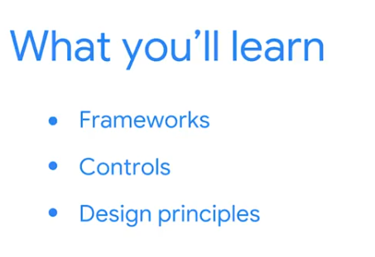

Frameworks Apr 9, 2026
This video explains how security frameworks help organizations protect against various threats, risks, and vulnerabilities.
Understanding Security Frameworks
- Security frameworks are guidelines used to build plans for mitigating risks and threats to data and privacy, such as social engineering attacks and ransomware.
- These frameworks cover both virtual and physical security, including measures like key card access for buildings.
Protecting Against Social Engineering Attacks
- Frameworks provide guidance on how to prevent, detect, and respond to security breaches, especially those from social engineering attacks like phishing.
- Since people are often the biggest security threat, frameworks help create plans to increase employee awareness and educate them on protecting the organization and themselves.
The Role of an Analyst
- Educating employees about security challenges and providing training on recognizing potential threats are crucial for minimizing breaches.
- As an analyst, understanding and implementing these security plans is essential to safeguard the organization, its employees, and the people it serves from various security incidents.
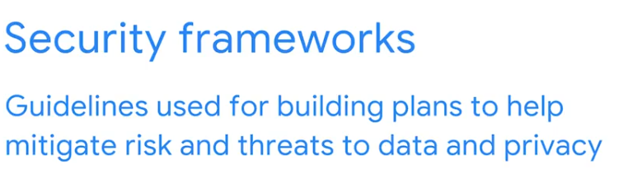

Controls Apr 9, 2026
This video explains how security controls are used to reduce specific risks and introduces three common types: encryption, authentication, and authorization.
Understanding Security Controls
- Security controls are safeguards designed to minimize specific security risks, preventing potential financial and reputational damage from threats like trespassing or fake accounts.
- Without proper controls, organizations are vulnerable to various risks, emphasizing the importance of implementing these safeguards.
Types of Security Controls
- Encryption converts data into an encoded format (ciphertext) to ensure confidentiality, making it unreadable until decrypted back into plaintext.
- Authentication verifies identity, ranging from basic username/password logins to advanced multi-factor authentication (MFA) using biometrics like fingerprints or voice scans.
- Authorization grants access to specific resources within a system, ensuring individuals only access data they have permission to view, such as federal employees accessing internal government data.
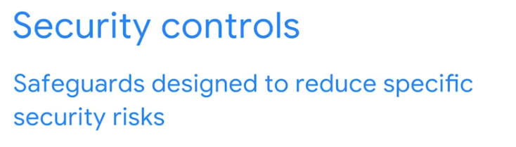
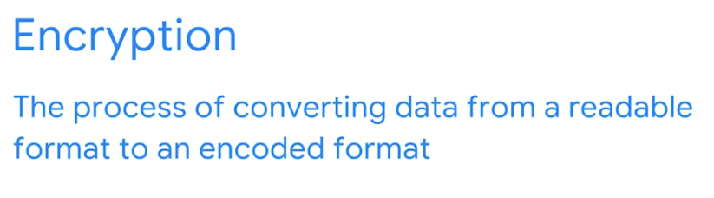
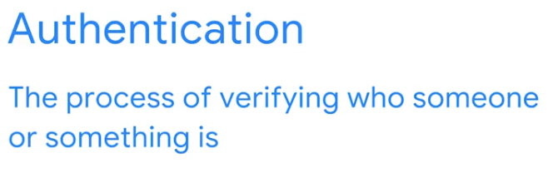
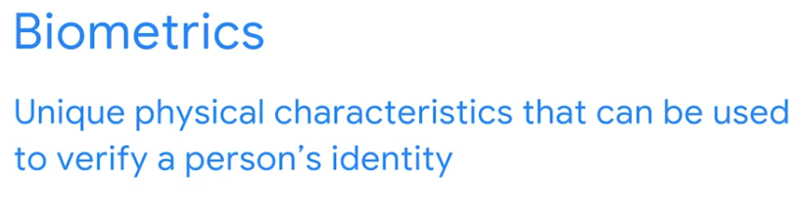
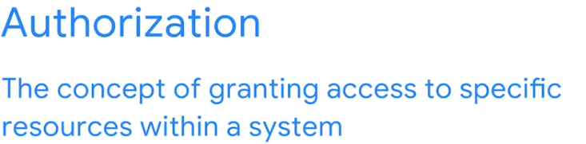

The relationship between frameworks and controls Apr 9, 2026
This reading explores how security frameworks and controls are used together to help mitigate organizational risk.
Security Frameworks and Controls
- Security frameworks are guidelines for building plans to mitigate risk and threats to data and privacy, helping organizations adhere to compliance laws and regulations.
- Security controls are safeguards designed to reduce specific security risks, such as multi-factor authentication (MFA) to validate identity.
Specific Frameworks
- The Cyber Threat Framework (CTF) provides a common language for describing and communicating information about cyber threat activity, improving analysis and information sharing.
- ISO/IEC 27001 is an internationally recognized framework that outlines requirements for an information security management system and best practices for managing asset security.
Types of Controls
- Controls can be physical (e.g., gates, security guards), technical (e.g., firewalls, antivirus software), and administrative (e.g., separation of duties, authorization).
- These controls are typically used to prevent, detect, or correct security issues, working alongside frameworks to reduce the possibility and impact of security threats.
In Module 2, you are shifting from high-level domains to the specific Frameworks and Controls that a security analyst uses to build a defense. Think of a framework as the architectural blueprint of a house and the controls as the individual locks, cameras, and alarms you install to protect it.
Here are the correct answers and the technical logic for the Test your knowledge: More about frameworks and controls practice assignment:

1. The Purpose of Frameworks
- Answer: They are used to establish guidelines for building security plans.
- Logic: A framework is a structured set of guidelines or "best practices." They don't have the force of law themselves (though laws often require you to follow one), and they aren't used for physical identity verification. Instead, they provide the roadmap for an organization to manage its security risks consistently.

2. Assessing Threat Actors
- Answer: False
- Logic: While competitors are a concern, they are rarely the "biggest" threat. The primary threats to most organizations are insider threats (unintentional mistakes or intentional harm by employees) and organized cybercriminals (motivated by financial gain).

3. The Role of Security Controls
- Answer: specific
- Logic: Controls are not broad or general; they are highly targeted. You don't just "apply security"—you apply a specific control (like a firewall rule) to mitigate a specific risk (like unauthorized network access).

4. Protecting Against Vishing and Biometric Exploits
- Answer: Authentication
- Logic: Vishing (voice phishing) often involves attackers trying to trick or bypass voice-based identity systems. Protecting biometrics and verifying that a person is who they claim to be is the core function of Authentication.
  - Encryption and Ciphertext protect data from being read, but they don't verify identity in this specific context.

Great start to Module 2! You are now ready to tackle the CIA Triad and the NIST Cybersecurity Framework functions.
Since you've been developing an automated content generation system, would you like to see how we could apply a "Specific Control" to protect your Google AI Studio API keys from accidental leaks?
Explore the CIA triad Apr 9, 2026
This video introduces the CIA triad, a core security model that helps protect an organization's sensitive assets and data from threats.
Understanding the CIA Triad
- The CIA triad stands for Confidentiality, Integrity, and Availability, and it informs how organizations consider risk when setting up systems and security policies.
- As an entry-level security analyst, you will constantly refer to these three core principles to protect your organization.
Components of the CIA Triad
- Confidentiality: Ensures that only authorized users can access specific assets or data, meaning sensitive information is available on a "need to know" basis.
- Integrity: Guarantees that data is correct, authentic, and reliable, allowing security professionals to determine if data can be trusted.
- Availability: Means that data is accessible to those authorized to access it, ensuring systems, networks, and applications function properly for timely and reliable access.
Applying the CIA Triad in Practice
- For organizations like banks, confidentiality is crucial to protect personal and financial information, while integrity ensures the accuracy of financial data.
- Availability is also critical for banks, as they must ensure customers can easily access their account information, often using validation processes to minimize damage from compromised accounts.
Explore the CIA triad Apr 9, 2026
This video introduces the CIA triad, a core security model that helps protect an organization's sensitive assets and data from threats.
Understanding the CIA Triad
- The CIA triad stands for Confidentiality, Integrity, and Availability, and it informs how organizations consider risk when setting up systems and security policies.
- As an entry-level security analyst, you will constantly refer to these three core principles to protect your organization.
Components of the CIA Triad
- Confidentiality: Ensures that only authorized users can access specific assets or data, meaning sensitive information is available on a "need to know" basis.
- Integrity: Guarantees that data is correct, authentic, and reliable, allowing security professionals to determine if data can be trusted.
- Availability: Means that data is accessible to those authorized to access it, ensuring systems, networks, and applications function properly for timely and reliable access.
Applying the CIA Triad in Practice
- For organizations like banks, confidentiality is crucial to protect personal and financial information, while integrity ensures the accuracy of financial data.
- Availability is also critical for banks, as they must ensure customers can easily access their account information, often using validation processes to minimize damage from compromised accounts.
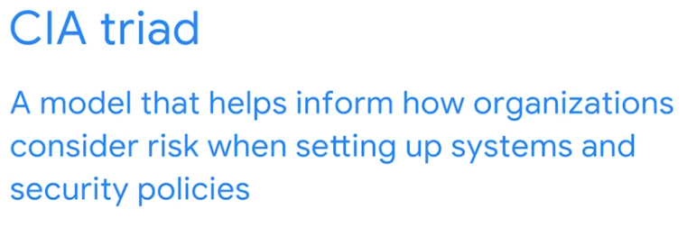
Use the CIA triad to protect organizations Apr 9, 2026
This reading explains how cybersecurity analysts use the Confidentiality, Integrity, and Availability (CIA) triad to manage risk and establish a strong security posture within organizations.
The CIA Triad in Cybersecurity
- The CIA triad is a model that guides organizations in assessing risk when designing systems and security policies.
- It consists of three core elements—confidentiality, integrity, and availability—that cybersecurity analysts strive to maintain.
Confidentiality
- Confidentiality ensures that only authorized users can access specific assets or data.
- This is often achieved through principles like "least privilege," which limits user access to only what is necessary for their tasks.
Integrity and Availability
- Integrity means that data is accurate, authentic, and reliable, often verified through methods like cryptography and encryption.
- Availability ensures that authorized users can access data when needed, such as remote employees accessing internal networks for work.
The CIA Triad is the most important model you will learn in cybersecurity. It acts as a benchmark for every security decision an organization makes. Whether you are managing cloud infrastructure or building AI agents, you are essentially trying to protect one or more of these three pillars.
Here are the correct answers and the technical logic for the Test your knowledge: The CIA triad practice assignment:

1. Defining the CIA Triad
- Answer: A foundational security model used to set up security policies and systems
- Logic: The CIA Triad isn't a single control or a law; it is a model. It provides the high-level philosophy that security professionals use to build their entire defense strategy. Every policy you write should aim to protect at least one of these three elements.

2. Restricting Access
- Answer: Confidentiality
- Logic: Confidentiality is about keeping data private. It ensures that only those with a legitimate "need to know" and the proper authorization can see the information. Encryption and access control lists (ACLs) are common tools used to maintain confidentiality.

3. Ensuring System Access
- Answer: Availability
- Logic: If a system is down, it doesn't matter how secure the data is—the business cannot function. Availability means ensuring that authorized users have reliable and timely access to the data and systems they need. Fixing a broken application or mitigating a DDoS attack are tasks focused on availability.

4. Verifying Data Accuracy
- Answer: Integrity
- Logic: Integrity is the certainty that data has not been tampered with, altered, or destroyed by unauthorized people or processes. It means the information is verifiably correct and authentic. Digital signatures and hashing are the primary technical tools used to prove integrity.

Great job, Venkatesh! You’ve successfully navigated the core principles of the CIA Triad.
Since you are working with large datasets in your Data Engineering course, would you like to see how "Hashing" is used in a batch pipeline to ensure the Integrity of the data before it reaches the Gold Zone?
NIST frameworks Apr 9, 2026
This video explains how organizations use frameworks, specifically those from the National Institute of Standards and Technology (NIST), to manage cybersecurity risks.
Purpose of Frameworks
- Frameworks serve as a starting point for organizations to develop plans that reduce risks, threats, and vulnerabilities to sensitive data and assets.
- Organizations worldwide create these frameworks to help security professionals develop effective security plans.
NIST Cybersecurity Framework (CSF)
- The NIST CSF is a voluntary framework providing standards, guidelines, and best practices for managing cybersecurity risk.
- It consists of five core functions: Identify, Protect, Detect, Respond, and Recover, which guide security professionals in handling incidents.
NIST Special Publication (SP) 800-53
- NIST SP 800-53 provides a unified framework for protecting information systems within the U.S. federal government.
- This framework's security controls are crucial for maintaining the Confidentiality, Integrity, and Availability (CIA) triad for government systems.
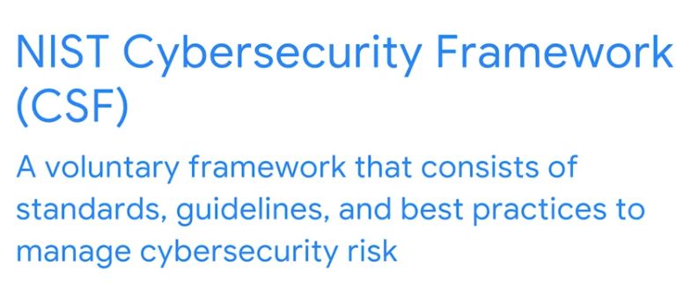

Update: The NIST Cybersecurity Framework is a voluntary framework that consists of standards, guidelines, and best practices to manage cybersecurity risk. In the latest version, CSF v2.0, a new 'Govern' function has been added, emphasizing the importance of strong cybersecurity governance. This framework is widely respected and essential for maintaining security regardless of the organization you work for.
The CSF now consists of six important core functions: Govern, Identify, Protect, Detect, Respond, and Recover, which we'll discuss in detail in a future video.
CSF v2.0 also places greater emphasis on supply chain risk management.
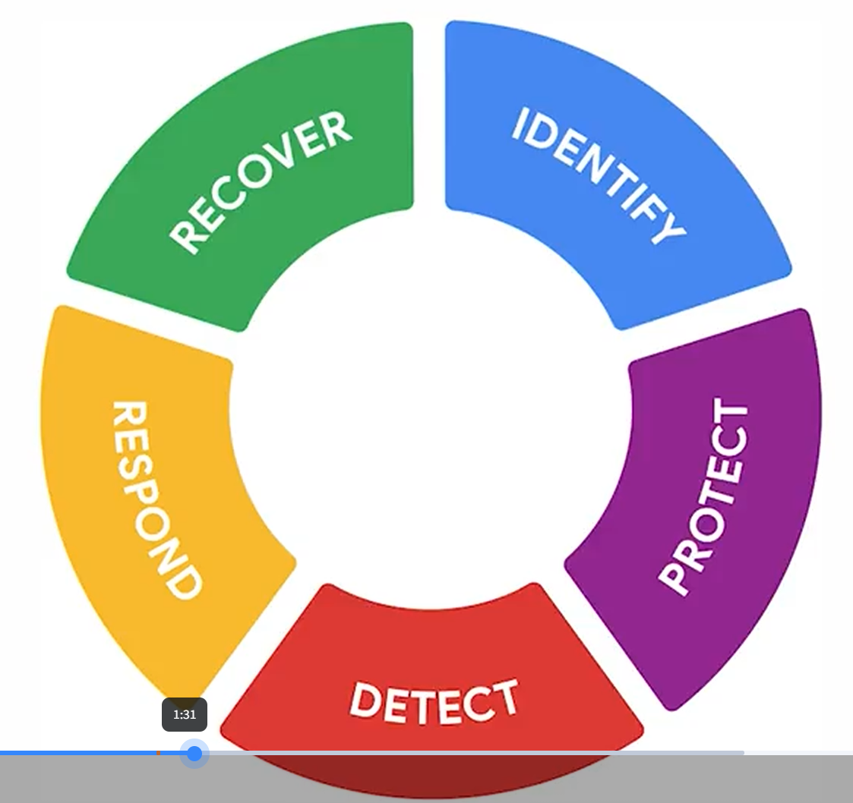

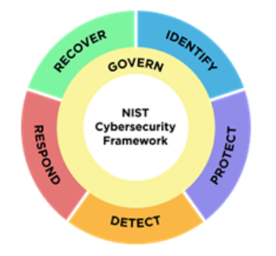

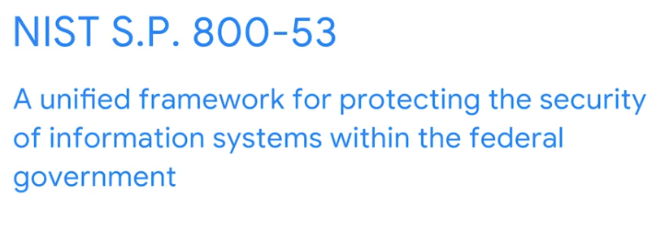
Explore the six functions of the NIST Cybersecurity Framework Apr 9, 2026
This video focuses on the five core functions of the NIST CSF framework, which help organizations manage cybersecurity risks and improve their security posture.
NIST CSF Core Functions
- Identify: This function involves managing cybersecurity risk and its impact on an organization's people and assets, such as monitoring systems for potential security issues.
- Protect: This function focuses on implementing policies, procedures, training, and tools to mitigate cybersecurity threats, including studying historical data to improve protective measures.
Detecting and Responding to Incidents
- Detect: This function aims to identify potential security incidents and enhance monitoring capabilities for faster and more efficient detection, such as configuring security tools to flag risks.
- Respond: This function ensures proper procedures are followed to contain, neutralize, and analyze security incidents, and to implement improvements to the security process.
Recovering from Incidents
- Recover: This function involves restoring affected systems back to normal operation after an incident, which may include working with a security team to restore data and assets.
- All five functions are crucial for effective security strategies, enabling organizations to quickly recover from incidents and minimize risk.
Update: Govern Function
A significant update in the latest version of the NIST Cybersecurity Framework is the inclusion of a new core function: Govern. This function emphasizes the importance of strong cybersecurity governance across all levels of the organization. It's about establishing and maintaining the structures and processes needed to effectively manage cybersecurity risk. This includes things like setting clear cybersecurity objectives, ensuring leadership commitment, developing and implementing a comprehensive risk management strategy, and continuously improving cybersecurity performance.


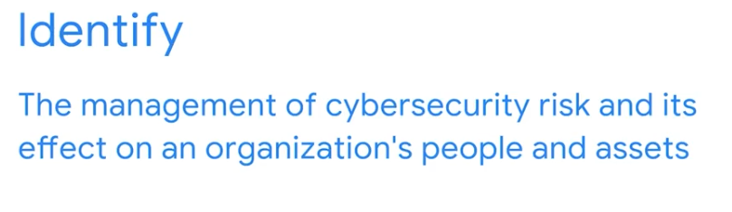
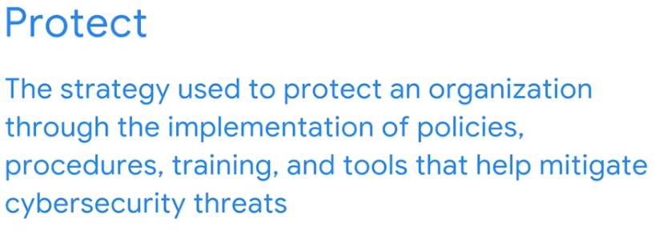
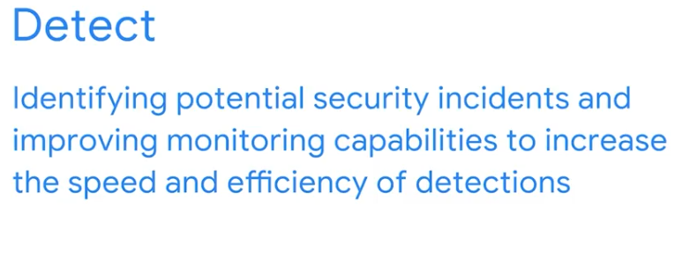
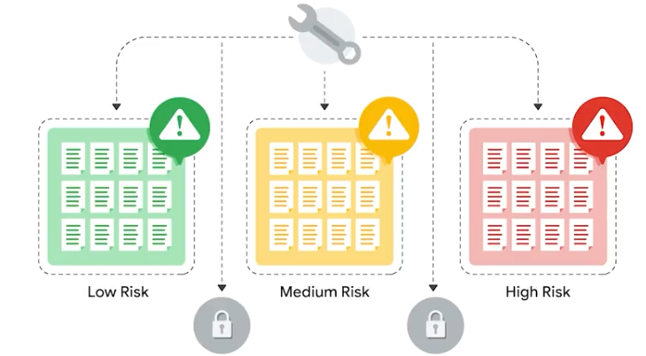
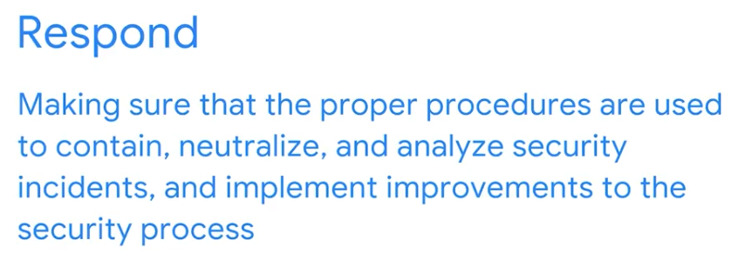
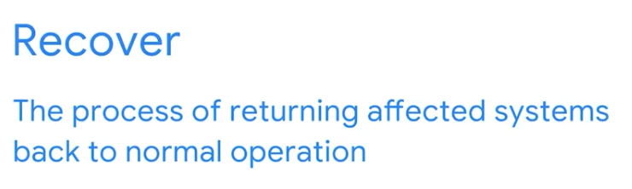

Moving from the CIA Triad into the NIST Cybersecurity Framework (CSF) is a major step in learning how professional security teams operate. While the CIA Triad gives you the "goals," the NIST CSF provides the "verbs"—the actual functions you perform to manage risk.
Here are the correct answers and the technical breakdown for the Test your knowledge: NIST frameworks practice assignment:

1. Defining the NIST CSF
- Answer: Standards, guidelines, and best practices that organizations follow voluntarily in order to manage cybersecurity risk
- Why: The NIST CSF is widely respected because it is comprehensive yet voluntary. It provides a common language for organizations to describe their current security state and where they want to be, regardless of their size or technical sophistication.

2. The Six Core Functions
- Answer: respond
- Why: The full lifecycle of the NIST CSF 2.0 consists of:
  - Govern: Strategy and policy.
  - Identify: Knowing your assets.
  - Protect: Safeguarding systems.
  - Detect: Finding problems.
  - Respond: Taking action when a problem is found.
  - Recover: Getting back to normal.

3. The Foundation: Identify
- Answer: identify
- Why: You cannot protect what you don't know exists. The Identify function is the groundwork where you inventory your hardware, software, and data, and determine which risks are most likely to impact the business.

4. Returning to Normal: Recover
- Answer: Return affected systems back to normal operation
- Why: The Recover function is about resilience. After an incident has been handled (the Respond phase), the focus shifts to restoring services, communicating with stakeholders, and learning lessons to improve future security.
  - Contain and neutralize is part of the Respond function.
  - Pinpoint threats is part of the Detect function.
  - Employee training is part of the Protect function.

Excellent work, Venkatesh! These functions are the standard workflow for any Security Operations Center (SOC).
Since you're managing complex data pipelines in your other courses, would you like to see how we could apply the "Identify" function to your GCP environment? For example, how would you inventory all the BigQuery datasets and Service Accounts you've created?
OWASP security principles Apr 9, 2026
This video explains key Open Web Application Security Project (OWASP) security principles that are important for security analysts to understand for protecting an organization's data and assets.
Minimizing Attack Surface and Least Privilege
- Minimize Attack Surface Area: This involves reducing potential vulnerabilities that threat actors could exploit by disabling unnecessary software features, restricting access, and implementing stronger password requirements.
- Principle of Least Privilege: Users should only have the minimum access necessary to perform their tasks, which limits the potential damage if their credentials are compromised.
Defense in Depth and Separation of Duties
- Defense in Depth: Organizations should implement multiple security controls, such as multi-factor authentication, firewalls, and intrusion detection systems, to create several layers of defense against threats.
- Separation of Duties: This principle prevents individuals from having too many privileges that could lead to fraudulent or illegal activities, ensuring that no single person has complete control over a critical process.
Keeping Security Simple and Fixing Issues Correctly
- Keep Security Simple: Avoid overly complex security solutions as they can become unmanageable and hinder collaborative efforts.
- Fix Security Issues Correctly: When security incidents occur, it's crucial to quickly identify the root cause, correct vulnerabilities, and conduct tests to ensure the repairs are effective.
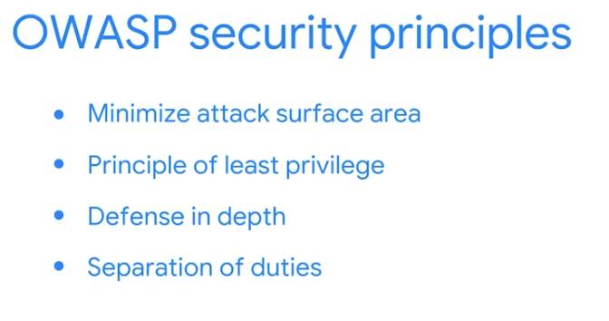

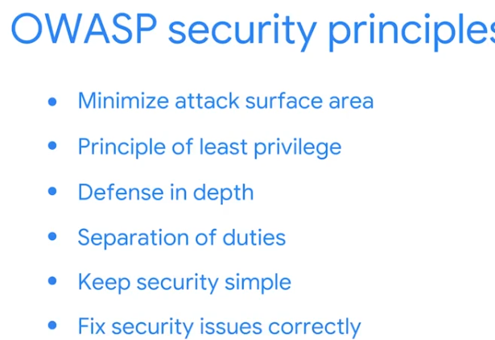
More about OWASP security principles Apr 9, 2026
This reading focuses on additional security principles from the Open Worldwide Application Security Project (OWASP) that cybersecurity analysts use to protect organizations.
Integrating Security Principles in Daily Tasks
- Security principles are fundamental to daily cybersecurity tasks, such as analyzing logs, monitoring SIEM dashboards, and using vulnerability scanners.
- Previously introduced OWASP principles include minimizing attack surface, principle of least privilege, defense in depth, separation of duties, keeping security simple, and correctly fixing security issues.
Additional OWASP Security Principles
- Establish secure defaults: Applications should be secure by default, requiring extra effort to make them insecure.
- Fail securely: When security controls fail, they should default to their most secure state, such as a firewall closing all connections.
Trust and Obscurity in Security
- Don't trust services: Organizations should not implicitly trust the security of third-party partners' systems due to differing security policies.
- Avoid security by obscurity: The security of key systems should not rely on keeping details hidden; instead, it should depend on factors like strong password policies, defense in depth, and robust network architecture.
Wajih: Stay up-to-date on the latest cybersecurity threats Apr 9, 2026
This video features a Google Security Engineer who shares insights on entering the cybersecurity field and strategies for staying current with industry trends.
Journey into Cybersecurity
- A background in cybersecurity isn't a prerequisite; the speaker initially pursued a biology major and worked in unrelated jobs before discovering cybersecurity.
- An accidental encounter sparked interest in a cybersecurity startup, highlighting that opportunities can arise unexpectedly.
Staying Current in Cybersecurity
- Online forums like Medium are valuable resources for researching security trends and topics, allowing for filtered searches by specific tags like "cybersecurity" or "cloud security."
- Attending conferences is highly recommended for networking and staying informed about the latest developments in the field.
Advice for Aspiring Cybersecurity Professionals
- Avoid feeling overwhelmed by the vastness of cybersecurity specializations; prioritize understanding fundamental concepts.
- Persistence is key, as the field offers significant challenges and rewards, despite perceptions of it being difficult to enter.
Plan a security audit Apr 9, 2026
This video explains how security audits help organizations assess their security posture and ensure compliance.
Understanding Security Audits
- Security audits review an organization's security controls, policies, and procedures against established expectations.
- Internal security audits, often conducted by an organization's compliance officer, security manager, and team members, aim to improve security and avoid non-compliance fines.
Key Elements of Internal Audits: Planning
- Establishing Scope and Goals: The scope defines the specific criteria of the audit, including people, assets, policies, procedures, and technologies. Goals outline the organization's security objectives.
- Conducting a Risk Assessment: This involves identifying potential threats, risks, and vulnerabilities to determine necessary security measures.
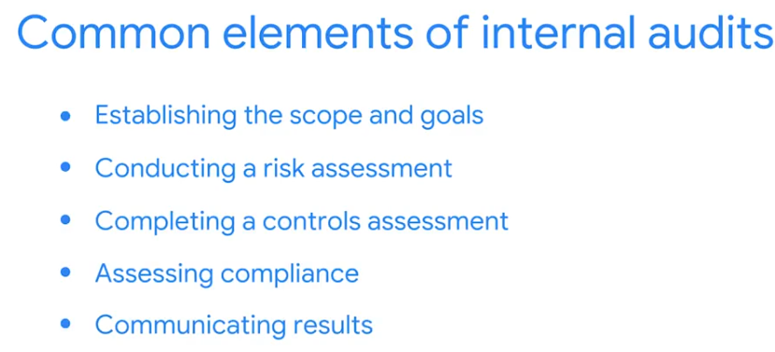

Complete a security audit Apr 9, 2026
This video outlines the final stages of an internal security audit, focusing on controls assessment, compliance, and communicating results.
Completing the Audit
- Before finalizing, review the audit's scope, goals, and risk assessment to ensure all aspects are covered.
- Consider questions like "What is the audit meant to achieve?" and "Are current controls sufficient?" to guide the remaining steps.
Assessing Controls and Compliance
- A controls assessment involves evaluating existing assets and potential risks to ensure internal controls are effective.
- Controls are categorized as administrative (policies), technical (software/hardware), and physical (access prevention).
- Compliance assessment determines if the organization adheres to necessary regulations, such as GDPR or PCI DSS for data protection.
Communicating Results
- The final step is to communicate audit results and recommendations to stakeholders.
- This communication summarizes the audit's scope and goals, lists existing risks, and suggests improvements for the organization's security posture.
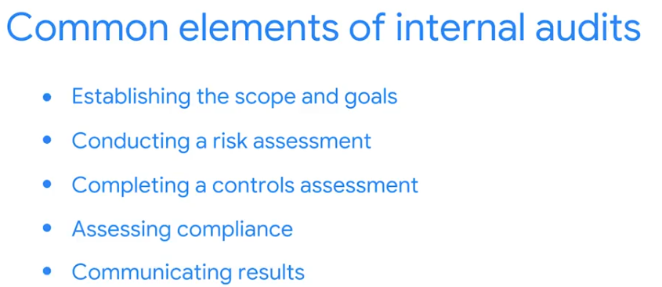
More about security audits Apr 9, 2026
This reading provides an overview of security audits, including their purpose, objectives, and key considerations.

Understanding Security Audits
- A security audit is an independent review of an organization's security controls, policies, and procedures against internal and external standards.
- The primary goal is to ensure IT practices meet industry and organizational standards, identify areas for improvement, and safeguard data.

Factors Influencing Audits
- The type and frequency of audits are influenced by industry, organization size, applicable government regulations, geographical location, and decisions to adhere to specific compliance.
- Frameworks like NIST CSF and ISO 27000, along with controls (administrative, technical, physical), play a crucial role in preparing for and conducting security audits.

Conducting a Security Audit
- An audit checklist is essential, outlining the scope, assets to be assessed, audit frequency, and evaluation of policies and procedures.
- The process involves conducting a risk assessment, performing the audit, creating a mitigation plan for identified risks, and communicating the results to stakeholders.

This section moves into the practical application of security—specifically how we use OWASP principles to design secure systems and Security Audits to verify that those systems are actually working.
Here are the correct answers and the technical logic for the Test your knowledge: OWASP principles and security audits practice assignment:

1. Reducing Vulnerabilities
- Answer: Minimize the attack surface
- Logic: The attack surface is the total sum of all points where an attacker could try to enter or extract data from an environment. By disabling unnecessary software features, closing unused ports, or removing old user accounts, you are making the "target" smaller and harder to hit.

2. Defining a Security Review
- Answer: audit
- Logic: A security audit is a formal, systematic evaluation. It compares the organization's current state (what is actually happening) against a set of established criteria or expectations (what should be happening).

3. Evaluating Internal Safeguards
- Answer: Controls assessment
- Logic: When an analyst examines the network to see if the safeguards (controls) are effective against potential risks, they are performing a controls assessment. This is a core part of an audit where you verify that your technical and administrative defenses are functioning as intended.

4. Communicating Audit Results
- Answers: 1. A list of risks and compliance requirements that need to be addressed
2. A summary of the audit's scope and goals
3. A recommendation about how to improve the organization’s security posture
- Logic: Stakeholders need to know three things: what was checked (scope), what is currently wrong (risks), and how to fix it (recommendations). While stakeholders may have questions for the analyst, providing them with a list of questions to answer is not a standard part of reporting audit results.

Excellent work! You are now ready for the Portfolio Activity where you will conduct a simulated security audit.
Since you've been building Python-based content generators, would you like to see how the "Minimize the attack surface" principle applies to your code? For example, why we should only import specific libraries instead of entire packages?

This is a great portfolio project, Venkatesh! Conducting a security audit for Botium Toys allows you to apply the NIST CSF functions (Identify, Protect, Detect, etc.) to a realistic business scenario.
I will generate a completed Controls and Compliance Checklist based on the Botium Toys scenario provided in your documents. I've analyzed the "Scope, goals, and risk assessment report" to identify which controls are currently in place (Yes) and which are missing (No).

Audit Summary for Botium Toys:
- Physical Security: Strong (Locks, CCTV, and Fire systems are present).
- Technical/Administrative: Weak (No IDS, no backups, no disaster recovery, and weak password/legacy system management).
- Compliance: Partially compliant with GDPR (notification plan exists) but struggling with PCI DSS (encryption and least privilege issues).
- Botium Toys Audit
- Apr 10, 8:22 AM
- Open

How to use this for your assignment:
- Check your work: Compare the "Yes/No" selections above with your own.
- Portfolio Tip: When you save this to your portfolio, add a brief introduction explaining that you acted as the lead analyst using the NIST CSF to identify these gaps.
- Self-Assessment: You can now answer "Yes" to all 5 self-assessment questions in the Coursera interface!
Would you like to try writing a "Professional Statement" for your portfolio that mentions this audit experience? I can help you draft it based on your goals.

Wrap-up Apr 10, 2026
This video provides a recap of the key security concepts covered in the course, emphasizing their importance for a career in the security profession.
Foundational Security Concepts
- The course began by defining security frameworks and their role in protecting critical information within organizations.
- It also explored security controls, highlighting their significance in mitigating risks, threats, and vulnerabilities.
Core Security Models and Frameworks
- A central discussion involved the CIA triad (Confidentiality, Integrity, and Availability), a fundamental security model.
- Two NIST frameworks, the Cybersecurity Framework (CSF) and Special Publication 800-53, were also introduced.
Practical Security Applications
- The course covered OWASP's secure design principles, offering practical guidance for secure development.
- It concluded with an introduction to security audits, focusing on the elements of internal audits that security professionals may conduct.
Glossary terms from module 2 Apr 10, 2026
This reading provides a glossary of key terms and definitions related to managing security risks in organizations.
Core Security Concepts
- Confidentiality, Integrity, Availability (CIA) triad: A foundational model guiding risk considerations in system and security policy setup, ensuring data is accessible only to authorized users, remains correct and authentic, and is consistently available.
- Risk and Threat: Risk refers to anything that can impact the CIA triad, while a threat is any circumstance or event that can negatively affect assets.
NIST Cybersecurity Framework (CSF)
- Framework Functions: The NIST CSF includes core functions like Identify (managing cybersecurity risk), Protect (implementing policies and tools to mitigate threats), Detect (identifying potential security incidents), Respond (containing and analyzing security incidents), and Recover (returning systems to normal operation).
- NIST Special Publication (S.P.) 800-53: A unified framework specifically for protecting information systems within the U.S. federal government.
Security Measures and Practices
- Authentication and Authorization: Authentication verifies a user's identity, while authorization grants access to specific resources. Biometrics are unique physical characteristics used for identity verification.
- Security Audits and Controls: A security audit reviews an organization's security controls, policies, and procedures against expectations, with security controls being safeguards designed to reduce specific risks.
This is the final milestone for Module 2, Venkatesh! This challenge tests your ability to synthesize everything from the CIA triad to the NIST CSF and the practical steps of an audit.
Here are the correct answers and the logic for your Module 2 Challenge:

1. The Goal of Frameworks
- Answer: To provide a structured guide for an organization to manage cybersecurity risk and protect data.
- Logic: Think of a framework as a template or a roadmap. It doesn't perform the analysis itself (that’s an audit) or act as the lock (that’s a control); it tells you how to build the program.

2. Identity Verification
- Answer: authentication
- Logic: Authentication is the process of proving you are who you say you are. MFA (Multi-Factor Authentication) adds layers to this process, such as a password (something you know) plus a fingerprint or token (something you have/are).

3. Physical Identity Factors
- Answer: Fingerprint
- Logic: Biometrics refers to unique physical characteristics used for identification. Fingerprints, facial recognition, and iris scans are all biometric factors.

4. Ensuring Data Accuracy
- Answer: Integrity
- Logic: When you are concerned with data being correct, authentic, and reliable, you are protecting its Integrity. This ensures the inventory numbers haven't been accidentally or maliciously changed.

5. Understanding the NIST CSF
- Answers: * The identify function of the CSF is related to the management of cybersecurity risk and its effects on an organization’s people and assets.
  - The CSF is a voluntary framework that consists of standards, guidelines, and best practices to manage cybersecurity risk.
- Logic: The NIST CSF is voluntary. The Identify function is the foundation where you understand your environment.
  - Note: Returning systems to normal is Recover, not Protect. Improving processes based on lessons learned is part of Recover, while Respond focuses on the immediate containment of an incident.

6. Layered Defenses
- Answer: Defense in depth
- Logic: This is the "Castle Moat" approach. By creating multiple layers of security (permissions, firewalls, encryption), you ensure that if one control fails, others are still in place to stop the threat actor.

7. Why We Audit
- Answers:
  - Help security teams identify organizational risk
  - Improve security posture
  - Avoid fines due to a lack of compliance
- Logic: Audits are diagnostic tools. They find risks and compliance gaps so they can be fixed to improve the overall posture. Developing a security statement is a separate leadership/governance task.

8. Defining the Audit Boundary
- Answer: scope
- Logic: Scope defines the "boundaries" of the audit. It specifies exactly what is being inspected—which departments, assets, and processes are included and which are not.

9. The Human Component
- Answer: Administrative controls
- Logic: Administrative (or Managerial) controls focus on the "people" side of security. This includes training, hiring practices, and the written policies that dictate how data should be handled.

10. Reporting to Stakeholders
- Answers:
  - Results and recommendations
  - Strategies for improving security posture
  - Compliance regulations to be adhered to
- Logic: High-level stakeholders need actionable information: What did you find? How do we fix it? What laws must we follow? They generally do not need "comprehensive details about each part of the process," as that level of technical minutiae is usually reserved for the security team's internal documentation.

Congratulations on finishing the Module 2 Challenge! You’ve effectively demonstrated a solid understanding of how to manage and audit security risks.
Since you've mastered the NIST CSF functions, would you like to see how these map to the "Shared Responsibility Model" you've been studying in your Google Cloud course?

Welcome to module 3 Apr 10, 2026
This section explores various security tools and their applications in maintaining organizational security.
The Importance of Security Tools
- Security tools help address specific challenges like data collection, threat detection, and task automation.
- They contribute to a more comprehensive security posture for organizations.
Key Topics Covered
- The discussion will begin with different types of logs, their tracking capabilities, and usage.
- It will then delve into Security Information and Event Management (SIEM) dashboards.
Common SIEM Tools
- The section will conclude by discussing common SIEM tools used within the security industry.
Logs and SIEM tools Apr 10, 2026
This video explains how security analysts use log data to identify and manage security threats, risks, and vulnerabilities.
Understanding Log Data
- Logs are records of events within an organization's systems and networks.
- Security analysts use various log sources, including firewall logs (for internet traffic), network logs (for device connections), and server logs (for service-related events like logins).
The Role of SIEM Tools
- Security Information and Event Management (SIEM) tools collect and analyze log data to monitor critical activities.
- SIEM tools provide real-time visibility, event monitoring, analysis, and automated alerts, centralizing log data and improving efficiency by minimizing manual review.
Customization and Continuous Monitoring
- SIEM tools need to be configured and customized to meet an organization's specific security needs.
- Continuous customization is essential to detect and address new threats and vulnerabilities as they emerge.
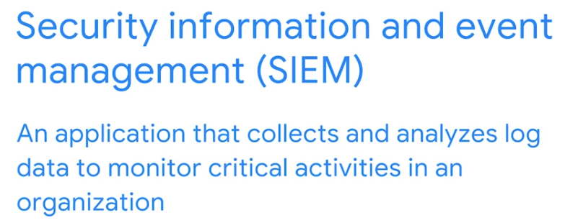

SIEM dashboards Apr 10, 2026
This video explains how SIEM tools use dashboards to help security analysts quickly understand and respond to security incidents.
SIEM Dashboards for Quick Analysis
- SIEM dashboards present security information in an easy-to-understand visual format, similar to how weather apps display data.
- They allow security analysts to quickly identify patterns and trends in security data, such as suspicious login attempts from unusual locations or times.
Customization and Metrics
- SIEM dashboards can be customized to display specific metrics relevant to different organizational roles.
- Metrics are key technical attributes like response time and failure rate, used to assess software performance and monitor daily operations.
The future of SIEM tools Apr 10, 2026
This reading explores how Security Information and Event Management (SIEM) tools are used to protect organizations and how they are evolving to address new threats.
Current SIEM Solutions
- SIEM tools collect and analyze log data to monitor critical activities and identify potential security threats, risks, or vulnerabilities.
- They provide real-time monitoring and various dashboard options to help cybersecurity teams manage and monitor organizational data, though human interaction is currently required for analysis.
The Future of SIEM Tools
- SIEM tools are evolving to function in cloud-hosted and cloud-native environments, offering advantages like availability, flexibility, and scalability without requiring organizations to maintain their own infrastructure.
- The development of interconnected devices (IoT) and advancements in AI/ML will enhance SIEM capabilities for better threat identification, visualization, and data storage, while automation through Security Orchestration, Automation, and and Response (SOAR) will streamline incident response.
Key Takeaways for Security Analysts
- SIEM tools are crucial for monitoring organizational data, and as an entry-level security analyst, you may monitor SIEM dashboards daily.
- Staying updated on SIEM technology advancements, such as cloud computing, application integration, and automation, is important for professional growth in cybersecurity.
Parisa: The parallels of accessibility and security Apr 10, 2026
This video emphasizes the critical role of accessibility in cybersecurity, highlighting how inclusive design benefits everyone and strengthens security measures.
The Essence of Accessibility in Technology
- Accessibility ensures information, activities, and environments are usable and meaningful for the widest possible audience, especially individuals with disabilities.
- In cybersecurity, this means making security measures effective for everyone, considering diverse abilities to prevent unintended exclusions.
Accessibility and Security: A Parallel Path
- Just as closed captioning, initially for the hearing impaired, benefits all users, accessible security solutions enhance protection for everyone.
- Designing for specific accessibility challenges can drive innovation that improves overall security, making systems more robust and user-friendly.
Building Inclusive Cybersecurity Solutions
- It is crucial to incorporate user research and feedback from individuals with a range of abilities to test and validate the effectiveness of security mitigations.
- Embracing diverse perspectives and backgrounds in cybersecurity teams is a superpower, leading to more comprehensive and effective security strategies.
Welcome to Module 3! This is where the theory you've learned meets real-time operations. As a technical professional who has worked with Data Lakes and GCP architectures, you’ll likely find SIEM tools very familiar—they are essentially specialized data analytics platforms for security events.
Here are the correct answers and technical context for your Test your knowledge: Security information and event management (SIEM) dashboards practice assignment:

1. Identifying Log Sources
- Answer: Server
- Logic: Server logs are the most detailed. They track application-level events (like email and web traffic) and identity-level events (like login attempts and password changes). While firewalls and network logs show how data moved, server logs show what the user or application actually did.

2. Defining SIEM
- Answer: event
- Logic: SIEM stands for Security Information and Event Management. The word "Event" is key because SIEM tools look at specific points in time—like a single failed login or a file download—and correlate them to find patterns.

3. Assessing Technical Performance
- Answer: Metrics
- Logic: In both data engineering and security, metrics are the quantifiable measurements used to track performance. Response time, availability (uptime), and failure rates are classic performance metrics that help an analyst determine if a system is healthy or under attack.

4. Configuring SIEM for the Business
- Answer: customized
- Logic: A SIEM is not a "plug-and-play" solution. Every organization has different assets and risks. To be effective, the tool must be customized—meaning you write specific rules to ignore normal activity and alert only on things that are suspicious for your specific environment.

Technical Insight:
Since you are interested in Agentic Workflows and LLMs, the future of SIEM often involves SOAR (Security Orchestration, Automation, and Response). This is where AI "agents" automatically take action—like blocking an IP address—the moment the SIEM detects a threat.
Would you like to see how a SIEM dashboard might display a "Brute Force Attack" vs. a "Successful Admin Login" using the metrics we just discussed?
This is the final milestone for Module 2, Venkatesh! This challenge tests your ability to synthesize everything from the CIA triad to the NIST CSF and the practical steps of an audit.
Here are the correct answers and the logic for your Module 2 Challenge:

1. The Goal of Frameworks
- Answer: To provide a structured guide for an organization to manage cybersecurity risk and protect data.
- Logic: Think of a framework as a template or a roadmap. It doesn't perform the analysis itself (that’s an audit) or act as the lock (that’s a control); it tells you how to build the program.

2. Identity Verification
- Answer: authentication
- Logic: Authentication is the process of proving you are who you say you are. MFA (Multi-Factor Authentication) adds layers to this process, such as a password (something you know) plus a fingerprint or token (something you have/are).

3. Physical Identity Factors
- Answer: Fingerprint
- Logic: Biometrics refers to unique physical characteristics used for identification. Fingerprints, facial recognition, and iris scans are all biometric factors.

4. Ensuring Data Accuracy
- Answer: Integrity
- Logic: When you are concerned with data being correct, authentic, and reliable, you are protecting its Integrity. This ensures the inventory numbers haven't been accidentally or maliciously changed.

5. Understanding the NIST CSF
- Answers: * The identify function of the CSF is related to the management of cybersecurity risk and its effects on an organization’s people and assets.
  - The CSF is a voluntary framework that consists of standards, guidelines, and best practices to manage cybersecurity risk.
- Logic: The NIST CSF is voluntary. The Identify function is the foundation where you understand your environment.
  - Note: Returning systems to normal is Recover, not Protect. Improving processes based on lessons learned is part of Recover, while Respond focuses on the immediate containment of an incident.

6. Layered Defenses
- Answer: Defense in depth
- Logic: This is the "Castle Moat" approach. By creating multiple layers of security (permissions, firewalls, encryption), you ensure that if one control fails, others are still in place to stop the threat actor.

7. Why We Audit
- Answers:
  - Help security teams identify organizational risk
  - Improve security posture
  - Avoid fines due to a lack of compliance
- Logic: Audits are diagnostic tools. They find risks and compliance gaps so they can be fixed to improve the overall posture. Developing a security statement is a separate leadership/governance task.

8. Defining the Audit Boundary
- Answer: scope
- Logic: Scope defines the "boundaries" of the audit. It specifies exactly what is being inspected—which departments, assets, and processes are included and which are not.

9. The Human Component
- Answer: Administrative controls
- Logic: Administrative (or Managerial) controls focus on the "people" side of security. This includes training, hiring practices, and the written policies that dictate how data should be handled.

10. Reporting to Stakeholders
- Answers:
  - Results and recommendations
  - Strategies for improving security posture
  - Compliance regulations to be adhered to
- Logic: High-level stakeholders need actionable information: What did you find? How do we fix it? What laws must we follow? They generally do not need "comprehensive details about each part of the process," as that level of technical minutiae is usually reserved for the security team's internal documentation.

Congratulations on finishing the Module 2 Challenge! You’ve effectively demonstrated a solid understanding of how to manage and audit security risks.
Since you've mastered the NIST CSF functions, would you like to see how these map to the "Shared Responsibility Model" you've been studying in your Google Cloud course?

Explore common SIEM tools Apr 10, 2026
This video discusses various industry-leading Security Information and Event Management (SIEM) tools and their deployment options.
Types of SIEM Tool Deployments
- Self-hosted SIEM tools: These require organizations to install, operate, and maintain the tool using their own physical infrastructure. They are ideal for organizations needing to maintain physical control over confidential data.
- Cloud-hosted SIEM tools: These are maintained and managed by SIEM providers and are accessible via the internet. They are suitable for organizations that prefer not to invest in creating and maintaining their own infrastructure.
Hybrid and Cloud-Native SIEM Solutions
- Hybrid SIEM solutions: Organizations can choose a combination of both self-hosted and cloud-hosted SIEM tools to leverage the benefits of the cloud while maintaining physical control over confidential data.
- Cloud-native tools: These are fully maintained and managed by the vendor and are specifically designed to take full advantage of cloud computing capabilities like availability, flexibility, and scalability.
Examples of Industry-Leading SIEM Tools
- Splunk Enterprise: A self-hosted data analysis platform that provides SIEM solutions for retaining, analyzing, and searching an organization's log data in real-time.
- Splunk Cloud: A cloud-hosted tool for collecting, searching, and monitoring log data, particularly useful for hybrid or cloud-only environments.
- Google's Chronicle: A cloud-native tool designed for retaining, analyzing, and searching data, offering log monitoring, data analysis, and data collection.

The future of SIEM tools Apr 10, 2026
This reading explores how Security Information and Event Management (SIEM) tools are used to protect organizations and how they are evolving to address new threats.
Current SIEM Solutions
- SIEM tools collect and analyze log data to monitor critical activities and identify potential security threats, risks, or vulnerabilities.
- They provide real-time monitoring and various dashboard options to help cybersecurity teams manage and monitor organizational data, though human interaction is currently required for analysis.
The Future of SIEM Tools
- SIEM tools are evolving to function in cloud-hosted and cloud-native environments, offering advantages like availability, flexibility, and scalability without requiring organizations to maintain their own infrastructure.
- The development of interconnected devices (IoT) and advancements in AI/ML will enhance SIEM capabilities for better threat identification, visualization, and data storage, while automation through Security Orchestration, Automation, and and Response (SOAR) will streamline incident response.
Key Takeaways for Security Analysts
- SIEM tools are crucial for monitoring organizational data, and as an entry-level security analyst, you may monitor SIEM dashboards daily.
- Staying updated on SIEM technology advancements, such as cloud computing, application integration, and automation, is important for professional growth in cybersecurity.
Talya: Myths about the cybersecurity field Apr 10, 2026
This video challenges common myths about cybersecurity careers and offers advice for aspiring professionals.
Debunking Cybersecurity Myths
- You don't need to be a coding expert, hacker, or math whiz; skills like relationship building, quick learning, and research are highly valuable.
- A cybersecurity degree is not a prerequisite; many successful professionals come from diverse educational backgrounds, such as business.
Navigating Your Cybersecurity Journey
- Cybersecurity roles are not isolated; collaboration is often a key aspect of the job, depending on the chosen path.
- Embrace creating your own unique career path, as journeys in cybersecurity vary greatly among individuals.
Use SIEM tools to protect organizations Apr 10, 2026
This reading explores how Security Information and Event Management (SIEM) dashboards are used by cybersecurity professionals to identify potential threats, risks, and vulnerabilities.
Splunk SIEM Tool
- Splunk offers Enterprise and Cloud options for reviewing an organization's data on dashboards.
- Security professionals use Splunk to collect, search, monitor, and analyze log data from multiple sources for full visibility into operations.
Key Splunk Dashboards
- Security posture dashboard: Designed for Security Operations Centers (SOCs) to display 24 hours of notable security events and trends, helping monitor and investigate real-time threats.
- Executive summary dashboard: Analyzes and monitors the overall health of the organization over time, providing high-level insights to stakeholders.
Chronicle SIEM Tool
- Chronicle is a cloud-native SIEM tool from Google that retains, analyzes, and searches log data to identify potential security threats.
- It allows for collecting and analyzing log data based on specific assets, domain names, users, or IP addresses.
Key Chronicle Dashboards
- Enterprise insights dashboard: Highlights recent alerts, identifies suspicious domain names (IOCs) with confidence scores and severity levels.
- IOC matches dashboard: Indicates top threats, risks, and vulnerabilities, allowing security professionals to observe trends in domain names, IP addresses, and device IOCs.
This section focuses on the operational reality of SIEM tools and how organizations choose the right deployment model based on their security and data residency needs.
Here are the correct answers and the technical logic for the Test your knowledge: Identify threats and vulnerabilities with SIEM tools practice assignment:

1. Choosing a SIEM Solution
- Answer: Hybrid
- Logic: A Hybrid SIEM is the "best of both worlds." It allows an organization to use the power and accessibility of the internet (Cloud) for some services while keeping highly confidential data on local, physical servers (On-premises). This is common for organizations with strict regulatory requirements about where data can be stored.

2. The Utility of Dashboards
- Answer: True
- Logic: SIEM dashboards are critical because they aggregate millions of raw log entries into visual summaries. They allow a security analyst to see patterns, such as a sudden spike in failed logins or unusual outbound traffic, which helps them focus on active threats rather than getting lost in the data.

3. Optimizing for the Cloud
- Answer: cloud-native
- Logic: A cloud-native SIEM is built specifically in and for the cloud environment. It doesn't just run on a virtual machine; it uses the cloud's inherent scalability (growing automatically as data increases) and flexibility to process massive amounts of information without needing to manage physical hardware.

4. Types of SIEM Tools
- Answers: Self-hosted, Cloud-hosted, Hybrid
- Logic: SIEM solutions are categorized by where they live and who manages them:
  - Self-hosted: Installed on the organization's own local servers.
  - Cloud-hosted: Managed by a provider and accessed via the internet.
  - Hybrid: A combination of both local and cloud environments.
  - Note: "Physical" is not a standard category for SIEM tools, as the tool itself is always software-based, even if it runs on physical hardware.

Great progress! You are mastering how SIEM tools function in modern cloud-integrated environments.
Since you've been working with AWS and GCP architectures, would you like to see how a "Cloud-native" SIEM like Google Chronicle or AWS Security Hub differs from a traditional "Self-hosted" setup?
Wrap-up Apr 10, 2026
This section of the course reviewed the importance of logs and SIEM tools in cybersecurity.
The Role of Logs in Cybersecurity
- Logs are crucial for cybersecurity, providing records of activities and events within IT systems.
- Different types of logs, such as firewall, network, and server logs, offer varied insights into security posture.
SIEM Dashboards for Security Insights
- SIEM dashboards visually represent security data, offering quick and clear insights into an organization's security status.
- These dashboards help security teams monitor and analyze security events efficiently.
Common SIEM Tools
- The course introduced widely used SIEM tools in the cybersecurity industry.
- Examples of these tools include Splunk and Chronicle, which aid in security information and event management.
Glossary terms from module 3 Apr 10, 2026
This reading provides definitions for key terms related to cloud-native tools, incident response, and security information and event management (SIEM).
Cloud-Native Tools
- Chronicle: A cloud-native tool designed for data retention, analysis, and searching.
- Splunk Cloud: A cloud-hosted tool used for collecting, searching, and monitoring log data.
Security Operations and Incident Response
- Incident response: An organization's process to identify, contain, and correct security breaches.
- Playbook: A manual detailing operational actions for security events.
Security Information and Event Management (SIEM)
- SIEM: An application that collects and analyzes log data to monitor critical activities and identify security threats.
- Splunk Enterprise: A self-hosted tool for retaining, analyzing, and searching an organization's log data to provide real-time security information and alerts.
The Module 3 Challenge marks your transition from understanding security architecture to mastering the tools that monitor it. As someone familiar with data engineering and cloud platforms, you can think of this module as the "Monitoring and Observability" layer of security.
Here are the correct answers and the technical logic for your Module 3 Challenge:

1. Understanding Log Records
- Answers: 1. A log is a record of events that occur within an organization’s systems and networks.
2. A network log is a record of all computers and devices that enter and leave a network.
3. Events related to websites, emails, or file shares are recorded in a server log.
- Logic: * Log 1 is the fundamental definition.
  - Network logs focus on connectivity and traffic flow.
  - Server logs capture application-level details.
  - Note: Username/password actions are typically recorded in server or application logs (Auth logs), while firewalls focus on blocking or allowing traffic based on rules.

2. Benefits of SIEM Tools
- Answers:
  - Collect log data from different sources
  - Provide event monitoring and analysis
  - Save time
- Logic: SIEMs aggregate data from across the enterprise (servers, firewalls, cloud) and use automation to alert you to patterns. While they significantly reduce manual work, they do not entirely "eliminate" the need for manual review; human analysts are still needed to investigate complex alerts.

3. Performance Indicators
- Answer: metrics
- Logic: Just like you monitor data pipeline performance, security professionals use metrics (the specific numbers) to gauge system health and detect anomalies that might indicate an attack.

4. Infrastructure Deployment: On-Premises
- Answer: Self-hosted
- Logic: Self-hosted means the organization owns and manages the physical servers and the software installation. This gives the most control but requires the most maintenance effort.

5. Infrastructure Deployment: Internet-Based
- Answer: Cloud-hosted
- Logic: A Cloud-hosted SIEM is managed by the vendor (SaaS model). You simply log in via the web, saving your team from managing the underlying hardware or software updates.

6. The Core Function of SIEM
- Answer: retain
- Logic: SIEM tools must retain log data for specific periods to comply with regulations and to allow analysts to perform forensic "look-backs" after an incident is discovered. They search and analyze the data, but they should never modify it, as that would destroy the integrity of the evidence.

7. Investigating Anomalies
- Answer: A SIEM tool dashboard
- Logic: Dashboards are designed to take thousands of raw logs (like those login attempts) and visualize them into a timeline or map. This allows an analyst to quickly see the "who, when, and where" of a potential brute-force attack.

8. Commercial Software
- Answer: Proprietary
- Logic: Proprietary software is owned by a company (like Splunk or LogRhythm) and requires a paid license or subscription. Open-source tools are generally free to use and modify, though they may have higher operational costs.

Excellent work, Venkatesh! You've cleared the hurdles for Module 3.
Since you've been exploring "Agentic Workflows" in your own projects, would you like to see how modern SIEMs use AI to automatically "Retain" and prioritize the most dangerous alerts so analysts can focus on the real threats?

Welcome to module 4 Apr 10, 2026
This section introduces security playbooks and the incident response process, building on the previous discussion of Security Information and Event Management (SIEM) tools.
Introduction to Security Playbooks
- Playbooks are essential tools that help security teams effectively respond to threats, risks, and vulnerabilities.
- They provide a structured approach to handling security incidents identified by SIEM tools.
Six Phases of Incident Response
- The course will delve into the six distinct phases involved in a comprehensive incident response plan.
- Understanding these phases is crucial for managing and mitigating security breaches.

Phases of an incident response playbook Apr 10, 2026
This video introduces security playbooks, focusing on incident response playbooks, and outlines their six phases for managing security incidents.
Understanding Security Playbooks
- A playbook is a manual detailing operational actions and specifying tools for security incident responses.
- They ensure consistent, efficient, and accurate responses to security threats, regardless of the individual handling the case.
Incident Response Playbook Phases
- Preparation: This initial phase involves documenting procedures, staffing, and user education to build a strong foundation for incident response.
- Detection and Analysis: The goal is to identify and analyze security events using defined processes and technology to determine if a breach occurred and its potential scope.
Managing and Recovering from Incidents
- Containment: This phase focuses on preventing further damage and minimizing the immediate impact of a security incident.
- Eradication and Recovery: This involves removing all traces of the incident and restoring the affected systems to a secure, operational state.
Post-Incident Actions and Coordination
- Post-Incident Activity: This includes documenting the incident, informing leadership, and applying lessons learned to improve future incident handling.
- Coordination: This final phase emphasizes reporting incidents and sharing information according to organizational standards to ensure compliance and a coordinated response.
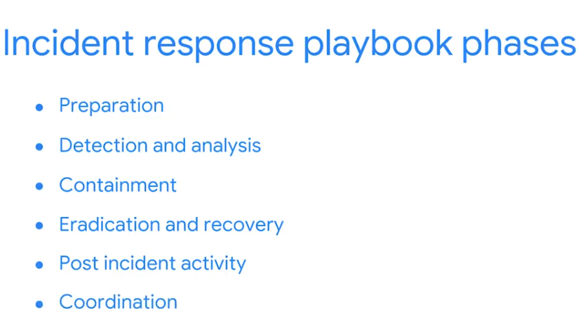

More about playbooks Apr 10, 2026
This reading explains the purpose and types of playbooks used by cybersecurity professionals to identify and respond to security incidents.
Playbook Overview
- A playbook is a manual detailing operational actions, providing a predefined list of steps for incident response.
- Playbooks are "living documents" that are frequently updated due to identified failures, changes in industry standards, or evolving cyber threats.
Types of Playbooks
- Playbooks can cover specific incidents and vulnerabilities like ransomware or business email compromise (BEC).
- Incident and vulnerability response playbooks are common and are developed based on an organization's business continuity plan.
Incident and Vulnerability Response Playbooks
- These playbooks help minimize errors and ensure timely actions, especially for entry-level cybersecurity professionals.
- Common steps include preparation, detection, analysis, containment, eradication, and recovery, along with post-incident activities and coordination.
Zack: Incident response and the value of playbooks Apr 10, 2026
This video provides insights into the role of a Software Engineer on a security team at Google, emphasizing the importance of processes and playbooks in responding to security incidents.
The Role of a Security Software Engineer
- Zack, a Software Engineer at Google, shares his non-traditional path into cybersecurity, highlighting the opportunity for career transitions within the tech industry.
- His work involves using processes and playbooks to manage and respond to security and privacy incidents, active attacks, and vulnerabilities.
The Importance of Playbooks
- Playbooks serve as crucial documentation that guides engineers in resolving security issues, especially for those new to the field.
- They encapsulate decades of experience, enabling individuals to effectively address problems like open attacks, privacy incidents, data leaks, and denial-of-service attacks.
Career Advice for Aspiring Cybersecurity Professionals
- Networking and communicating with people in the industry are vital for understanding job roles, required skills, and available opportunities.
- The reality of a cybersecurity role involves significant communication and collaboration, dispelling the myth of solitary coding.
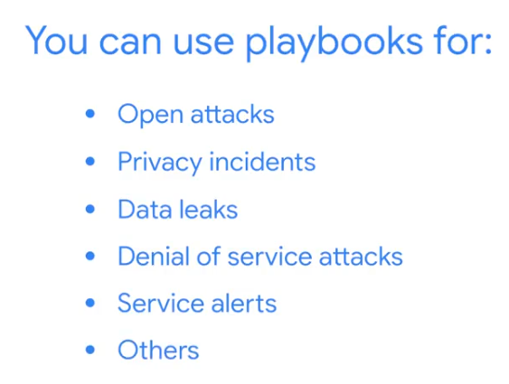

Welcome to the final module of Course 2! You are moving from monitoring and detection (SIEM) into Incident Response. If the SIEM is the alarm system, the Playbook is the step-by-step manual that tells the fire department exactly what to do when that alarm goes off.
Here are the correct answers and the professional logic for the Test your knowledge: Incident response practice assignment:

1. When to Use a Playbook
- Answer: Throughout the entire incident
- Logic: A playbook is a comprehensive guide. It doesn't just tell you how to identify an attack; it provides instructions for every stage, from the moment a suspicious alert appears until the final "lessons learned" meeting is held. Using it consistently ensures the response is organized and that no critical steps are missed.

2. Evaluating the Situation
- Answer: detection and analysis
- Logic: This is the phase where you play detective. Once an alert is triggered, the detection and analysis phase involves investigating the logs, verifying that the incident is real (and not a false positive), and determining exactly how much of the network has been affected.

3. Learning and Improving
- Answer: Post-incident activity
- Logic: The "Post-mortem" or Post-incident activity phase is vital for growth. Here, the team documents what happened, how the response was handled, and what can be done to prevent it from happening again. This documentation is what makes the organization more resilient against future attacks.

4. SIEM and Playbook Integration
- Answer: They work together to provide a structured and efficient way of responding to security incidents.
- Logic: These two tools have a symbiotic relationship. The SIEM provides the "Detection" (the data and the alert), and the Playbook provides the "Action Plan" (the steps to follow). Together, they allow a security team to respond quickly and consistently, which is essential for minimizing damage.

Technical Context for your Career:
As you advance in your cloud engineering studies, you'll see this concept evolve into Automated Playbooks. For example, in AWS or Google Cloud, you can write a script (using Lambda or Cloud Functions) that automatically follows "Playbook" steps—like isolating a compromised VM—the millisecond a SIEM alert is generated.
Would you like to see a simplified example of an Incident Response Playbook for a "Brute Force Login" attempt on a server?
Use a playbook to respond to threats, risks, or vulnerabilities Apr 10, 2026
This video explains how Security Information and Event Management (SIEM) tools and playbooks are used together to reduce organizational threats, risks, and vulnerabilities.
Understanding Incident Response Playbooks
- Playbooks are guides that help security professionals quickly and accurately mitigate issues, ensuring structure, compliance, and clear communication.
- Organizations use different playbooks for various attack types, such as ransomware, malware, or Distributed Denial of Service (DDoS).
Using a Playbook for SIEM Alerts
- When a SIEM alert, like a potential malware attack, occurs, a playbook guides the analyst through necessary actions.
- The first step involves assessing the alert's validity by analyzing log data and metrics to understand why the SIEM generated it.
Incident Containment and Resolution
- Playbooks outline actions and tools to contain malware and prevent further damage, such as isolating infected network systems.
- After containment, the playbook details steps to eliminate all traces of the incident and restore affected systems using clean backups.
Lab Review: Exploring IAM Apr 10, 2026
This lecture walkthrough focuses on managing Cloud Identity and Access Management (IAM) roles and permissions in Google Cloud Platform (GCP) through a hands-on lab.
Lab Setup and User Access
- Two users (username 1 and username 2) are set up to demonstrate granting and revoking IAM roles.
- Username 1 has multiple roles including admin and owner, while username 2 initially has only Viewer access.
Creating and Managing Storage Resources
- Username 1 creates a unique Cloud Storage bucket and uploads a sample file named "sample.txt."
- Username 2 verifies it can view the bucket and file due to inherited Viewer access.
Modifying IAM Roles and Permissions
- Username 1 removes the project viewer role from username 2, revoking its access to the bucket.
- Username 1 then grants username 2 the Storage Object Viewer role to restore limited access to the bucket.
- Verification is done using both the GCP Console and Cloud Shell commands.
Service Account Role Management and VM Creation
- A service account named "read-bucket-objects" is created and assigned the Storage Object Viewer role.
- The service account user role is granted to a domain for demonstration.
- Compute Engine permissions are assigned to the service account, and a VM instance is created using this service account.
- Testing shows the service account can read from the bucket but cannot perform other project-wide actions like listing instances.
Overall, the lab demonstrates practical steps to grant, revoke, and verify IAM roles for users and service accounts, emphasizing role-based access control in GCP.
Erin: The importance of diversity of perspective on a security team Apr 13, 2026
This video emphasizes the importance of incorporating diverse perspectives and soft skills in technology development, particularly in privacy engineering.

The Role of a Privacy Engineer
- A privacy engineer's main responsibility is to ensure privacy is integrated into new technologies from the outset, building user trust.
- This involves anticipating user needs and protecting their data before they even interact with a product.

Importance of Soft Skills and Diverse Perspectives
- Soft skills, such as the ability to relate to people, are considered more crucial than technical skills because they are harder to teach.
- Diversity of thought and perspective among team members leads to more equitable and robust product development, as different experiences offer varied insights.

Your Unique Voice in Technology
- Every individual's unique experiences contribute valuable perspectives that are essential for creating better products for a wide range of users.
- The speaker encourages individuals from all backgrounds to engage in STEM fields, highlighting that diverse voices are needed across all areas of technology, including product security and privacy.
Playbooks, SIEM tools, and SOAR tools Apr 13, 2026
This reading explains how playbooks are used by security teams to address security-related issues and respond to incidents.
Playbooks and SIEM Tools
- Playbooks provide a consistent list of actions for security teams to follow during an incident, ensuring a standardized response.
- They are used with Security Information and Event Management (SIEM) tools to guide analysts on how to address issues flagged by SIEM, such as unusual user behavior.
Playbooks and SOAR Tools
- Playbooks are also used with Security Orchestration, Automation, and Response (SOAR) tools, which automate repetitive tasks.
- If a SOAR tool automatically blocks an account due to suspicious activity, playbooks provide analysts with steps to resolve the issue.
Key Takeaways
- Playbooks, also known as runbooks, detail who needs to do what and when in the event of a security incident.
- Following playbooks helps reduce the impact of incidents and minimizes damage to an organization's critical assets.
It looks like you are wrapping up Course 2 of your cybersecurity certification! These practice questions are a great way to solidify your understanding of incident response before the graded module challenge.
Here is a breakdown of the concepts behind those questions to help you prepare:

1. Playbook Flexibility
Question: Playbooks are permanent, best-practice documents, so a security team should not make changes to them.
- Answer: False
- Reasoning: Security playbooks are living documents. Threat landscapes change, and new vulnerabilities emerge constantly. A security team must update playbooks based on "Lessons Learned" from previous incidents to ensure they remain effective and relevant.

2. The Recovery Phase
Question: A business recently experienced a security breach. Security professionals are currently restoring the affected data using a clean backup. What playbook phase does this describe?
- Answer: Eradication and recovery
- Reasoning: Once the threat is contained, the goal is to remove the traces of the attack (eradication) and bring systems back to a normal, functional state (recovery). Restoring from a clean backup is a classic recovery action.

3. Post-Incident Collaboration
Question: Once a security incident is resolved, security analysts perform various post-incident activities and _____ efforts with the security team.
- Answer: coordination
- Reasoning: Post-incident activity is heavily focused on communication and documentation. The team must coordinate to discuss what went wrong, how the response went, and what steps are needed to prevent a recurrence.

4. SIEM Alert Assessment
Question: Which action can a security analyst take when they are assessing a SIEM alert?
- Answer: Analyze log data and related metrics
- Reasoning: When a SIEM (Security Information and Event Management) tool triggers an alert, the analyst’s first job is analysis. You look at the logs and metrics to determine if the alert is a "True Positive" (a real threat) or a "False Positive" (a mistake). The other options (isolating or restoring) are actions taken after the analysis confirms there is an actual incident.

Quick Summary Table: NIST Incident Response Phases
Phase | Key Actions
Preparation | Training, creating playbooks, and setting up tools.
Detection & Analysis | Monitoring alerts (SIEM) and verifying the threat.
Containment | Isolating systems to stop the threat from spreading.
Eradication & Recovery | Removing the threat and restoring data from backups.
Post-Incident Activity | Documenting lessons learned and improving the playbook.
Are there any specific phases of the incident response lifecycle you'd like to dive deeper into before you take the final module challenge?

Wrap-up Apr 13, 2026
This section reviewed the purpose and phases of incident response playbooks, highlighting their importance for security analysts.
Purpose of Playbooks
- Playbooks provide a structured and consistent approach to handling security incidents.
- They help security analysts respond to incidents quickly and effectively.
Six Phases of an Incident Response Playbook
- Playbooks guide security professionals in making informed decisions during a security incident.
- Following playbook steps and communicating with the team minimizes impact and damage to an organization.

Phase | Purpose | Example Task
Preparation | Get ready | Staffing plans, training, writing the playbook.
Detection & Analysis | Find the threat | Investigating a SIEM alert for a virus.
Containment | Stop the spread | Unplugging a compromised server from the network.
Eradication & Recovery | Fix the system | Deleting malware and restoring data from backups.
Post-Incident Activity | Learn and grow | Holding a meeting to discuss how to improve.

Reflect and connect with peers Apr 13, 2026
This reading celebrates your completion of the "Play It Safe: Manage Security Risks" course and encourages you to further your learning and career by joining the Google Cybersecurity Community.

Course Completion and Key Learnings
- You have successfully completed the "Play It Safe: Manage Security Risks" course, gaining knowledge in security risks, security domains, and the use of security tools for threat identification and response.
- The course equipped you with essential skills to manage security risks effectively.

Benefits of Joining the Google Cybersecurity Community
- Discuss Course Content: Engage with peers to get answers, share insights, and deepen your understanding of the course material.
- Expand Your Network: Connect with fellow learners globally, build professional relationships, and grow your network within the cybersecurity field.

Career Advancement and Support
- Unlock Career Opportunities: Explore various career paths, discover job leads, and receive valuable advice from experienced professionals and peers.
- Continuous Support: The community offers ongoing support throughout your learning journey, and participation is optional and free of charge.
Course wrap-up Apr 13, 2026
This course recap summarizes the key topics covered, focusing on security domains, frameworks, tools, and incident response.
Security Foundations
- The course reviewed CISSP's eight security domains, emphasizing threats, risks, and vulnerabilities to business operations.
- It explored security frameworks and controls, including the CIA triad and NIST frameworks, as starting points for security policies and processes.
Security Tools and Practices
- The course discussed the relationship between frameworks, controls, principles, and security audits.
- It covered basic security tools like SIEM dashboards and their use in protecting business operations.
Protecting Assets and Data
- The course highlighted the use of playbooks for protecting assets and data.
- Understanding and utilizing available tools is crucial for security analysts to elevate their knowledge and accomplish daily tasks.
Introduction to Course 3 Apr 13, 2026
This video introduces the course "Connect and Protect: Networks and Network Security," focusing on the importance of securing networks due to increasing attacks.
Course Overview
- The course will cover the basic structure of networks (network architecture) and commonly used network tools.
- You will learn about network operations and explore fundamental network protocols.
Understanding Network Threats
- The course will address common network attacks and how intrusion tactics can pose a threat.
- You will learn about security hardening practices to help secure a network.
Instructor's Background
- The instructor, Chris, is the Chief Information Security Officer for Google Fiber.
- Chris has over 20 years of experience in network security and engineering.
Course 3 overview Apr 13, 2026
This course, "Connect and Protect: Networks and Network Security," is the third in the Google Cybersecurity Certificate program and focuses on understanding and securing computer networks.
Course Focus
- You will learn about network architecture, operations, common vulnerabilities, and attack types.
- The course covers network protocols, firewalls, Virtual Private Networks (VPNs), and system hardening.
Google Cybersecurity Certificate Program
- This is the third of eight courses in the certificate program.
- Previous courses covered cybersecurity foundations and managing security risks.
Course Modules
- Module 1: Network architecture introduces network security and how it relates to threats and vulnerabilities.
- Module 2: Network operations explores network protocols and security measures like firewalls.
- Module 3: Secure against network intrusions focuses on understanding and defending against network attacks.
- Module 4: Security hardening teaches practices to strengthen network systems and address cloud infrastructure challenges.
Chris: My path to cybersecurity Apr 13, 2026
This video features Chris, the Chief Information Security Officer at Google Fiber, who shares his career journey and insights into the cybersecurity field.
Chris's Career Path
- Chris started his career in unexpected roles, including working as a butcher and in a college computer center, before becoming a software developer.
- He transitioned into cybersecurity out of necessity to defend the systems he was building, discovering a passion and career opportunity in the process.
Key Aspects of Cybersecurity
- Cybersecurity is a constantly evolving field that requires continuous learning and curiosity.
- Building connections and networking with other professionals in the industry is crucial for career advancement and discovering new opportunities.
Getting into Cybersecurity
- While the field can seem daunting due to its breadth, a fundamental understanding of skills and background can open many different directions.
- Active involvement in professional organizations, trade associations, and meetups can help build reputation and relationships.
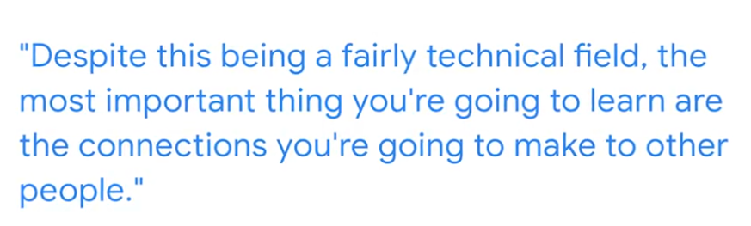


What are networks? Apr 13, 2026
This video explains the fundamental concepts of computer networks, including their definition, how devices communicate, and different types of networks.
Understanding Computer Networks
- A network is a collection of connected devices that can communicate with each other.
- Devices use unique addresses, such as IP and MAC addresses, to locate and communicate with other devices on the network.
Types of Networks
- Local Area Network (LAN): Spans a small geographical area like a home, office, or school, allowing devices within that area to connect and share resources.
- Wide Area Network (WAN): Covers a large geographical area, such as a city, state, or country, with the internet being a prime example of a vast WAN.

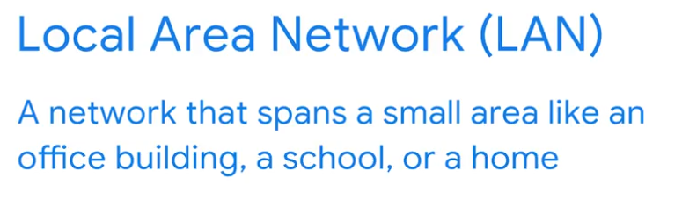
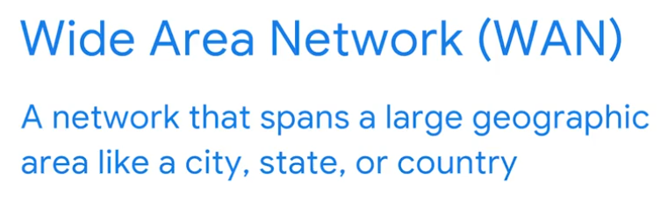

Tina: Working in network security Apr 13, 2026
This video features Tina, a software engineer at Google, who discusses her role in network security and offers advice for aspiring cybersecurity professionals.
The Role of a Software Engineer in Network Security
- Tina works on an internal tool at Google that supports security and network engineers, focusing on ensuring network systems are secure and resilient against malicious attacks and protecting user data.
- Her daily tasks involve a lot of coding, design, and collaborating with security and network teams to address their priorities and blockers, often developing solutions for specific platform or feature requirements.
Importance of Network Security
- Network security is crucial for safeguarding network systems and user data from malicious hackers.
- Working in network security provides a comprehensive view of an entire company's network infrastructure.
Advice for Aspiring Cybersecurity Professionals
- Tina emphasizes the importance of continuous learning and curiosity in the ever-evolving field of cybersecurity.
- Cybersecurity is a collaborative effort, where teamwork and brainstorming are essential for tackling complex problems and finding diverse solutions.
Emmanuel: Useful skills for network security Apr 13, 2026
This video provides an overview of the role of an offensive security engineer at Google and introduces key technical skills for an entry-level cybersecurity analyst.
The Role of an Offensive Security Engineer
- Emmanuel, an offensive security engineer at Google, simulates adversaries and threats to identify vulnerabilities in Google's infrastructure.
- His work involves programming and understanding operational and platform security to make it harder to hack Google.
Essential Skills for Entry-Level Cybersecurity Analysts
- Command Line: Used to interact with various levels of an operating system, from low-level components like memory and the kernel to high-level applications.
- Log Parsing: Helps in debugging programs and applications by analyzing logs to find and resolve root issues.
- Network Traffic Analysis: Involves examining network traffic across different layers to identify vulnerabilities, secure data, and ensure network functionality.
Importance of Effective Communication
- A crucial skill for security professionals is effectively communicating identified issues to product teams and engineers.
- This ensures that vulnerabilities are not only found but also promptly fixed, aligning technical findings with business objectives.
Network tools Apr 13, 2026
This video explains the common devices that form the backbone of a network, detailing their functions and how they facilitate data transfer.
Network Devices and Their Functions
- Hubs: These devices broadcast information to every connected device on a network, similar to a radio tower.
- Switches: More intelligent than hubs, switches create specific connections between devices and only send data to the intended destination, improving security and network performance.
Connecting Networks and the Internet
- Routers: Routers connect multiple networks, directing information between them based on destination addresses.
- Modems: Modems connect your router to the internet, enabling internet access for your local area network (LAN).
Virtualization in Networking
- Virtualization Tools: These are software programs that perform the functions of physical network devices like hubs, switches, routers, and modems.
- Benefits of Virtualization: Virtualization tools, often offered by cloud service providers, provide cost savings and scalability in network operations.
Network components, devices, and diagrams Apr 13, 2026
This reading provides an overview of network devices and connections, essential for understanding network architecture and security vulnerabilities.
Network Devices and Their Functions
- Network devices like routers and switches manage data flow, while end-user devices such as computers and phones connect to the network through them.
- Firewalls act as a primary security measure, monitoring and restricting network traffic between internal and external networks.
Key Network Components
- Servers provide information and services to client devices, operating on a client-server model where clients request and servers fulfill.
- Hubs and Switches direct traffic on a local network; switches are preferred over hubs due to their improved performance and security in forwarding data packets to specific destinations.
Connecting to the Internet and Network Visualization
- Modems connect local networks to Internet Service Providers (ISPs), translating digital signals for internet transmission.
- Network diagrams are visual maps used by security analysts to understand network architecture, identify devices, and plan security strategies.
Cloud networks Apr 13, 2026
This video explains how cloud computing is changing the way companies manage their networks, offering benefits over traditional on-premise solutions.
Cloud Computing vs. Traditional Networks
- Cloud computing utilizes remote servers and applications hosted on the internet, reducing the need for local physical devices.
- Traditional networks host web servers directly at a business's physical location, requiring companies to own and maintain their network devices.
Benefits of Cloud Networks
- Cloud networks help companies save money and access more network resources by using third-party providers.
- They offer on-demand storage and processing power, allowing organizations to pay only for what they use.
Cloud Security
- Cloud security is becoming increasingly important as more organizations migrate their services to the cloud.
- Security professionals need to focus on verifying both the origin of network traffic and the identity associated with it.
Cloud computing and software-defined networks Apr 13, 2026
This section explores cloud computing and networking, including hybrid networks and software-defined networks, and their benefits.
Cloud Computing Fundamentals
- Cloud computing utilizes remote servers and applications hosted on the internet by Cloud Service Providers (CSPs) instead of on-premise company infrastructure.
- CSPs offer services like Software as a Service (SaaS), Infrastructure as a Service (IaaS), and Platform as a Service (PaaS) from large data centers.
Hybrid and Software-Defined Networks
- Hybrid cloud environments combine CSP services with an organization's on-premise resources, while multi-cloud environments use multiple CSPs.
- Software-Defined Networks (SDNs) use virtual network devices and services, often hosted by CSPs, allowing for programmatic network configurations.
Benefits of Cloud Computing and SDNs
- Cloud computing offers increased reliability through consistent access to resources and secure connections.
- It provides cost savings by reducing the need for companies to purchase and maintain their own network infrastructure.
- Cloud computing enhances scalability, allowing organizations to easily adjust their resource consumption based on changing business needs.
Congrats on starting Course 3! Moving from incident response into the "plumbing" of the internet is a big step. Understanding how data actually moves across wires and through the air is what makes security possible.
Here is a breakdown of the core networking concepts for these practice questions:

1. LAN vs. WAN (Scope of Networks)
Question: To connect an entire city, the most effective network type would be a local area network (LAN).
- Answer: False
- Reasoning: A LAN is for a small area, like a home, office, or single building. To connect an entire city, you would need a Metropolitan Area Network (MAN) or a Wide Area Network (WAN).

2. Network Devices: The Hub
Question: A security professional wants to ensure information is being broadcast to every computer on their organization’s network. What device should they investigate?
- Answer: Hub
- Reasoning: A Hub is a "dumb" device. When it receives a packet of data, it doesn't know where it’s supposed to go, so it sends (broadcasts) that data to every single port. This is generally inefficient and less secure than using a switch.

3. The Intelligence of Switches
Question: What are some benefits of switches?
- They can improve network performance. (Correct: Because they reduce unnecessary traffic).
- They only pass data to the intended destination. (Correct: They use MAC addresses to send data to the right "door").
- They control the flow of traffic. (Correct: They manage the connections between devices).
- Note: Switches are hardware for traffic; they do not install software like antivirus.
- 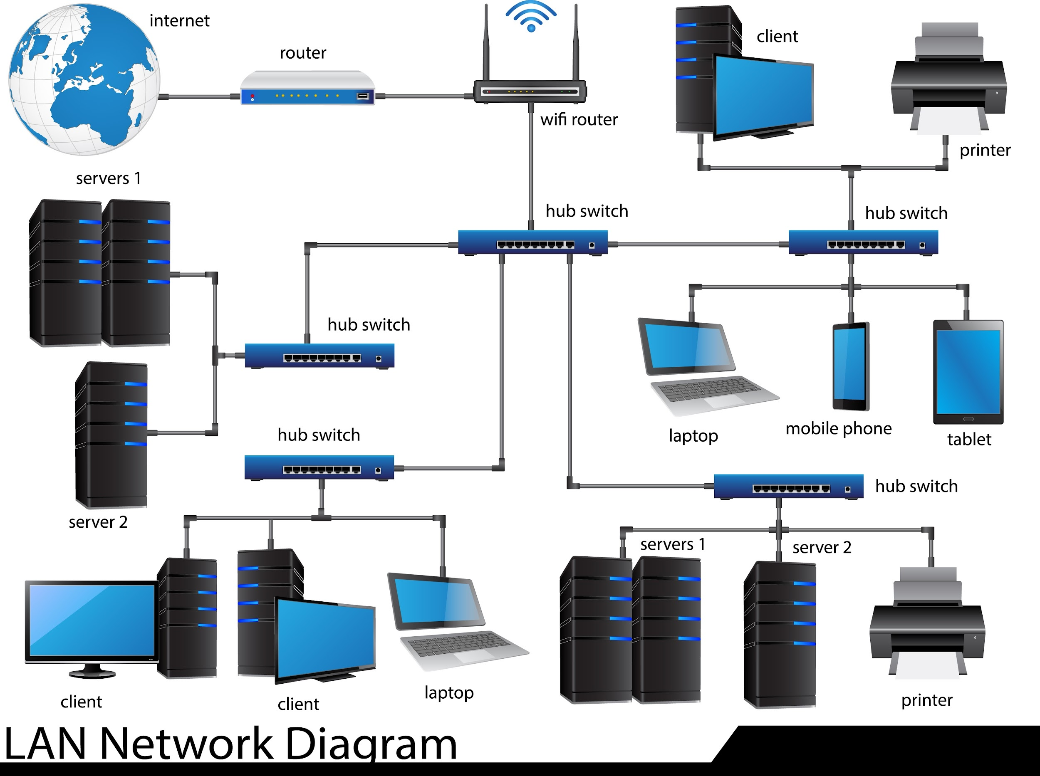
- Shutterstock

4. Modern Infrastructure: Cloud Computing
Question: The practice of using servers, applications, and network services that are hosted on the internet is called _____ computing.
- Answer: cloud
- Reasoning: Cloud computing allows organizations to rent computing power and storage over the internet rather than maintaining all their own physical servers on-site.

Quick Comparison: Network Hardware
Device | Intelligence Level | Primary Function
Hub | Low | Connects devices; broadcasts data to everyone.
Switch | Medium | Connects devices; sends data only to the intended device.
Router | High | Connects different networks together (e.g., your home to the ISP).
Modem | Specialized | Converts signals from your ISP into a format your router understands.
As you move into the next sections, you'll start looking at the TCP/IP and OSI models—these are the "languages" these devices use to talk to each other. Do you have any questions about how these physical devices differ before you dive into the communication models?
Introduction to network communication Apr 13, 2026
This video explains how networks facilitate communication and how data packets are fundamental to this process, while also highlighting the security risks involved.

Data Packet Fundamentals
- Data packets are the basic units of information transferred across a network, containing destination and source addresses, and the message content.
- Similar to a physical letter, a data packet has a header (IP and MAC addresses, protocol number), a body (the message), and a footer (signals the end of the packet).

Network Performance and Security
- Network performance is measured by bandwidth (amount of data received per second) and speed (rate of data packet reception).
- Irregularities in bandwidth or speed can indicate a network attack, making these metrics crucial for security personnel.

Network Communication and Threats
- Networks enable organizations to share resources and data efficiently, but this communication also creates opportunities for attacks.
- Packet sniffing, the act of capturing and inspecting data packets, is a method malicious actors can use to exploit vulnerabilities.
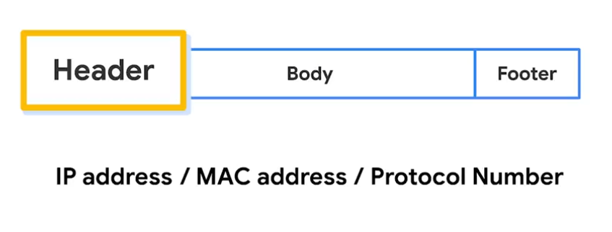
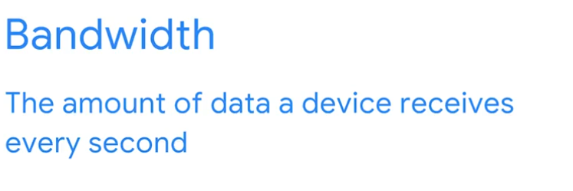
The TCP/IP model Apr 13, 2026
This video explains the TCP/IP model, a standard for network communication, by detailing the functions of TCP and IP, and how ports facilitate data transfer.
TCP (Transmission Control Protocol)
- Establishes connections and organizes data for streaming across a network.
- Ensures data packets reach their correct destination.
IP (Internet Protocol)
- Provides standards for routing and addressing data packets between devices.
- Includes the IP address, which acts as a unique identifier for each private network.
Ports and Data Transfer
- Ports are software-based locations within a network device that organize data sending and receiving.
- They divide network traffic into segments based on the service required, using port numbers to prioritize and process data.
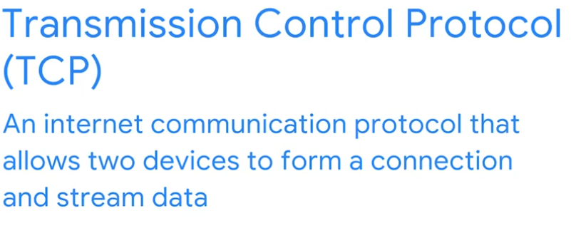
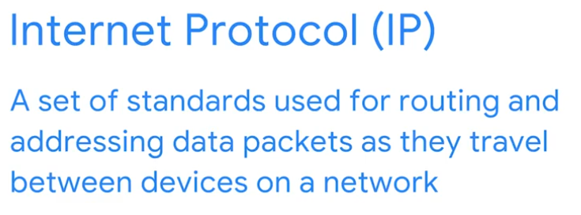
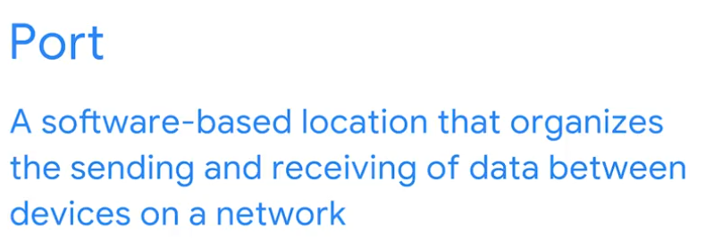
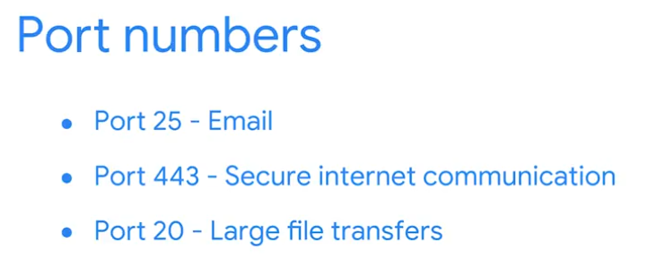

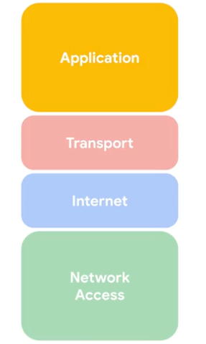

Learn more about the TCP/IP model Apr 13, 2026
This reading provides an overview of the TCP/IP model, its layers, and common protocols used within each layer, highlighting its importance for security professionals.
TCP/IP Model Overview
- The TCP/IP model is a framework for visualizing how data is organized and transmitted across a network, helping professionals understand network processes and identify disruptions or security threats.
- It consists of four layers: network access, internet, transport, and application.
Layers of the TCP/IP Model
- Network Access Layer: This layer handles the creation and transmission of data packets across a network, involving physical hardware like hubs, modems, and cables, and protocols such as ARP for mapping IP addresses to MAC addresses.
- Internet Layer: Responsible for delivering data to the destination host, potentially on a different network, by attaching IP addresses to data packets and determining the appropriate protocol for delivery. Common protocols include IP for sending packets and ICMP for sharing error information.
- Transport Layer: This layer manages data delivery between systems or networks and controls traffic flow. Key protocols are TCP, which ensures reliable data transmission, and UDP, a connectionless protocol used for performance-sensitive applications like video streaming.
- Application Layer: Similar to the application, presentation, and session layers of the OSI model, this layer handles network requests and responses, defining accessible internet services and applications. Protocols like HTTP, SMTP, SSH, FTP, and DNS operate at this layer.
TCP/IP Model versus OSI Model
- Both the TCP/IP and OSI models are conceptual frameworks that help network professionals visualize network processes and protocols for data transmission.
- The TCP/IP model is a simplified version of the OSI model, combining multiple layers into its four-layer structure, while the OSI model has seven layers.
The OSI model Apr 13, 2026
This reading provides an in-depth look into the OSI model, comparing it to the TCP/IP model and detailing the functions of each of its seven layers.

TCP/IP Model vs. OSI Model
- Both models are conceptual frameworks for understanding how data is organized and transmitted across a network, used by network engineers and security analysts to identify disruptions or threats.
- The TCP/IP model has four layers (network access, internet, transport, and application), while the OSI model is a more detailed, standardized concept with seven layers.

The Seven Layers of the OSI Model
- Application Layer (Layer 7): This layer directly involves the end-user and includes protocols that software applications use to connect to the internet, such as HTTP/HTTPS for web browsing, SMTP for email, and DNS for translating domain names to IP addresses.
- Presentation Layer (Layer 6): Functions at this layer involve data translation, encryption (like SSL for HTTPS), and compression to ensure data can be understood by applications on both sending and receiving systems.
- Session Layer (Layer 5): This layer establishes, maintains, and terminates connections (sessions) between two devices, handling authentication, reconnection, and setting checkpoints for data transfer.
- Transport Layer (Layer 4): Responsible for delivering data between devices, managing data transfer speed, flow, and segmenting large data transmissions into smaller pieces for easier transport, using protocols like TCP and UDP.
- Network Layer (Layer 3): Oversees the delivery of data packets between different networks, using IP addresses to route them to their intended destination.
- Data Link Layer (Layer 2): Organizes the sending and receiving of data packets within a single network, involving devices like switches and network interface cards, and protocols such as NCP, HDLC, and SDLC.
- Physical Layer (Layer 1): This layer corresponds to the physical hardware involved in network transmission, including hubs, modems, cables, and the translation of data packets into a stream of 0s and 1s for physical transmission.
Since you've moved on to Network Communication, you're now looking at how data is actually packaged and shipped across those networks you studied earlier. This section is all about the "rules of the road."
Here is a breakdown of the concepts for your practice assignment:

1. Anatomy of an IP Packet
Question: What type of information is contained within the header of an IP packet?
- Answer: The sender’s IP address, the destination's MAC address, and the protocol to use
- Reasoning: Think of the header like the envelope of a letter. It doesn't contain the "message" (the payload); it contains the routing info. It tells the network where the packet came from, where it is going, and what "language" (protocol) is inside.

2. Comparing TCP/IP and OSI Models
Question: What characteristics do the TCP/IP and OSI models share?
- Both models define standards for networking and divide the network communication process into different layers. (Correct: This is the core purpose of both).
- Both models include an application and a transport layer. (Correct: These two layers exist in both, though they handle things slightly differently).
- Both models illustrate network processes and protocols for data transmission between two or more systems. (Correct: They are both conceptual maps for how data moves).
- Note: They do NOT both have 7 layers. OSI has 7, while TCP/IP typically has 4.

3. Understanding TCP
Question: What is the Transmission Control Protocol (TCP)?
- Answer: An internet communication convention
- Reasoning: TCP is a protocol, which is just a fancy word for a "convention" or a set of rules. It ensures that data is delivered reliably and in the correct order. It’s the "certified mail" of the internet.

4. Ports: The Digital Doorways
Question: A _____ is a software-based location that organizes the sending and receiving of data between devices on a network.
- Answer: port
- Reasoning: While an IP address gets data to the right house (the computer), a port gets it to the right room (the specific application, like a web browser or email client).

5. The Application Layer
Question: Which layer of the TCP/IP model has protocols that organize file transfers and email services?
- Answer: Application layer
- Reasoning: This is the layer closest to the user. Protocols like HTTPS (web), FTP (files), and SMTP (email) all live here. It’s where the data is formatted into something a human can actually use.

Quick Layer Logic (TCP/IP)
Layer | Analogy | Key Protocols
Application | The actual letter content | HTTP, FTP, SMTP
Transport | The delivery service (FedEx vs. USPS) | TCP, UDP
Internet | The address on the envelope | IP, ICMP
Network Access | The actual truck/road | Ethernet, Wi-Fi
Do these layers make sense in the context of the Agentic AI or the document automation projects you've been working on? Seeing how the data moves from a script (Application) down to the network might help bridge the gap!
IP addresses and network communication Apr 14, 2026
This video explains how IP addresses and MAC addresses are used for communication over a network.
IP Addresses
- An IP address is a unique string of characters that identifies a device's location on the internet, similar to a mailing address for a house.
- There are two types: IPv4, which consists of four sets of 1-3 digit numbers separated by decimals, and IPv6, which uses 32 characters to accommodate more devices.
Public vs. Private IP Addresses
- Public IP addresses are assigned by your internet service provider and are connected to your geographic location, with all devices on a network sharing the same public-facing address.
- Private IP addresses are used for communication between devices on the same local network and are not visible to the rest of the internet.
MAC Addresses
- A MAC address is a unique alphanumeric identifier assigned to each physical device on a network.
- Switches use MAC address tables, like an address book, to direct data packets to the correct device on a network.
Components of network layer communication Apr 14, 2026
This reading focuses on the network layer (Layer 3) of the OSI model, detailing how data packets are addressed and delivered across networks, and differentiating between IPv4 and IPv6.

Network Layer Operations
- The network layer organizes the addressing and delivery of data packets from the source to the destination device, directing them across routers.
- Each data packet contains a destination IP address in its header, which is used for routing and stored in routing tables.

IPv4 Packet Format
- An IPv4 packet consists of a header (20 to 60 bytes) and a data section, with the header containing crucial routing information like source and destination IP addresses, packet size, and protocol.
- Key fields in the IPv4 header include Version, Header Length, Type of Service, Total Length, Identification, Flags, Fragmentation Offset, Time to Live (TTL), Protocol, Header Checksum, Source IP Address, Destination IP Address, and Options.

IPv4 vs. IPv6
- IPv6 was developed to address IPv4 address exhaustion, offering a significantly larger address space (340 undecillion vs. 4.3 billion possible addresses).
- IPv6 addresses are 16 bytes long and use eight hexadecimal numbers, while IPv4 addresses are 4 bytes long and use four decimal numbers; IPv6 also has a simpler header format and offers improved security and routing efficiency.
Nice work moving through Course 3! You are now looking at the specifics of how devices are addressed and located, both within a small office and across the entire globe.
Here is a breakdown of the concepts for your Local and Wide Network Communication practice:

1. The Function of an IP Address
Question: An IP address is a unique string of characters that identifies the _____ of a device on the internet.
- Answer: location
- Reasoning: In the networking world, an IP address acts like a physical home address. It tells the rest of the internet where to send data so it reaches your specific connection.

2. IPv4 vs. IPv6 and MAC Addresses
Question: Which of the following is an example of an IPv4 address?
- Answer: 172.16.254.1
- Reasoning: IPv4 addresses are made of four sets of numbers (octets) separated by dots.
  - The version with colons and letters (2001:0db...) is IPv6.
  - The version with dashes (00-B1-D0...) is a MAC Address.

3. Public vs. Private IP Addresses
Question: What type of address is assigned by an internet service provider (ISP) and connected to a geographic location?
- Answer: Public IP address
- Reasoning: Your Private IP is used inside your house or office (assigned by your router). Your Public IP is what the outside world sees; it is assigned by your ISP and is how websites know which general region you are connecting from.

4. How Switches Move Data
Question: A switch uses a MAC _____ to direct data packets to the correct device.
- Answer: address table
- Reasoning: A switch is "smarter" than a hub because it keeps a "map" in its memory. This map, called a MAC address table, matches a device's physical hardware address (MAC) to the specific port it's plugged into.

Key Concepts to Remember
Term | Analogy | Scope
MAC Address | Your Social Security Number | Permanent; assigned to the hardware.
Private IP | Your room number in a hotel | Local; used only inside your network.
Public IP | The hotel's street address | Global; used to find you on the internet.
Subnet Mask | Identifying which part of the address is the "neighborhood" | Helps the network split into smaller parts.
Since you've been working with Agentic AI and Cloud Infrastructure, understanding these addresses is vital—especially when you have to configure "Allow lists" in a firewall or set up a Cloud SQL instance that only accepts connections from a specific Public IP.
Are these distinctions between Public and Private IPs clear, or would you like to look at how NAT (Network Address Translation) connects them?
This is the final milestone for Module 1 of Course 3! You’ve already shown a strong grasp of these concepts in your practice sets, and this challenge is designed to bring it all together—from the physical hardware like hubs and switches to the logical addressing of IPv4 and IPv6.
Here is a breakdown of the core concepts covered in these challenge questions to ensure you're ready for the graded attempt:

1. Network Scope & Hardware
- LAN (Local Area Network): This spans a limited area like a single building or home.
- Hub vs. Switch: A Hub is a "broadcast" device that sends data to everyone. A Switch is "intelligent"—it sends data only to the specific intended device using its MAC address table.
- Cloud Computing: This is the shift from on-premise physical hardware to remote servers hosted on the internet. Businesses love it because it offers on-demand storage and global accessibility.
- 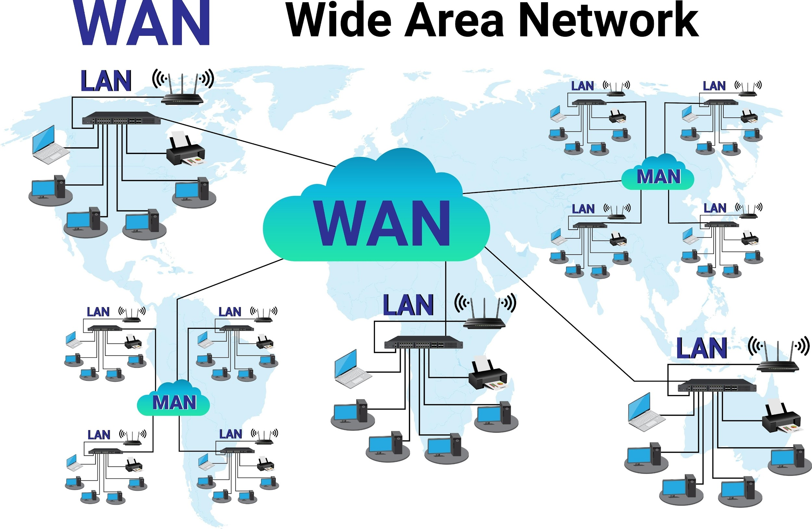
- Shutterstock

2. The Mechanics of a Data Packet
- Protocol Number: Think of this as the "instructions" on an envelope. It tells the receiving device exactly what to do with the data inside (e.g., "this is a web page" or "this is an email").
- Ports: Specific numbers direct traffic to the right application. Port 20 is specifically used for the data transfer part of FTP (File Transfer Protocol).

3. The TCP/IP Layers
- Layer 4 (Application Layer): This is where human-facing services live. It handles the protocols for things you interact with directly, like email (SMTP) and file transfers (FTP).

4. Addressing: IPv4 vs. IPv6
- IPv4: Consists of four numbers (0–255) separated by dots. Example: 192.168.0.2.
- IPv6: Created because we ran out of IPv4 addresses. It uses hexadecimal (numbers and letters) separated by colons. Example: fd45:3efd....

Quick Concept Check
Topic | Key Detail
Switch | Targeted communication (Efficient).
Hub | Broadcast communication (Inefficient).
Port 20 | Large file transfers (FTP).
Application Layer | Handles Email and File services.
IPv6 | Long string with colons and hex characters.
I've put together a quick review quiz to help you verify these details one last time before you click "Submit" on that graded assignment.
Module 1: Network Architecture Review
Apr 14, 8:20 AM
Open
Take a moment to run through these questions. They cover exactly the type of logic you'll need for the challenge. You've been doing great—good luck on your final submission!
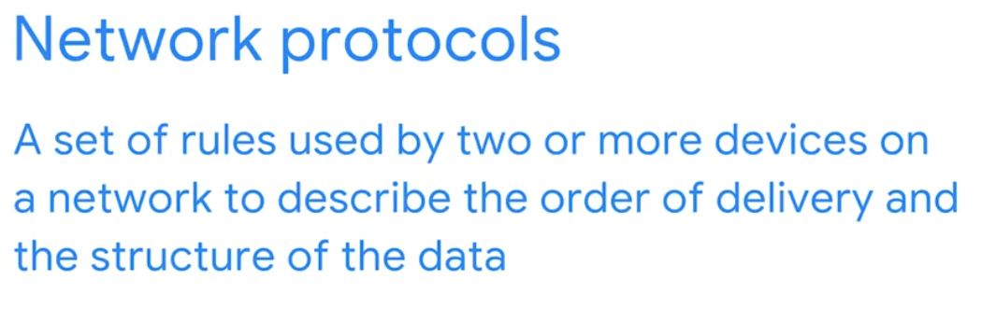
Network protocols Apr 14, 2026
This content explains how network protocols facilitate communication between devices and ensure data security.
Understanding Network Protocols
- Network protocols are sets of rules that govern how devices on a network communicate, ensuring data is delivered correctly and in the right order.
- They define the structure of data and the delivery process, allowing different devices to interact seamlessly.
Key Network Protocols in Action
- TCP (Transmission Control Protocol): Establishes a connection and verifies devices (handshake) before data streaming, ensuring reliable communication.
- ARP (Address Resolution Protocol): Determines the MAC address of the next router or device in the data's path, guiding data to its correct destination.
Secure Communication and Domain Resolution
- HTTPS (Hypertext Transfer Protocol Secure): Provides a secure method for web browsers and servers to communicate, encrypting data using SSL/TLS to protect against malicious actors.
- DNS (Domain Name System): Translates human-readable internet domain names (like "www.yummyrecipesforme.org") into machine-readable IP addresses, enabling devices to locate websites.
Common network protocols Apr 14, 2026
This reading provides an in-depth look at network protocols, their categories, and their role in network security.
Overview of Network Protocols
- Network protocols are sets of rules that govern how devices communicate on a network, acting like a common language for data exchange.
- Security analysts need to understand protocol vulnerabilities, as malicious actors can exploit them (e.g., using DNS to divert traffic to malicious websites).
Categories of Network Protocols
- Network protocols are broadly categorized into communication, management, and security protocols.
- While there are many protocols, this reading focuses on those essential for an entry-level security analyst.
Specific Protocol Examples
- Communication Protocols: TCP (reliable, connection-oriented), UDP (fast, connectionless), HTTP (web communication, insecure), and DNS (translates domain names to IP addresses).
- Management Protocols: SNMP (monitoring and managing network devices) and ICMP (reporting data transmission errors and troubleshooting network connectivity).
- Security Protocols: HTTPS (secure web communication using SSL/TLS encryption) and SFTP (secure file transfer using SSH encryption).
Additional network protocols Apr 14, 2026
This reading introduces several key networking concepts and protocols essential for understanding how data is transmitted and secured across networks.

Network Address Translation (NAT)
- NAT allows devices on a private network to communicate with the public internet using a single public IP address.
- It involves a router or firewall replacing private IP addresses with a public IP for outgoing messages and performing the reverse for responses.

Dynamic Host Configuration Protocol (DHCP)
- DHCP is a management protocol that automatically assigns unique IP addresses to devices on a network.
- It also provides devices with the addresses of the appropriate DNS server and default gateway.

Address Resolution Protocol (ARP)
- ARP translates IP addresses into MAC addresses, which are unique hardware identifiers for network interface cards.
- This protocol is crucial for devices to communicate within the same local network when a MAC address is unknown.

Remote Access Protocols
- Telnet is an application layer protocol for connecting to remote systems, but it sends information in clear text, making it less secure.
- Secure Shell (SSH) provides a secure, encrypted connection to remote systems, offering a safer alternative to Telnet.

Email Protocols
- Post Office Protocol (POP) is used to retrieve emails from a mail server, typically downloading them to a local device.
- Internet Message Access Protocol (IMAP) allows users to access emails from multiple devices by keeping messages on the mail server.
- Simple Mail Transfer Protocol (SMTP) is responsible for sending and routing emails from the sender to the recipient.
Antara: Working in network security Apr 14, 2026
This video provides insights into the role of a network security engineer at Google, highlighting the problem-solving aspects and best practices in the field.
Journey to Network Security
- The speaker, Antara, started her career in electronics and communication, later transitioning to computer security.
- She pursued a master's degree in security to gain expertise, which led her to Google as a security engineer.
A Day in the Life of a Network Security Engineer
- A typical day involves debugging network issues, such as excessive traffic or slow endpoints.
- Problem-solving often includes capturing traffic, recreating issues in a lab environment, and consulting with experts from different domains.
Best Practices and Career Outlook
- It's important to leverage existing, tested protocols and algorithms rather than reinventing solutions.
- Cybersecurity is a growing and exciting field with many new challenges, making it a good career choice in the current information age.
Wireless protocols Apr 14, 2026
This video introduces the IEEE 802.11 protocol, commonly known as Wi-Fi, and its importance in wireless communication and security.
Understanding IEEE 802.11 (Wi-Fi)
- IEEE 802.11 is a set of standards that define communications for wireless Local Area Networks (LANs).
- The Institute of Electrical and Electronics Engineers (IEEE) is the organization responsible for maintaining these Wi-Fi standards.
Evolution of Wi-Fi Security
- Wi-Fi protocols have continuously evolved to enhance security and reliability, aiming to match the security levels of wired connections.
- Wi-Fi Protected Access (WPA) was introduced in 2004 as a security protocol for wireless devices connecting to the internet.
Advanced Wi-Fi Security Protocols
- WPA has advanced through versions like WPA2 and WPA3, incorporating more sophisticated encryption and security improvements.
- As a security analyst, ensuring the security of an organization's wireless connections, utilizing these advanced protocols, is a key responsibility.
The evolution of wireless security protocols Apr 14, 2026
This reading explores the evolution of wireless security protocols, from early, less secure options to the more robust standards used today.
Early Wireless Communication and Wi-Fi
- The internet initially relied on physical cables, with wireless communication expanding after the mid-1980s with designated radio wave frequencies.
- Wi-Fi, a marketing term by the Wi-Fi Alliance, refers to a set of standards (IEEE 802.11) that define communication for wireless Local Area Networks (LANs).
Evolution of Wireless Security Protocols
- Wired Equivalent Privacy (WEP): Developed in 1999, WEP aimed to provide wired-level privacy but is now considered high-risk due to vulnerabilities that allow malicious actors to break its encryption.
- Wi-Fi Protected Access (WPA): Introduced in 2003 as a transitional measure to improve upon WEP, WPA used Temporal Key Integrity Protocol (TKIP) and larger encryption keys, but it still had vulnerabilities like the KRACK attack.
Advanced Wireless Security Protocols
- WPA2: Released in 2004, WPA2 enhanced security by using Advanced Encryption Standard (AES) and Counter Mode Cipher Block Chain Message Authentication Code Protocol (CCMP), making it the current security standard for Wi-Fi transmissions.
- WPA3: Developed in 2018, WPA3 addresses the KRACK attack vulnerability present in WPA2 by using Simultaneous Authentication of Equals (SAE) and offers increased encryption with 128-bit (and optional 192-bit for Enterprise mode) encryption.
Congratulations on clearing the first Module Challenge with a perfect score! You are making excellent progress.
Now that you've moved into Module 2, the focus shifts from "where" the data goes to "how" it behaves. Network protocols are the specific rules that keep the digital world organized and secure.
Here is a breakdown of the concepts for your current practice assignment:

1. The Function of Protocols
Question: Network protocols are rules used by two or more devices on a network to describe the _____ and structure of data.
- Answer: order of delivery
- Reasoning: Without a protocol, a receiving device might get a bunch of data packets but have no idea which one is the start, which is the middle, or if one is missing. Protocols ensure data arrives in the correct sequence and is reconstructed properly.

2. Secure Web Communication
Question: Which network protocol provides a secure method of communication between clients and web servers?
- Answer: HTTPS
- Reasoning: HTTPS (Hypertext Transfer Protocol Secure) is the encrypted version of HTTP. It uses SSL/TLS to ensure that the data moving between your browser and the server (like passwords or credit card numbers) cannot be intercepted by attackers.

3. Encryption Protocols (SSL/TLS)
Question: To keep information safe from malicious actors, what security protocol can be used?
- Answer: Secure sockets layer and transport layer security (SSL/TLS)
- Reasoning: These are the backbone of internet security. They provide encryption, authentication, and data integrity. While SSL is the older version, TLS is the modern, more secure standard used today.

4. Wireless Standards
Question: IEEE 802.11, also known as Wi-Fi, is a set of standards that define communication for wireless LANs.
- Answer: True
- Reasoning: In the world of tech standards, 802.11 is the formal name given by the IEEE (Institute of Electrical and Electronics Engineers) to the technology we commonly call Wi-Fi.

Protocol Cheat Sheet
Protocol | What it does | Real-world example
HTTPS | Secure Web Browsing | Checking your bank balance online.
DNS | Matches names to IP addresses | Typing google.com instead of 8.8.8.8.
ARP | Matches IP addresses to MAC addresses | Helping a switch find the right laptop on a local network.
SSL/TLS | Encrypts data | The "padlock" icon in your browser address bar.
Given your interest in Agentic AI and Cloud Engineering, you'll likely run into these protocols frequently when configuring API endpoints or securing connections between different AI agents.
Would you like to look at how DNS acts as the "phonebook" of the internet before you move to the next section?
Firewalls and network security measures Apr 14, 2026
This video explains different types of firewalls, how they operate, and their role in network security.
Firewall Fundamentals
- A firewall is a network security device that monitors and controls incoming and outgoing network traffic based on predefined security rules.
- It can use port filtering to allow or block specific port numbers, limiting unwanted communication according to an organization's security policy.
Types of Firewalls
- Hardware Firewalls: These are physical devices that inspect each data packet before it enters the network, offering a basic defense against threats.
- Software Firewalls: These are programs installed on a computer or server that perform the same functions as hardware firewalls but are more cost-effective and don't require extra space.
- Cloud-based Firewalls (FaaS): Offered by cloud service providers, these software firewalls protect an organization's onsite network and cloud assets by filtering incoming traffic.
Stateful vs. Stateless Firewalls
- Stateful Firewalls: These firewalls track information passing through them and proactively filter out suspicious threats by analyzing network traffic characteristics and behavior.
- Stateless Firewalls: These firewalls operate based on predefined rules and do not retain information from data packets, making them less secure as they don't discover suspicious trends.
Next-Generation Firewalls (NGFW)
- NGFWs offer enhanced security beyond stateful firewalls by providing in-depth security functions like deep packet inspection and intrusion protection.
- Some NGFWs connect to cloud-based threat intelligence services to quickly update defenses against emerging cyber threats.
Security zones Apr 14, 2026
This section discusses security zones as a network security feature that protects internal networks from external threats.

Network Segmentation and Security Zones
- Security zones are segments of a network that divide it into parts, each with its own access permissions and security rules.
- They act as a barrier to internal networks, maintain privacy, and prevent issues from spreading across the entire network.

Types of Security Zones
- Uncontrolled Zone: This refers to any network outside an organization's control, such as the internet.
- Controlled Zone: This is a subnet that protects the internal network from the uncontrolled zone and contains several types of networks.

Networks within the Controlled Zone
- Demilitarized Zone (DMZ): This outer layer contains public-facing services like web servers, proxy servers, and DNS servers that access the internet.
- Internal Network: This network holds private servers and data that require protection.
- Restricted Zone: This innermost zone protects highly confidential information, accessible only to employees with specific privileges.
Subnetting and CIDR Apr 14, 2026
This reading explains subnetting as a networking strategy that enhances efficiency and security.
Understanding Subnetting
- Subnetting involves dividing a network into smaller, logical groups called subnets, essentially creating a "network inside a network."
- This process improves network efficiency by allowing devices within the same subnet to communicate directly, without involving the main network.
Classless Inter-Domain Routing (CIDR)
- CIDR is a modern method for assigning subnet masks to IP addresses, replacing the older "classful addressing" system.
- CIDR IP addresses include an IP network prefix (e.g., 198.51.100.0/24), which specifies the range of IP addresses within that subnet.
Security Benefits of Subnetting
- Subnetting allows organizations to create isolated subnetworks, enhancing security by segmenting different parts of the network.
- This strategy helps in creating security zones and managing network bandwidth more efficiently without needing additional IP addresses from an internet service provider.
Virtual networks and privacy Apr 14, 2026
This reading provides a review of network security topics, including network protocols, wireless security, firewalls, proxy servers, and Virtual Private Networks (VPNs).
Network Protocols
- Network protocols are rules that direct traffic and facilitate data transfer across a network, categorized into communication, management, and security protocols.
- Examples include TCP, UDP, SMTP for communication; ICMP for management; and IPSec, SSL/TLS for security, along with HTTP, DNS, and ARP.
Wireless Security Protocols
- Various wireless security protocols like WEP, WPA, WPA2, and WPA3 exist, with WPA3 offering the strongest encryption using AES.
- WPA2 and WPA3 offer personal mode for home networks and enterprise mode for business networks.
Network Security Tools and Practices
- Firewalls inspect and filter network traffic, with stateless firewalls using predefined rules and stateful firewalls tracking connections for proactive threat filtering.
- Next-generation firewalls (NGFWs) offer advanced protection through deep packet inspection, intrusion prevention, and application-aware traffic control.
Proxy Servers and VPNs
- Proxy servers act as a barrier between internal clients and external threats, using Network Address Translation (NAT) and configurable rules to filter traffic.
- VPNs encrypt data in transit and disguise IP addresses through encapsulation, protecting communications for both organizations and individuals, often combined with SD-WAN for enhanced security.
VPN protocols: Wireguard and IPSec Apr 14, 2026
This reading explains what a Virtual Private Network (VPN) is, how it works, and differentiates between various types and protocols.
Understanding VPNs
- A VPN is a network security service that masks your public IP address and virtual location, ensuring data privacy on public networks.
- It functions by creating a secure, encrypted tunnel between your device and the internet via a VPN server.
Types of VPNs
- Remote Access VPNs: Used by individuals to secure connections between personal devices and a VPN server, encrypting data sent or received.
- Site-to-Site VPNs: Employed by enterprises to extend their network securely to multiple locations, often using IPSec for encrypted tunnels.
VPN Protocols: WireGuard vs. IPSec
- WireGuard VPN: A newer, high-speed, and open-source protocol known for its advanced encryption, simpler setup, and faster download speeds.
- IPSec VPN: An older, more complex protocol widely supported by operating systems, valued for its extensive security testing and widespread adoption.
Glossary terms from module 2 Apr 14, 2026
This reading provides definitions for key terms and concepts related to network protocols and security measures.
Network Protocols
- Address Resolution Protocol (ARP): Used to find the MAC address of a device on a network.
- Domain Name System (DNS): Translates internet domain names into IP addresses.
Network Security Measures
- Firewall: Monitors and controls network traffic based on security rules.
- Virtual Private Network (VPN): Encrypts data and masks your IP address for private communication over public networks.
Network Segmentation and Proxies
- Network Segmentation: Divides a network into smaller, isolated segments to improve security.
- Proxy Server: Acts as an intermediary for requests from clients seeking resources from other servers.
Excellent work on clearing the practice sets! You’re now tackling Module Challenge 2, which moves from simple connectivity to advanced network defense and traffic management.
Here is a breakdown of the core concepts for this challenge:

1. Communication & Wireless Standards
- TCP (Transmission Control Protocol): This is the "connection-oriented" protocol. It sets up a handshake between two devices to ensure data streams reliably and in order.
- IEEE 802.11: This is the formal technical standard for Wi-Fi. While WPA and WEP are security protocols used by Wi-Fi, the standard itself is 802.11.

2. Firewalls & Security Features
- Port Filtering: This is the act of specifically allowing or blocking traffic based on port numbers (like blocking Port 80 for unencrypted web traffic).
- Next-Generation Firewall (NGFW): These are the most advanced. While stateful firewalls track connections, NGFWs add "Deep Packet Inspection," integrated intrusion prevention, and application-level filtering.

3. Privacy & VPNs
- VPN (Virtual Private Network): Its main job is to mask your location and keep data private. It does this through Encapsulation—wrapping your sensitive data packets inside a secure "outer shell" to travel across public networks safely.

4. Network Zones
- Uncontrolled Zone: This is simply the Internet. It includes everything outside of your company's physical or logical control.
- DMZ (Demilitarized Zone): This is a buffer zone. It isolates servers that must be public (like a web server) from your internal "crown jewels" to prevent an attacker from jumping directly from the web into your database.

5. Proxy Servers
- Proxy Server (General): A middleman that forwards client requests to other servers.
- Forward Proxy: * It sits in front of users (employees).
  - It hides the user’s IP address from the internet and filters outgoing requests to ensure they are safe.
  - It provides a unified layer of protection for the internal network.

Quick Recap for Success
Component | Key Function to Remember
TCP | Connection-based data streaming.
NGFW | Most advanced security features.
Encapsulation | How VPNs "wrap" and protect data.
DMZ | Isolates public-facing servers from the internal network.
Forward Proxy | Hides user IPs and filters outgoing requests.
You’ve got a solid foundation here. This is exactly the kind of architecture you'd consider when securing the multi-agent AI systems you’ve been building. Good luck with the challenge—you've got this!
The case for securing networks Apr 15, 2026
This video explains the critical need for secure networks by detailing various cyber threats and their potential impact on organizations.
The Importance of Network Security
- Networks are constantly vulnerable to attacks from malicious hackers, including malware, spoofing, packet sniffing, and packet flooding.
- Protecting networks is crucial because a single attack can have catastrophic consequences for an organization.
Impact of Cyberattacks
- Cyberattacks can lead to the leakage of valuable or confidential information, causing significant harm.
- Beyond financial losses, attacks can damage an organization's reputation and result in a loss of customer trust and retention.
Real-World Example of a Cyberattack
- The 2014 Home Depot breach serves as a notable example, where hackers compromised servers with malware.
- This attack resulted in the theft of credit and debit card information for over 56 million customers, highlighting the extensive damage cyberattacks can inflict.
How intrusions compromise your system Apr 15, 2026
This reading focuses on common network attack types, their mechanisms, and the potential consequences for organizations.
Network Attack Vulnerabilities
- Every network has inherent vulnerabilities that can be exploited by attackers with various motivations, including financial gain, personal reasons, political agendas, or disgruntled employment.
- Security analysts must remain vigilant to identify and mitigate potential vulnerabilities in their organization's network.
Types of Network Attacks
- Network Interception Attacks: These involve intercepting network traffic to steal information or interfere with data transmission, often through "packet sniffing" to capture and inspect data in transit. Attackers can also alter intercepted traffic, such as changing bank transfer details.
- Backdoor Attacks: These exploit intentional weaknesses left by programmers or administrators to bypass normal access controls, or backdoors installed by attackers for persistent access after an initial compromise. Once inside, attackers can install malware, launch Denial of Service (DoS) attacks, steal private information, or alter security settings.
Impacts of Network Attacks
- Financial Impact: Attacks can lead to significant financial losses due to interrupted operations, reparation costs, ransomware payments, and potential litigation from compromised customer data.
- Reputational Damage and Public Safety Risks: Cyberattacks can damage an organization's reputation, leading to a loss of public trust and customers. In critical infrastructure like government networks, power grids, or public water systems, attacks can pose serious risks to public safety and welfare.
Matt: A professional on dealing with attacks Apr 15, 2026
This video features Matt, a Google Chaos Specialist, who shares his journey into cybersecurity and offers insights into incident response.
From Lifeguard to Cyber Specialist
- Matt's early career involved lifeguarding and firefighting, driven by a desire to help people in crisis.
- A friend's invitation led him into the tech world, where he discovered a similar passion for incident response in digital forensics.
Understanding Cyberattacks and Incident Response
- Google faces various attacks, including ransomware, industrial espionage, and nation-state intelligence gathering.
- A notable attack involved adversaries building fake social media personas to distribute malware to security researchers.
The 3 Cs of Incident Response
- Effective incident response relies on "Command, Control, and Communications."
- Clear communication is crucial, emphasizing that team members should always communicate their actions and findings to others.
Denial of Service (DoS) attacks Apr 15, 2026
This video explains Denial of Service (DoS) attacks, their objectives, and different types of network-level DoS attacks.
Understanding Denial of Service (DoS) Attacks
- A DoS attack targets a network or server by flooding it with traffic to disrupt normal business operations.
- The goal is to overload a network device, causing it to crash or become unresponsive to legitimate users, leading to financial losses and potential security vulnerabilities.
Distributed Denial of Service (DDoS) Attacks
- DDoS is a type of DoS attack that uses multiple devices or servers from various locations to overwhelm a target network with unwanted traffic.
- The use of numerous devices increases the likelihood of successfully overwhelming the target server.
Common Network-Level DoS Attacks
- SYN Flood Attack: This attack exploits the TCP connection handshake by flooding a server with SYN packets, overwhelming its available ports and causing it to become unresponsive.
- ICMP Flood Attack: Attackers repeatedly send ICMP packets to a network server, forcing it to send ICMP responses, which consumes bandwidth and can lead to a server crash.
- Ping of Death Attack: This DoS attack involves sending an oversized ICMP packet (larger than 64 kilobytes) to a vulnerable network server, causing it to overload and crash.
Real-life DDoS attack Apr 15, 2026
This reading discusses a significant Distributed Denial of Service (DDoS) attack that occurred in 2016, targeting DNS servers and causing widespread outages.
Understanding DDoS Attacks
- Volumetric Distributed Denial of Service (DDoS) attacks overwhelm networks with unwanted data, making servers unable to serve normal users.
- Such attacks can lead to financial losses, inability to meet customer needs, and damage to an organization's reputation.
The 2016 DNS Server Attack
- On October 21, 2016, a DDoS attack targeted a DNS service provider, which hosted DNS systems for many large companies.
- The attack involved a botnet, a collection of malware-infected computers controlled by a "bot-herder," sending tens of millions of DNS requests, causing the service to shut down.
Key Takeaways for Security Analysts
- DDoS attacks are serious and can be very damaging to organizations.
- Security analysts should be aware of these threats and implement strategies to protect networks, such as distributing important operations across dynamically scalable hosts.
Malicious packet sniffing Apr 15, 2026
This video explains packet sniffing, a technique used by both security analysts and malicious actors to intercept and analyze data packets on a network.
Understanding Packet Sniffing
- Packet sniffing involves using software or hardware to observe data as it travels across a network.
- Data packets contain valuable information in their body, such as personal messages, financial details, and credit card numbers, along with sender and receiver IP addresses in the header.
Types of Packet Sniffing Attacks
- Passive Packet Sniffing: Malicious actors read data packets in transit without altering them, similar to a postal worker reading someone's mail.
- Active Packet Sniffing: Attackers manipulate data packets, such as redirecting them or changing their content, comparable to a neighbor intercepting and altering mail.
Preventing Malicious Packet Sniffing
- Use a VPN: Encrypts data, making it unreadable to attackers even if intercepted.
- Utilize HTTPS: Ensures encrypted communication between your device and websites, preventing eavesdropping.
- Avoid Unprotected WiFi: Public WiFi networks often lack encryption, making your data vulnerable to anyone on the network.
IP Spoofing Apr 15, 2026
This video explains IP spoofing, a type of network attack where an attacker disguises their identity to gain unauthorized access, and discusses various forms of this attack along with protective measures.
Understanding IP Spoofing
- IP spoofing involves an attacker altering the source IP address of data packets to impersonate an authorized system, bypassing firewall rules.
- This allows the attacker to communicate with a target computer as if they are a trusted entity within the network.
Common IP Spoofing Attacks
- On-path attacks: The attacker positions themselves between two communicating devices, intercepts data, and learns IP and MAC addresses to impersonate either device.
- Replay attacks: A malicious actor intercepts and either delays or retransmits data packets to cause connection issues or impersonate an authorized user at a later time.
- Smurf attacks: This combines a Distributed Denial of Service (DDoS) attack with IP spoofing, where an attacker floods a target's IP address with packets, overwhelming the system and potentially crashing the network.
Protecting Against IP Spoofing
- Encryption: Always implement encryption to prevent malicious actors from reading data transferred across the network.
- Firewall Configuration: Configure firewalls to reject incoming traffic from the internet that has the same IP address as the local network, as such traffic should originate from within the local network.
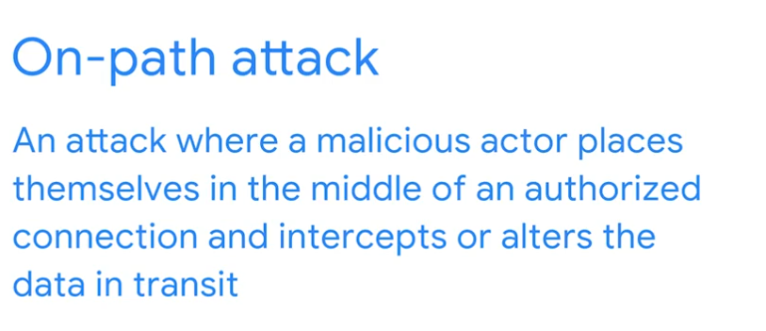
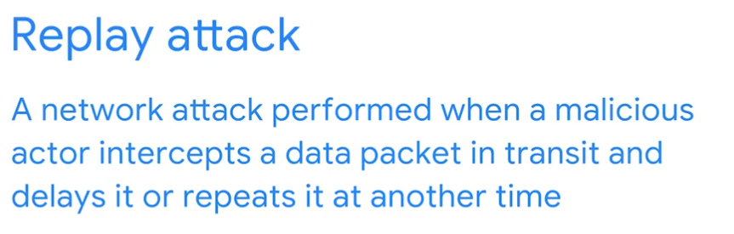
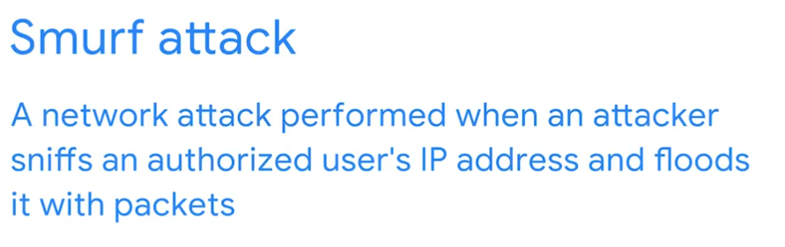

Overview of interception tactics Apr 15, 2026
This reading explains how interception attacks, specifically packet sniffing and IP spoofing, are used by malicious actors and how security analysts can defend against them.
Packet Sniffing
- Packet sniffing involves capturing and inspecting data packets across a network, often by setting a device's Network Interface Card (NIC) to promiscuous mode to accept all traffic.
- Malicious actors can use tools like Wireshark to capture data, including personal information or IP and MAC addresses, for later misuse or to perform IP spoofing.
IP Spoofing and Related Attacks
- IP spoofing occurs when an attacker impersonates authorized devices by using their IP and MAC addresses after sniffing packets, which firewalls can prevent by refusing unauthorized packets.
- An on-path attack, also known as a meddler-in-the-middle attack, involves intercepting communication between two trusted devices to steal sensitive information or redirect DNS lookups to malicious sites.
Types of Denial of Service (DoS) Attacks
- A Smurf attack combines IP spoofing with a DoS technique by flooding a spoofed IP address with packets, overwhelming the network and causing a denial of service.
- DoS attacks prevent compromised systems from legitimate activity by flooding them with traffic, and while similar to IP spoofing, the attacker doesn't receive a response and uses authorized-looking packets to crash the server.
Glossary terms from module 3 Apr 15, 2026
This reading provides definitions for various terms related to network attacks and security in Course 3, Module 3.
Denial of Service (DoS) Attacks
- Denial of Service (DoS) attack: An attack that floods a network or server with traffic to make it unavailable.
- Distributed denial of service (DDoS) attack: A DoS attack using multiple devices from different locations to overwhelm a target network.
Packet Sniffing and Interception
- Packet sniffing: The act of capturing and examining data packets on a network.
- On-path attack: A malicious actor intercepts or alters data by positioning themselves between an authorized connection.
Specific Attack Types
- IP spoofing: An attacker changes the source IP address of a data packet to impersonate an authorized system.
- Replay attack: A malicious actor intercepts and then delays or repeats a data packet to gain unauthorized access or disrupt services.
Security hardening Apr 15, 2026
This video explains security hardening, a crucial process for protecting systems from cyberattacks by reducing vulnerabilities.
Understanding Security Hardening
- Security hardening is the process of strengthening a system to minimize its vulnerability and attack surface, which refers to all potential weaknesses a threat actor could exploit.
- It's like putting locks on all doors and windows of a house to prevent a robber from gaining access, but for computer systems and networks.
Methods and Applications
- Hardening can be applied to various components such as hardware, operating systems, applications, networks, and databases, and also includes physical security measures like cameras and guards.
- Common procedures include software updates (patches), configuration changes (e.g., stronger password requirements), updating encryption standards, and disabling unused applications, services, and ports.
Proactive Security Measures
- Minimizing the number of applications, devices, ports, and access permissions makes network monitoring more efficient and reduces the overall attack surface.
- Regular penetration testing, or "pen tests," are simulated attacks that help identify vulnerabilities, allowing organizations to develop plans for fixing them.
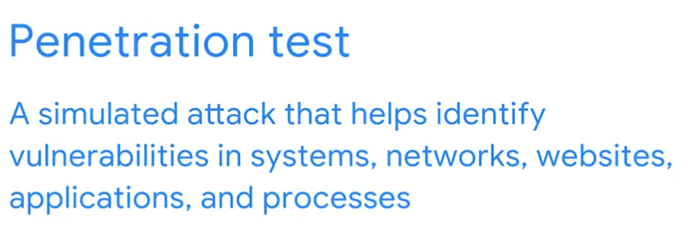

OS hardening practices Apr 15, 2026
This video explains operating system (OS) hardening, which is crucial for maintaining network security by securing the interface between computer hardware and the user.
Importance of OS Hardening
- An insecure OS can compromise an entire network, making it essential to secure each system.
- OS hardening involves practices performed regularly and one-time preliminary safety measures.
Regular OS Hardening Practices
- Patch Installation: Regularly updating the OS with patches from vendors fixes security vulnerabilities.
- Baseline Configuration: Maintaining a documented set of specifications for the OS helps detect unauthorized changes.
Other OS Hardening Techniques
- Hardware and Software Disposal: Properly wiping and disposing of old hardware and removing unused software reduces vulnerabilities.
- Strong Password Policies: Implementing policies that require complex passwords and multi-factor authentication (MFA) enhances security.
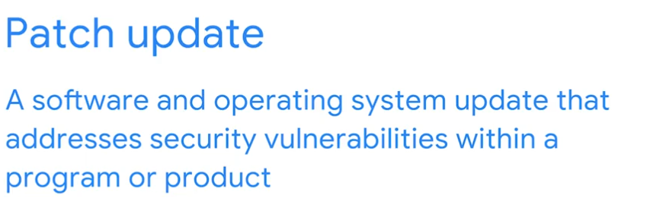
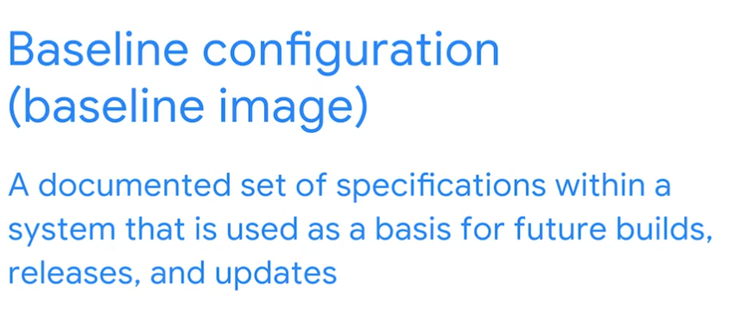

Security hardening Apr 16, 2026
This video explains security hardening, a crucial process for protecting systems from cyberattacks.
Understanding Security Hardening
- Security hardening is the process of strengthening a system to reduce its vulnerability and attack surface, which refers to all potential vulnerabilities an attacker could exploit.
- It's like putting locks on all doors and windows of a house to prevent a robber from gaining access.
Methods of Security Hardening
- Hardening involves regular maintenance, such as software updates (patches) and configuration changes like requiring stronger passwords or updating encryption standards.
- Other methods include removing or disabling unused applications, services, and ports, and reducing access permissions to minimize the attack surface.
Penetration Testing
- Penetration testing, or pen testing, is a simulated attack that helps identify vulnerabilities in systems, networks, websites, applications, and processes.
- The findings from pen tests help security teams identify and fix vulnerabilities, strengthening the network against future attacks.
Brute force attacks and OS hardening Apr 16, 2026
This reading focuses on brute force attacks, how to assess vulnerabilities using virtual machines and sandboxes, and various prevention measures.
Brute Force Attacks
- Brute force attacks involve trial-and-error to guess private information, often login credentials.
- Types include simple brute force, where attackers guess combinations, and dictionary attacks, which use lists of common or stolen passwords.
Assessing Vulnerabilities
- Virtual machines (VMs) are software versions of physical computers that provide an isolated environment to run and test suspicious files or malware without affecting the host system.
- Sandboxes are testing environments, often virtual, used to execute software separately from the network to identify bugs, test patches, or simulate attack scenarios.
Prevention Measures
- Salting and hashing enhance password security by converting information into a unique, irreversible value and adding random characters to hashed passwords.
- Multi-factor authentication (MFA) and two-factor authentication (2FA) require multiple verification methods to access systems, while CAPTCHA and reCAPTCHA help distinguish humans from bots to prevent automated attacks.
You are moving into the final module of the course: Security Hardening. This is a critical domain where you learn how to reduce the "attack surface" of a system to make it as difficult as possible for a malicious actor to get in.
Here is the breakdown of the core concepts for your OS Hardening practice assignment:

1. The Foundation of the Computer
Question: The _____ acts as an intermediary between software applications and computer hardware.
- Answer: operating system (OS)
- Reasoning: The OS (like Windows, Linux, or macOS) is the manager. It handles how software uses the CPU, memory, and storage. Because it sits in the middle of everything, hardening the OS is the most important step in securing a device.

2. Defining Security Hardening
Question: Which of the following activities are security hardening tasks?
- Answer: Disposing of hardware and software properly (Ensures no data is left behind on old drives).
- Answer: Enforcing password policies (Prevents brute force attacks).
- Answer: Making patch updates (Closes known vulnerabilities in the code).
- Note: Exploiting an attack surface is what an attacker does; hardening is about closing that surface.

3. Layering Identity Verification
Question: Multifactor authentication (MFA) is a security measure that requires a user to verify their identity in at least two ways...
- Answer: True
- Reasoning: MFA is a core hardening practice. It moves security beyond just "something you know" (a password) to include "something you have" (a physical token or phone) or "something you are" (a fingerprint).

4. Physical vs. Digital Hardening
Question: What are examples of physical security hardening?
- Answer: Installing security cameras
- Answer: Hiring security guards
- Reasoning: Security is multi-layered. Physical hardening protects the actual hardware (the servers and laptops). Removing unused applications or reducing permissions are examples of logical (digital) hardening, which protects the software and data inside the machine.

OS Hardening Quick Reference
Hardening Type | Example Task | Goal
Physical | Cable locks, badge access. | Prevent theft or unauthorized physical access.
Logical | Disabling guest accounts, MFA. | Prevent unauthorized digital login.
Software | Patching, removing "bloatware." | Close "holes" (vulnerabilities) in the code.
Compliance | Password complexity policies. | Ensure users follow high-security standards.
Since you have experience with Technical Troubleshooting and Docker, you’ve likely already practiced OS hardening by keeping your Linux kernels updated or using "minimal" container images to reduce the attack surface.
Do you have any questions about the difference between Patching and Updating before you take the quiz?
Network hardening practices Apr 16, 2026
This video explains network hardening, which focuses on securing networks through various practices.
Regularly Performed Network Hardening Tasks
- Firewall Rules Maintenance and Network Log Analysis: These tasks are performed regularly to ensure network security. Network log analysis involves examining logs to identify events of interest, often using Security Information and Event Management (SIEM) tools.
- Patch Updates and Server Backups: Consistent patch updates and regular server backups are crucial for maintaining a secure network environment.
One-Time Network Hardening Tasks
- Port Filtering and Network Access Privileges: Port filtering on firewalls blocks or allows specific port numbers to limit unwanted communication. Network access privileges ensure that only authorized users can access certain parts of the network.
- Network Segmentation and Encryption: Network segmentation creates isolated subnets for different departments, preventing issues from spreading across the entire company. All network communication should be encrypted using the latest standards, with higher encryption for restricted zones containing sensitive data.
Network security applications Apr 16, 2026
This reading focuses on network hardening and monitoring, explaining how various security devices and strategies contribute to a layered defense approach.
Defense in Depth with Security Devices
- Firewalls: These are fundamental for network security, allowing or blocking traffic based on rules and inspecting packet headers. Next-Generation Firewalls (NGFWs) offer advanced inspection capabilities by examining packet payloads.
- Intrusion Detection Systems (IDS): IDSs monitor system activity for signs of intrusion, alerting administrators to known attack signatures or anomalies. They are placed behind firewalls to reduce false positives.
Advanced Threat Detection and Prevention
- Intrusion Prevention Systems (IPS): IPSs actively monitor for intrusive activity and take action to stop it, such as blocking senders or dropping suspicious packets. They offer a higher level of protection than IDSs but can disrupt legitimate traffic if false positives occur.
- Security Information and Event Management (SIEM) Tools: SIEM systems collect and analyze log data from various network devices, providing a centralized dashboard for security analysts to monitor critical activities and identify suspicious behavior in real time.
Key Considerations for Network Security
- Layered Security: Combining different security tools like firewalls, IDSs, IPSs, and SIEMs creates a robust, multi-layered defense against various threats.
- Cost and Risk: Organizations must balance the cost of implementing and maintaining security tools with the level of risk they are willing to accept, as each tool adds to expenses and may require additional personnel.
You are making great progress through the Network Hardening section. These concepts are all about creating layers of defense to ensure that even if one part of the network is compromised, the rest remains secure.
Here is the breakdown of the concepts for your practice assignment:

1. Centralized Visibility
Question: Security teams can use _____ to examine network logs and identify events of interest.
- Answer: security information and event management (SIEM) tools
- Reasoning: A SIEM (like Splunk or Google Chronicle) acts as a central brain for security. It collects logs from firewalls, servers, and databases across the entire network and uses "correlation rules" to flag suspicious activity that a human might miss.

2. The Logic of Port Filtering
Question: What is a basic principle of port filtering?
- Answer: Allow ports that are used by normal network operations.
- Reasoning: Port filtering follows the "Principle of Least Privilege." You start by blocking everything and then specifically allow only the traffic required for the business to function (e.g., allowing Port 443 for web traffic but blocking Port 21 for insecure FTP).

3. Containing the Blast Radius
Question: A security professional creates different subnets for the various departments... What does this scenario describe?
- Answer: Network segmentation
- Reasoning: Network segmentation involves dividing a large network into smaller, isolated "subnets" (like separate islands). This ensures that if the Marketing department's network is attacked, the hacker cannot easily "hop" over to the Finance department's sensitive data.

4. Protecting the Most Sensitive Data
Question: Data in restricted zones should have the same encryption standards as data in other zones.
- Answer: False
- Reasoning: In a hardened environment, we use Defense in Depth. Restricted zones house your most sensitive "crown jewels." Because the risk is higher in these zones, they typically require higher/stronger encryption standards and more rigorous access controls than standard zones.

Network Hardening Cheat Sheet
Method | Primary Goal | Real-World Analogy
SIEM | Log analysis & Alerting. | A security guard watching a wall of monitors.
Port Filtering | Blocking unnecessary entry points. | Locking all windows except the one with the AC unit.
Segmentation | Isolating network sections. | Using separate keys for every room in a building.
Encryption | Making data unreadable to hackers. | Writing a message in a secret code.
Since you have been working with Google Cloud Infrastructure, you might recognize that VPC Service Controls and Cloud Armor are the primary tools used to implement these exact hardening strategies in a cloud environment.
Are you ready to move on to the Cloud Hardening section?
Network security in the cloud Apr 16, 2026
This video explains the importance of securing cloud networks, highlighting the differences and similarities between cloud network hardening and traditional network hardening.

Cloud Network Security Fundamentals
- Organizations are increasingly using cloud services, making cloud network security a critical aspect of a security analyst's role.
- Cloud networks, like regular web servers, require proper maintenance and security hardening procedures to prevent intrusions.

Distinctions in Cloud Network Hardening
- A key difference in cloud network hardening is the use of a server baseline image for all server instances.
- This baseline allows for comparison to detect unverified changes, which could indicate an intrusion.

Shared Responsibilities and Data Separation
- Cloud service providers and organizations share responsibility for cloud security, but organizations must still implement their own security measures.
- Data and applications on a cloud network should be separated based on their service category, similar to OS hardening, to enhance security.
Kelsey: Cloud security explained Apr 16, 2026
This video provides insights into career opportunities in cloud technology and emphasizes the importance of hands-on experience.

Career Transition to Tech
- The speaker shares their personal journey from fast food jobs to a career in technology, highlighting the accessibility of tech careers through certifications.
- The tech industry in 1999 is described as a booming field with high demand for certified professionals.

Understanding Cloud Computing
- Private Cloud vs. Public Cloud: The analogy of living alone (private cloud) versus having roommates (public cloud) illustrates the difference in security considerations.
- Security Implications: Moving to the public cloud necessitates a shift in security discipline due to shared environments.

Gaining Practical Cloud Experience
- Beyond Certification: Simply having certifications is not enough; practical application of skills is crucial.
- Hands-on Learning: The speaker advises actively using cloud platforms, deploying existing software, and utilizing diagnostic tools to identify and strengthen areas of weakness.
Secure the cloud Apr 16, 2026
This reading explores the unique security considerations within cloud computing environments and introduces the shared responsibility model for cloud security.
Cloud Security Challenges
- Cloud computing offers benefits like ease of deployment and scalability but introduces specific security challenges that cybersecurity analysts need to address.
- Key areas of concern include identity access management (IAM), where misconfigured user roles can lead to unauthorized access, and the complexity of configuring various cloud services to maintain security and compliance.
Attack Surface and Zero-Day Attacks
- The use of numerous cloud services can increase an organization's attack surface, requiring enhanced security measures to mitigate risks.
- Cloud Service Providers (CSPs) are generally better equipped to handle zero-day attacks (previously unknown exploits) than traditional on-premise networks, often patching hypervisors and migrating workloads to protect customers.
Visibility and Shared Responsibility
- While CSPs offer strong security, organizations accustomed to full network access might find the limited visibility into CSP servers a concern, though CSPs do provide tools like flow logs for monitoring.
- The shared responsibility model clarifies that CSPs secure the cloud infrastructure, while organizations are responsible for securing their assets and configurations within the cloud.
Cryptography and cloud security Apr 16, 2026
This reading focuses on securing cloud networks through various hardening practices and the fundamentals of cryptography.

Cloud Security Hardening Techniques
- Identity and Access Management (IAM): This involves managing digital identities and authorizing user access to different cloud resources.
- Hypervisors: These abstract hardware from operating software. Type one hypervisors, commonly used by Cloud Service Providers (CSPs), run directly on hardware, and CSPs are responsible for their management and security.

Implementing Cloud Security Measures
- Baselining: This involves configuring and setting up a cloud environment as a fixed reference point to compare changes and improve security and performance.
- Key Management: Modern encryption relies on secure key management. Tools like Trusted Platform Module (TPM) and Cloud Hardware Security Module (CloudHSM) help store and process cryptographic keys securely.

Fundamentals of Cryptography
- Cryptography in the Cloud: Cryptography secures data in the cloud by using encryption to scramble information into ciphertext, making it unreadable without an encryption key.
- Cryptographic Erasure: This method, also known as crypto-shredding, involves destroying encryption keys to render encrypted data undecipherable, which is more effective than traditional data destruction methods in the cloud.
You have reached the final section of Module 4! This is where you apply hardening principles specifically to the Cloud, which differs from traditional networking because it relies heavily on automation, virtualization, and shared responsibility.
Here is the breakdown of the core concepts for your Cloud Hardening practice assignment:

1. The Importance of Baselines
Question: A server baseline image enables security analysts to prevent _____ by comparing data to the image.
- Answer: unverified changes
- Reasoning: In the cloud, we use "Infrastructure as Code." A baseline image (or "Golden Image") is a pre-configured, hardened version of a server. If a server in production looks different from the baseline, it flags an unverified change, which could be a sign of a misconfiguration or a hacker establishing persistence.

2. Logical Separation in the Cloud
Question: Data and applications on cloud networks do not need to be separated based on their service category...
- Answer: False
- Reasoning: Just like network segmentation in traditional offices, the cloud requires logical separation. You should group applications and data by their sensitivity, functionality, or age. This ensures that a vulnerability in a legacy app doesn't provide a pathway to your most secure modern databases.

3. The Shared Responsibility Model
Question: Who is responsible for ensuring the safety of cloud networks?
- Answer: Cloud service provider (CSP)
- Answer: Security team
- Answer: Individual users
- Reasoning: Cloud security is a Shared Responsibility Model. The CSP (like Google Cloud) is responsible for the "Security of the Cloud" (hardware, physical data centers), while the customer (Security teams and users) is responsible for "Security in the Cloud" (data, configurations, and IAM).

4. The #1 Cloud Vulnerability
Question: _____ cloud services are a common source of cloud security issues.
- Answer: Misconfigured
- Reasoning: Unlike traditional hardware where you might have physical wires, cloud resources are defined by software settings. A misconfigured setting—such as an S3 bucket or Cloud Storage bucket accidentally set to "Public"—is the leading cause of massive data breaches in cloud environments.

Cloud Hardening Cheat Sheet
Hardening Practice | Definition | Key Benefit
Identity Management (IAM) | Controlling "who" can access "what." | Prevents unauthorized lateral movement.
Encryption | Scrambling data at rest and in transit. | Protects data even if the storage is breached.
Logging & Monitoring | Tracking every API call and change. | Detects misconfigurations or "unverified changes."
Network Security Groups | Virtual firewalls for cloud instances. | Implements port filtering at a software level.
Since you have been working with Google Cloud Platform (GCP) and Google Cloud Infrastructure, these concepts are exactly what you encounter when setting up VPCs and IAM roles for your AI agents!
Do you have any questions about how the Shared Responsibility Model shifts when you move from Infrastructure-as-a-Service (IaaS) to Software-as-a-Service (SaaS)?

Course wrap-up Apr 16, 2026
This course item provides a comprehensive review of key concepts in network security, emphasizing the importance for security analysts.
Network Fundamentals
- Understanding network design is crucial for identifying vulnerabilities and securing network components.
- Network operations and protocols dictate data transmission, and malicious actors can exploit these processes.
Network Security Measures
- Security analysts use tools like firewall rules to protect against attacks such as denial of service, packet sniffing, and IP spoofing.
- Security hardening, implemented at hardware, software, or network levels, reduces the attack surface and prevents entire network disablement.
Future Learning
- The next course will cover computing basics for security analysts, including using the Linux command line for user authentication and authorization, and SQL for database communication.
- The concepts learned in this course are essential for success as a security analyst.
Introduction to Course 4 Apr 16, 2026
This video introduces the "Tools of the Trade: Linux and SQL" course, focusing on foundational computing skills essential for security analysts.
Instructor's Background and Motivation
- The instructor, Kim, is a Technical Program Manager in security who developed an interest in the field after seeing its integration with technology.
- Her experience working with a security team on a cloud application led her to pursue a CISSP certification and transition into a security role.
Course Focus and Importance for Security Analysts
- The course emphasizes understanding how an organization's systems work to enhance a security analyst's efficiency in protecting against attacks.
- Familiarity with the Linux operating system and SQL for data interaction are highlighted as crucial skills for investigating events and correcting system errors.
Course Content Overview
- The curriculum will cover operating systems, their relationship to applications and hardware, and a detailed exploration of the Linux operating system.
- Learners will gain practical experience using the Linux command line in a security context and applying SQL to query databases as a security analyst.

